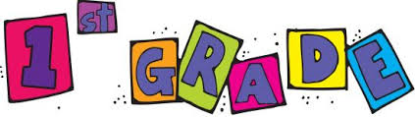
Supply List
- 2-pkg. Ticonderoga pencils
- 2-pkg. cap erasers
- 2-pkg. glue sticks
- 1-pkg. highlighters
- 2-boxes Crayola crayons
- 4-plastic 3-hole folders with pockets
- 2-handwriting tablets
- Pencil pouch (no boxes)
- Scissors (blunt tip)
- Index cards
- Ear buds or headphones
- Paper towels
- Kleenex
- Clorox wipes
- Hand sanitizer
- Lysol disinfectant spray
- Girls: sandwich bags
- Boys: gallon bags
Appreciated Supplies
- Markers
- Colored pencils
- Page protectors
- Expo dry erase markers
- Baby wipes

