**Instructional Focus**:

**Reading**- Story for week- Dot and Jabber and the Great Acorn Mystery

Reading Skill: Monitor and Clarify

**Phonics Skills**:

Review Skills: Vowel Patterns ow, ou /Syllables V/CV, VC/V

New Skills: Vowel Sound in foot: oo / Adding Endings

**Grammar Skill:** Pronouns: I and Me

**Math** – Topic 14 – Using Data to Answer Questions

**Science/ Social Studies** – Habitats

**Leader in Me** – Review all 7 Habits

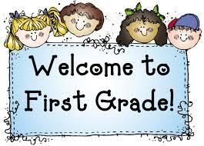 Week of May 10th – May 14th

Mrs. Lyness’ Newsletter

Spelling Words:

1. book

2. food

3. zoo

4. foot

5. moon

6. look

7. noon

8. took

9. pool

10. good

*Spelling Test Friday

**Important Dates Coming Up**:

May 24th – Field Day

May 27th – 1st Grade Awards Day (More info coming)

May 31st – No School; Memorial Day Holiday

June 4th – Last Day of School!

*If you can send in some Clorox Wipes and Paper towels that would be greatly appreciated.

High – Frequency Words:

1. among

2. another

3. instead

4. none

*On Reading Test Thursday