Amite County Elementary School
March 2020 Lunch Menu
Monday | Tuesday | Wednesday | Thursday | Friday
Mar - 2  Chicken Tenders  Sweet Potato Waffle Fries  Lima Beans  Roll  Applesauce  Ketchup 1  Dipping Sauce 1  Assorted Milk | Mar - 3  Cheesy Chicken /Rice  Cornbread  Southern Mustard Green  Glazed Carrots  Fruited Gelatin  Assorted Milk | Mar - 4  SAM I AM’s favorite  WHO HASH  GRINCH SALAD  ONE FISH, TWO FISH  Ham  Macaroni & Cheese  Hashbrown Potatoes  Tossed Salad w/ Dress  Crackers, fish shape  Ketchup 1  Assorted Fresh Fruit  Assorted Milk | Mar - 5  Spaghetti & Meat Sauce  Garlic Toast  Corn on the Cob  Baby Carrots w/ Dressing  Assorted Fruit Juices  Assorted Milk | Mar - 6  Pepperoni Pizza Wedge  Spicy Fries  Green Beans  Chilled Peaches  Ketchup 1  Assorted Milk
Mar - 9  Mandarin Chicken  Stir Fried Rice  Roll  Green Peas  Sliced Carrots  Mandarin Fruit Cup  Assorted Milk | Mar - 10  Spicy or Grilled Chicken Sandwich  Fries  Green Beans  Orange Smiles  Ketchup1  Mayonnaise  Assorted Milk | Mar - 11  Chili  Cheesy Breadsticks  Crackers 1  Cucumber Sticks /Dressing  Whole Kernel Corn  Chocolate Chip Cookie  Applesauce  Assorted Milk | Mar - 12  Red Beans & Rice /Sausage  Cornbread  Cheesy Broccoli  Yam Patties  Fruited Gelatin  Assorted Milk | Mar - 13  Sloppy Joe on Bun  Tater Tots  Baked Beans  Ketchup 1  Chilled Diced Pears  Assorted Milk
Mar – 16  NO SCHOOL | Mar – 17  NO SCHOOL | Mar – 18  NO SCHOOL | Mar – 19  NO SCHOOL | Mar – 20  NO SCHOOL
Mar - 23  Honey BBQ Chicken Bites  Roll  Sweet Potato Fries  Cheesy Broccoli  Apricots  Assorted Milk | Mar - 24  Breaded Steak  Rice / Gravy  Roll  Glazed Carrots  Green Beans  Chilled Peaches  Assorted Fruit Juices  Assorted Milk | Mar - 25  Beef-A-Roni  Cream-Style Corn Green Beans  Roll  Mandarin Fruit Cup  Assorted Milk | Mar - 26  Spring Break  Chicken Salad /Crackers 4  OR  Chicken Quesadillas  Tossed Salad w/ Dress  Refried Beans  Pineapple Tidbits  Sour Cream 1  Taco Sauce 1  Assorted Milk | Mar - 27  Corn Dog  Fries  Mixed Vegetables  Sugar Cookie  Applesauce  Ketchup 3  Mustard 1  Assorted Milk
Mar - 30  Chicken and Sausage  Jambalaya  Green Peas  Lemon-Glazed Carrots  Roll  Sugar Cookie  Sliced Strawberries  Assorted Milk | Mar - 31  Beefy Nachos Grande  Corn  Baby Carrots w/ Dressing  Chocolate Chip Cookie  Applesauce  Taco Sauce 1  Sour Cream 1  Assorted Milk | 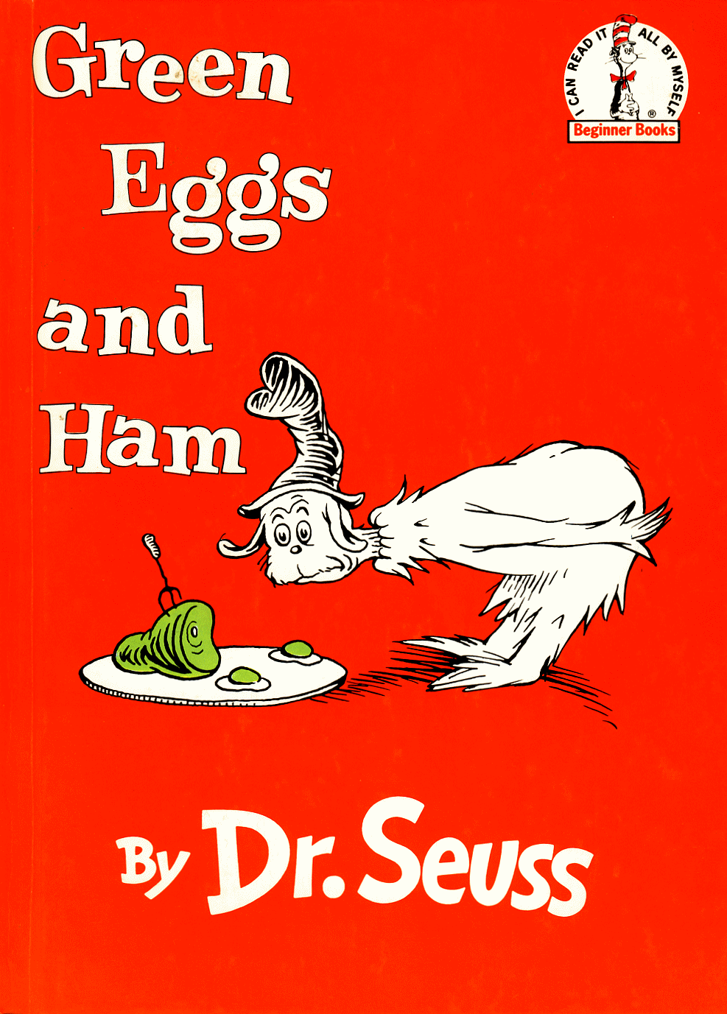 | 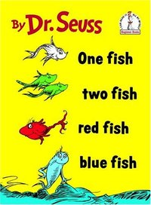
***Students are encouraged to select five components: fruit, vegetable, grain, meat/meat alternative and milk. However students are only required to select three components with one being a fruit or vegetable.***
*Milk served daily: fat-free Chocolate and 1% milk.
***Menu subject to change due to unforeseen circumstances.***
***This institution is an equal Opportunity Provider and Employer.***
Happy Birthday Dr Seuss

