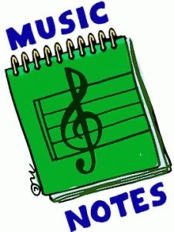
Week of:
APR. 27-may 1
4/13: This week we are reviewing the integrity letters A-E. Kids who show all of these are definitely kids of integrity and nothing can stop them! So, this week see if you can keep the beat with our integrity song of the week, “Nothing’s Gonna Stop Me Now” by Olivia Holt
4/14: Watch a Silly Symphony titled “The Ugly Duckling”
4/15: Let’s dance to “The Duck Dance”
4/16: Let’s play “Listen and Move”
4/17: Let’s Dance and Sing to our fun song Friday tune, “Old Town Road”

