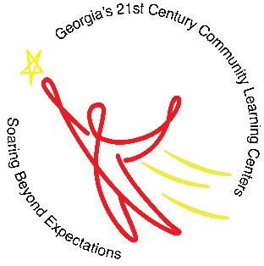
Mrs. Deirdre Brown Ms. Ashley Smith
Program Director Program Coordinator
Quitman County School District
Nita M. Lowey 21st CCLC S.O.A.R. Program
When: August 16, 2021 to May 5, 2022
Days: Monday – Thursday
Time: 3:00 p.m. – 6:00 p.m.
Where: QCS Pre-K-12 School
Homework assistance/Tutoring, Moby Max Reading/ELA and Math, Youth development, Robotics, Physical Education, STEM

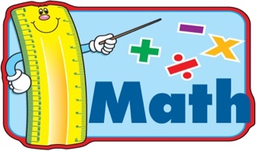
Quitman County School District does not discriminate on the basis of race, color, national origin, sex, sexual orientation, gender, gender identity, age, religion, national origin, or disability in its programs, services, or activities—in access to them, in treatment of individuals, or in any aspect of their operations.

