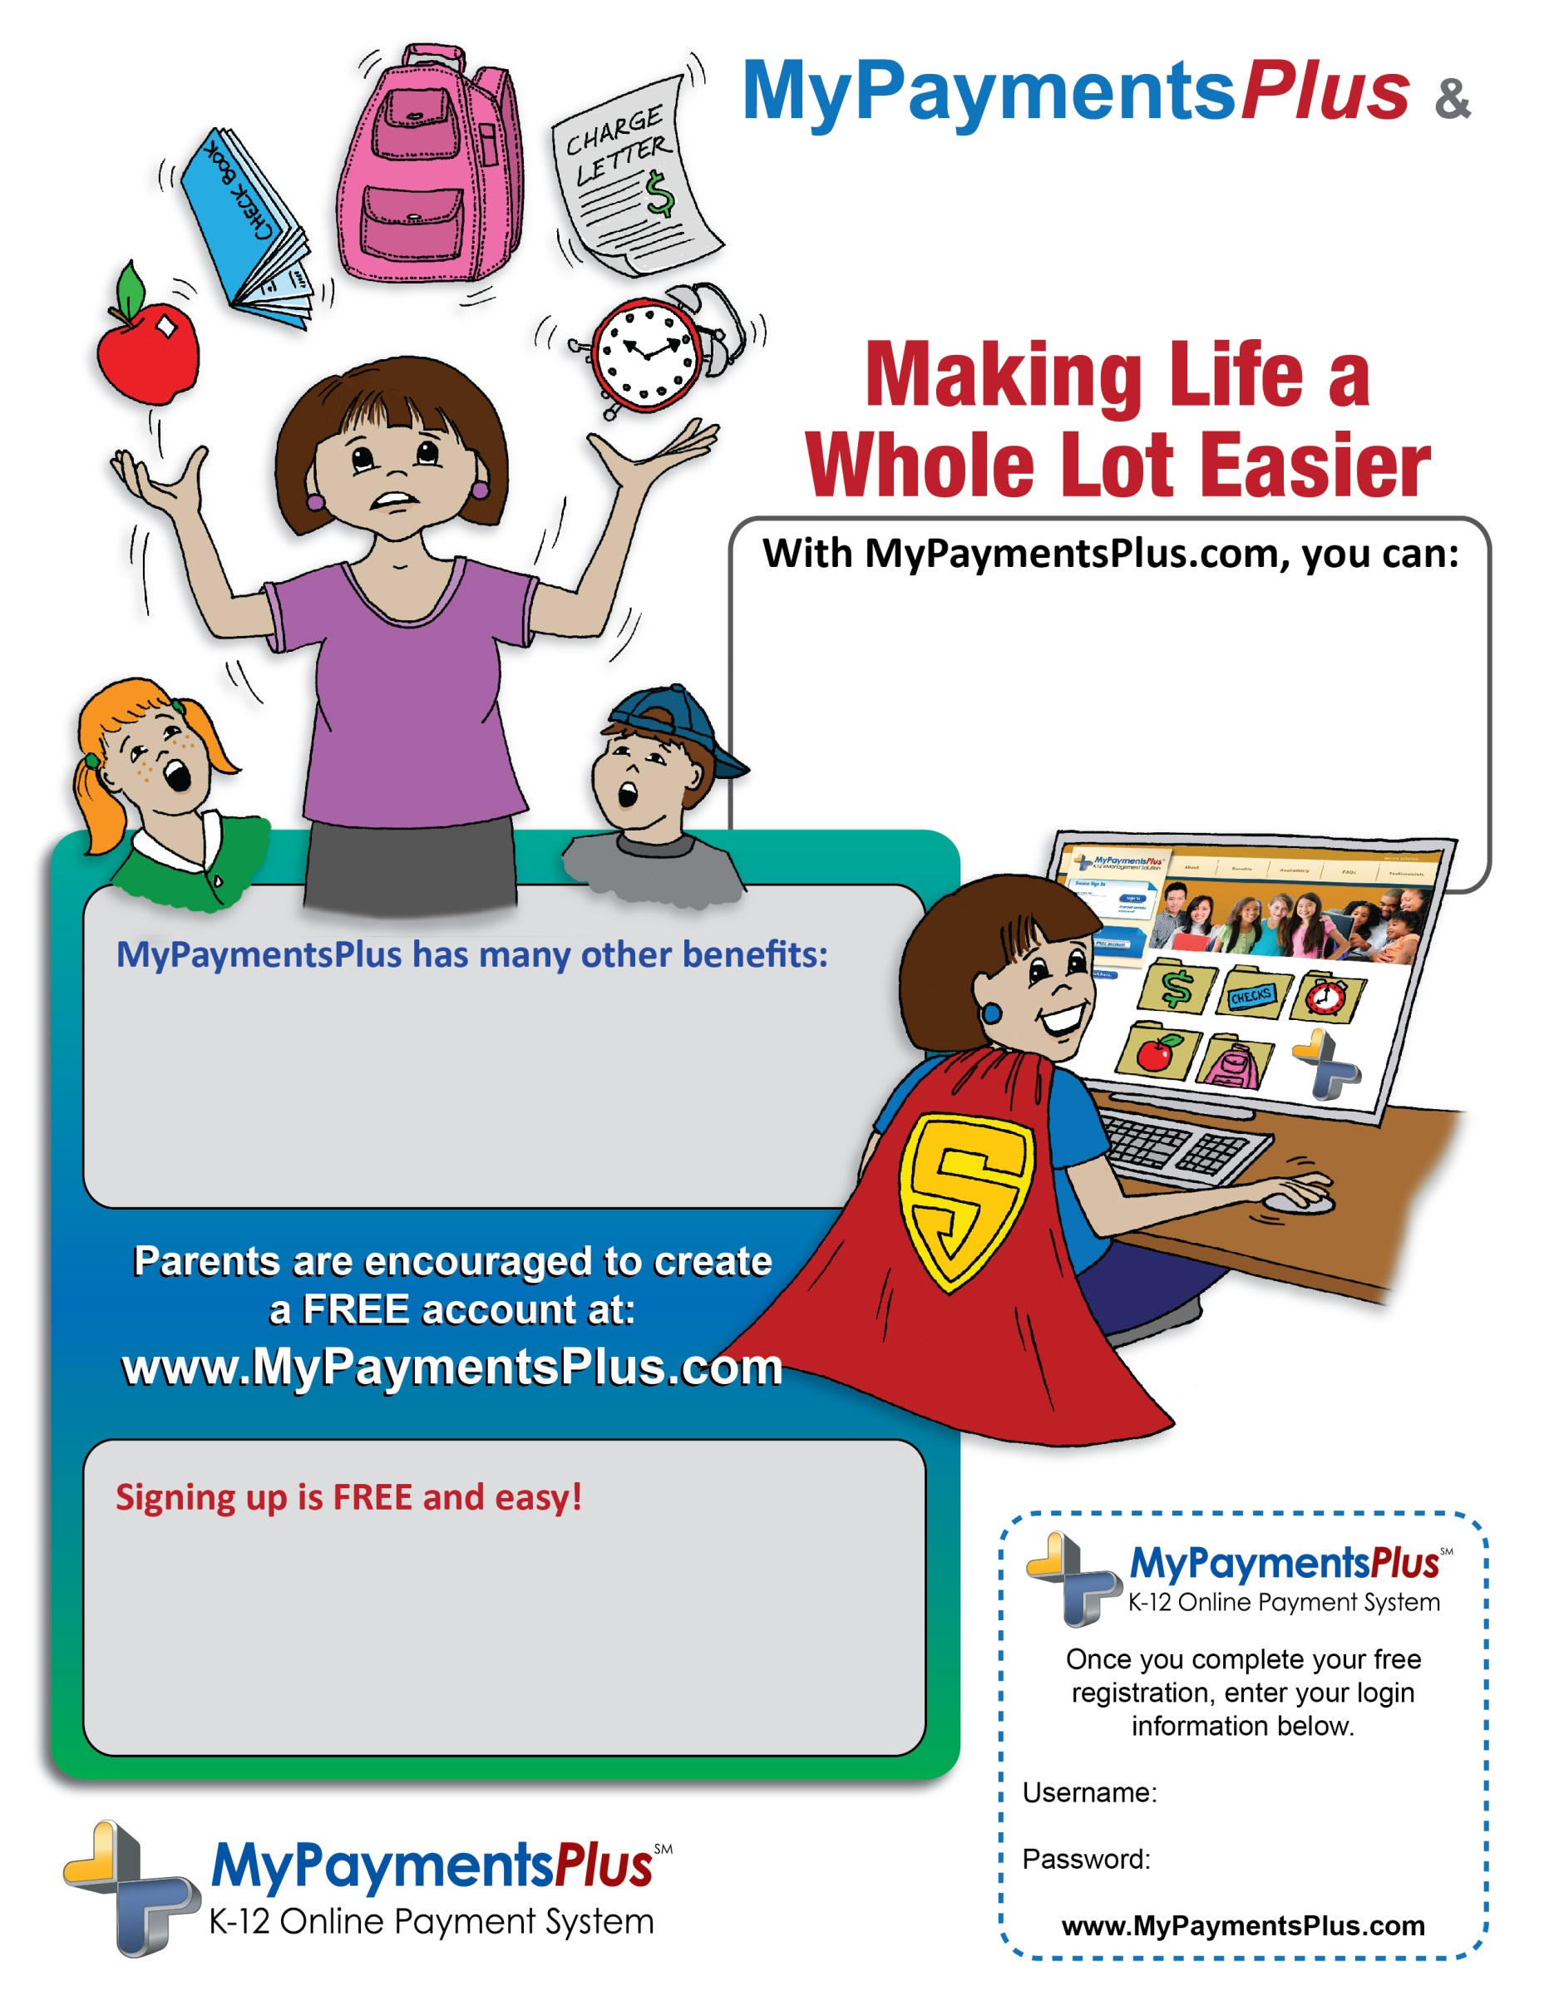

**Hamblen County-Russellville Elementary**

* View your child’s cafeteria account balance online, anytime
* Make all school-related payments in one location
* Digitally agree to district-required reading documents
* Register your student(s) for various activities
* Set up automatic low balance e-mail reminders, auto-replenish for student meals and so much more!
* Streamlines the orientation process, providing more time for student’s to interact with teachers
* Eliminates the worry of lost or forgotten money
* Ensures that your student will receive a nutritious meal and speeds up serving lines in the cafeteria
* Visit [www.MyPaymentsPlus.com](http://www.MyPaymentsPlus.com)
* Click “Register a FREE account” and follow the simple onscreen instructions
* Add your student by using their Student ID number