Mrs. Cook’s Messages
This week we will be learning about our skills that
are listed below but we will also be practicing for
the ACAP test that we will take when we return
from
Spring Break.
March 22-26, 2021
Grammar (pronouns I and me) and Reading Skills (plot and theme) Tests: Thursday or Friday
Topic 14 Math, Vocabulary, and Spelling (kn, wr, gn, mb) Tests: Friday
 | Enjoy your break next week!
Story:  Bad Dog, Dodger!”  by Barbara Abercrombie  Phonics/Fluency:  consonant patterns (silent letters)  kn, wr, gn, mb  Text-Based Comprehension:  plot and theme; background knowledge  Grammar:  pronouns I and me |  |  | Selection Vocabulary Words (Students will be tested on these):  - chased – ran after someone or something  - chewing – to crush something with your teeth  - dripping – falling in drops  - grabbed – to take it suddenly  - practice – a training session  - treat – a gift of food, drink, a free ticket, or the like  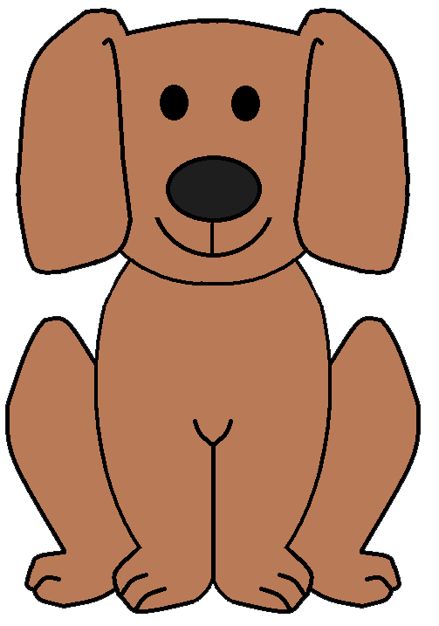  - wagged – to move from side to side or up and down  Amazing Words  behavior, obedient, consider, confident,  cooperate, companion, reprimand, property
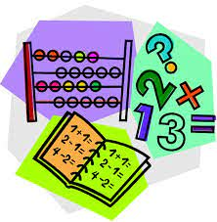  Topic 14:  Lesson 1: Adding Money  Lesson 2: Subtracting Money  Lesson 3: Estimating Sums and  Differences  Lesson 4: Problem Solving (Try, Check and  Revise) |  |  |  | Social Studies/Science  We are studying ways to be healthy: exercising, resting, eating right, and visiting  the doctor. We will be learning  through videos, online articles,  and books.
Spelling Words:
- knock  - sign  - knee |  | - wrong  - write  - climb |  |  | - wrap  - wren  - gnat |  |  | - lamb  - comb  - knob

