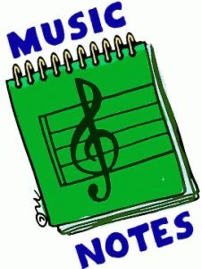
Week of:
May 18 - may 21
5/18: This week see if you can keep the beat with our song of the week, “Cake by the Ocean”
5/19: Watch “A Hole in the Bottom of the Sea”
5/20: Let’s dance to “Get Ready to Wiggle” with the Just Dance Kids
5/21: Let’s do “The Hokey Pokey” with Maximo from GoNoodle
Let’s Dance and Sing to our fun song Friday tune, “Giant”

