Examples of manipulatives (concrete objects)
The list includes examples of "teacher-made" manipulatives as well "commercially-made" ones.

- Counting/Basic Addition & Subtraction
- Place Value
- Multiplication/Division
- Positive & Negative Integers
- Fractions
- Geometry
- Beginning Algebra
1. Counting/Basic Addition & Subtraction Pictures
See examples
- Colored chips
- Beans
- Unifix cubes
- Golf tees
- Skittles or other candy pieces
- Packaging popcorn
- Popsicle sticks/tongue depressors
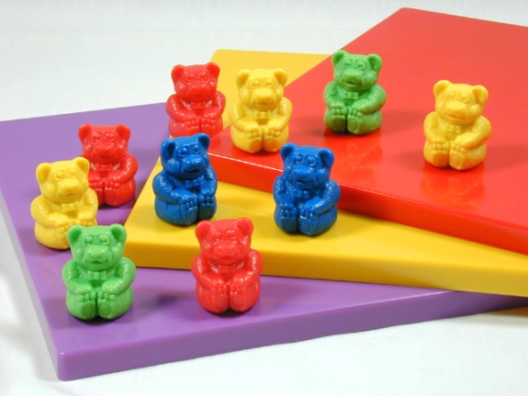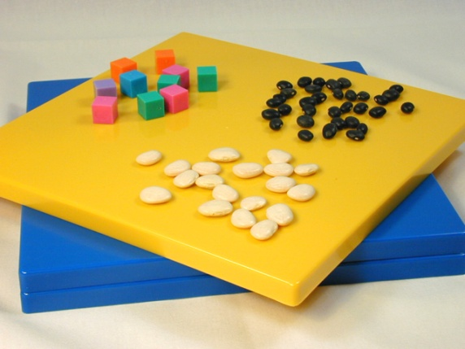
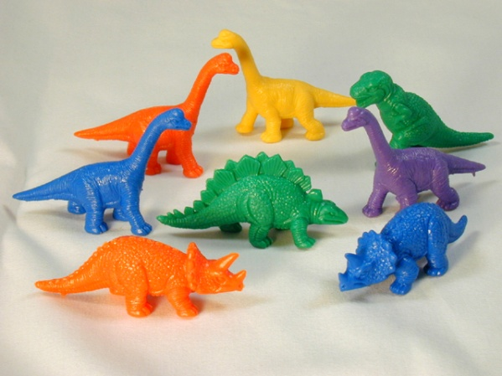
Description of use: Students can use these concrete materials to count, to add, and to subtract. Students can count by pointing to objects and counting aloud. Students can add by counting objects, putting them in one group and then counting the total. Students can subtract by removing objects from a group and then counting how many are left.
2. Place Value Pictures
- Base 10 cubes/blocks
- Beans and bean sticks
- Popsicle sticks & rubber bands for bundling
- Unifix cubes (individual cubes can be combined to represent "tens")
- Place value mat (a piece of tag board or other surface that has columns representing the "ones," "tens," and "hundreds" place values)
See examples
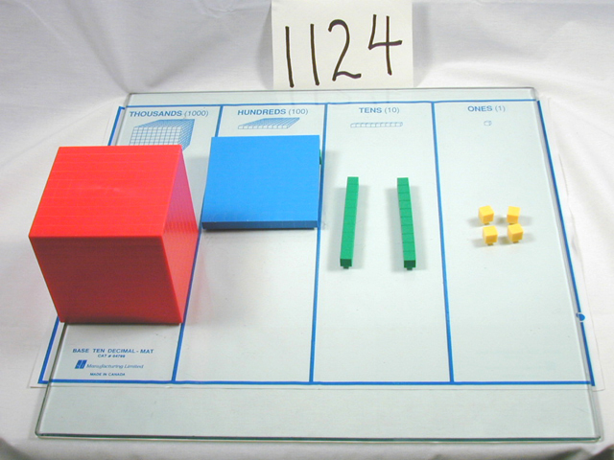
Description of use: Students are first taught to represent 1-9 objects in the "ones" column. They are then taught to represent "10" by trading in ten single counting objects for one object that contains the ten counting objects on it (e.g. ten separate beans are traded in for one "beanstick" - a popsicle stick with ten beans glued on one side. Students then begin representing different values 1-99. At this point, students repeat the same trading process for "hundreds."

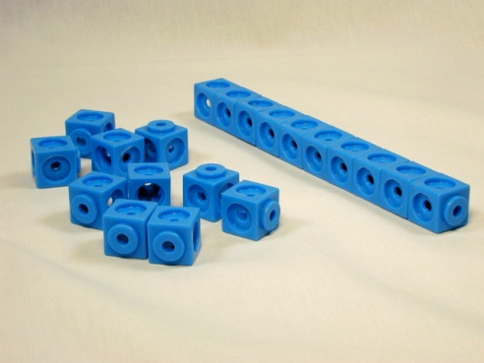
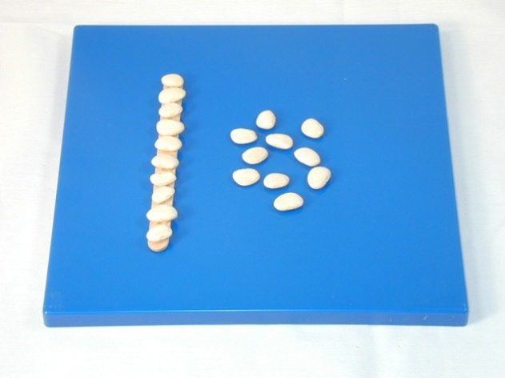
3. Multiplication/Division Pictures
- Containers & counting objects (paper dessert plates & beans, paper or plastic cups and candy pieces, playing cards & chips, cutout tag board circles & golf tees, etc.). Containers represent the "groups" and counting objects represent the number of objects in each group. (e.g. 2 x 4 = 8: two containers with four counting objects on each container)
Counting objects arranged in arrays (arranged in rows and columns). Color-code the "outside" vertical column and horizontal row helps emphasize the multipliers
See examples
. 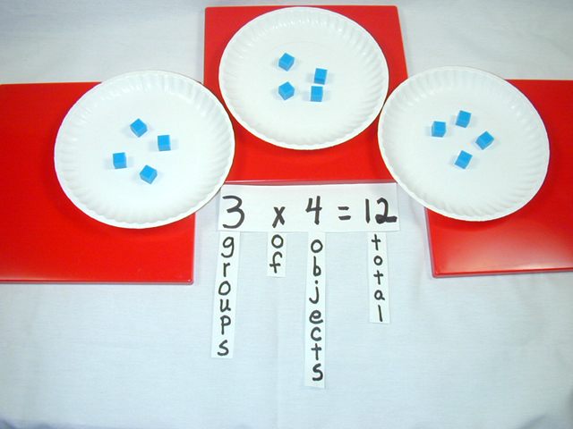
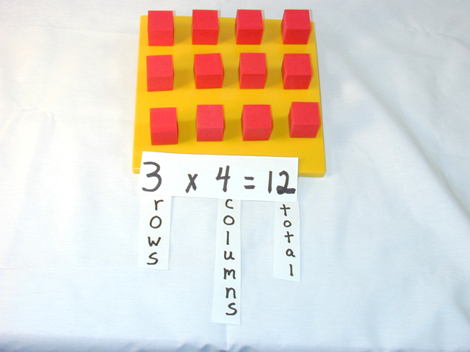
4. Positive & Negative Integers Pictures

- Counting objects, one set light colored and one set dark colored (e.g. light & dark colored beans; yellow & blue counting chips; circles cut out of tag board with one side colored, etc.).

See examples
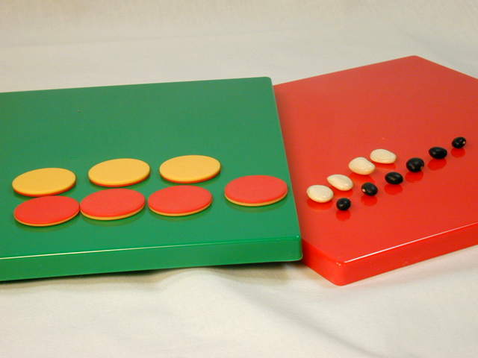
Description of use:
Light colored objects represent positive integers and dark colored objects represent negative integers. When adding positive and negative integers, the student matches pairs of dark and light colored objects. The color and number of objects remaining represent the solution.

5. Fractions Pictures
- Fraction pieces (circles, half-circles, quarter-circles, etc.)
- Fraction strips (strips of tag board one foot in length and one inch wide, divided into wholes, ½'s, 1/3's, ¼'s, etc.
- Fraction blocks or stacks. Blocks/cubes that represent fractional parts by proportion (e.g. a "1/2" block is twice the height as a "1/4" block).
See examples
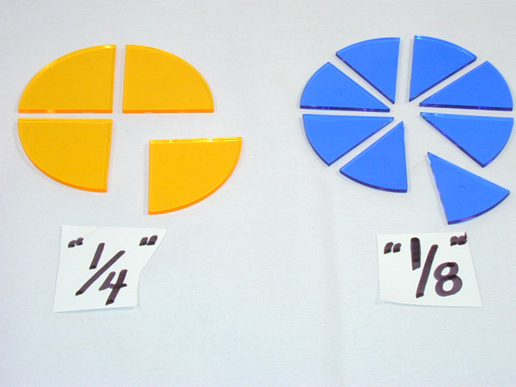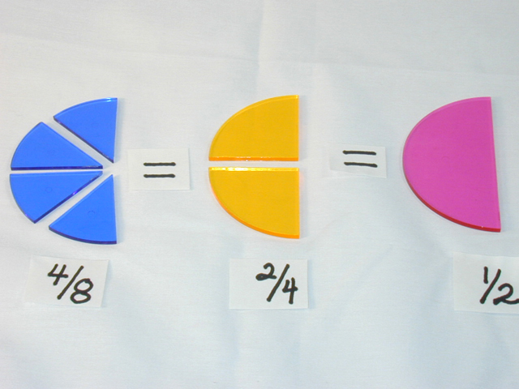
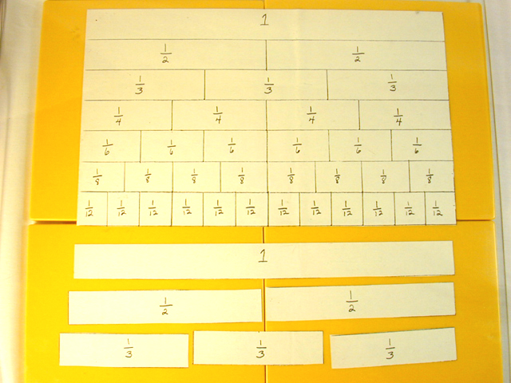
Description of use: Teacher models how to compare fractional parts using one type of manipulative. Students then compare fractional parts. As students gain understanding of fractional parts and their relationships with a variety of manipulatives, teacher models and then students begin to add, subtract, multiply, and divide using fraction pieces.

Geometry Pictures
- Geoboards (square platforms that have raised notches or rods that are formed in a array). Rubber bands or string can be used to form various shapes around the raised notches or rods.
See examples
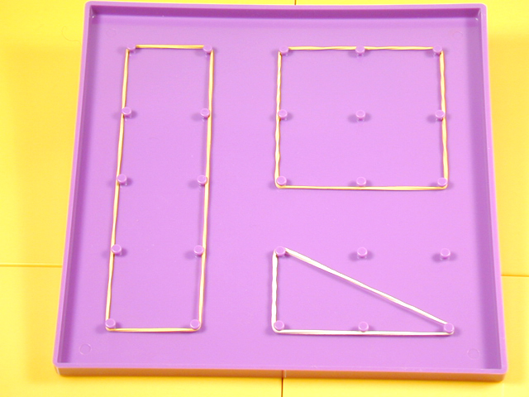
Description of use: Concepts such as area and perimeter can be demonstrated by counting the number of notch or rod "units" inside the shape or around the perimeter of the shape.

Beginning Algebra Pictures
- Containers (representing the variable of "unknown") and counting objects (representing integers) -e.g. paper dessert plates & beans, small clear plastic beverage cups 7 counting chips, playing cards & candy pieces, etc.
See examples
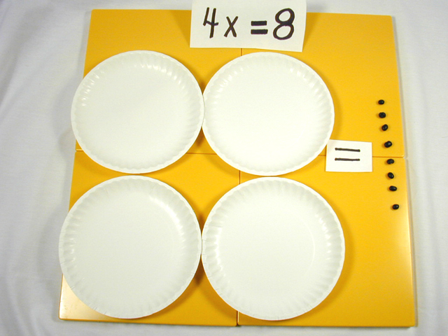
Description of use: The algebraic expression, "4x = 8," can be represented with four plates ("4x"). Eight beans can be distributed evenly among the four plates. The number of beans on one plate represent the solution ("x" = 2).

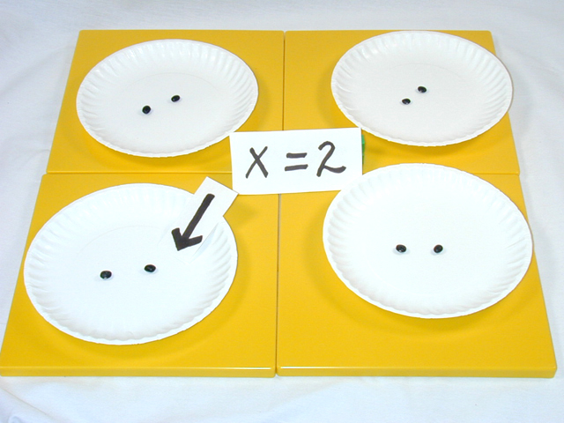

Suggestions for using manipulatives (Burns, 1996)
- Talk with your students about how manipulatives help to learn math.
- Set ground rules for using manipulatives.
- Develop a system for storing manipulatives.
- Allow time for your students to explore manipulatives before beginning instruction.
- Encourage students to learn names of the manipulatives they use.
- Provide students time to describe the manipulatives they use orally or in writing. Model this as appropriate.
- Introduce manipulatives to parents

Representational
- What is it?
- Examples of drawing solutions by math concept level
1. What is it?
At the representational level of understanding, students learn to problem-solve by drawing pictures. The pictures students draw represent the concrete objects students manipulated when problem-solving at the concrete level. It is appropriate for students to begin drawing solutions to problems as soon as they demonstrate they have mastered a particular math concept/skill at the concrete level. While not all students need to draw solutions to problems before moving from a concrete level of understanding to an abstract level of understanding, students who have learning problems in particular typically need practice solving problems through drawing. When they learn to draw solutions, students are provided an intermediate step where they begin transferring their concrete understanding toward an abstract level of understanding. When students learn to draw solutions, they gain the ability to solve problems independently. Through multiple independent problem-solving practice opportunities, students gain confidence as they experience success. Multiple practice opportunities also assist students to begin to "internalize" the particular problem-solving process. Additionally, students' concrete understanding of the concept/skill is reinforced because of the similarity of their drawings to the manipulatives they used previously at the concrete level.
Drawing is not a "crutch" for students that they will use forever. It simply provides students an effective way to practice problem solving independently until they develop fluency at the abstract level.
2. Examples of drawing solutions by math concept level
The following drawing examples are categorized by the type of drawings ("Lines, Tallies, & Circles," or "Circles/Boxes"). In each category there are a variety of examples demonstrating how to use these drawings to solve different types of computation problems. Click on the numbers below to view these examples.
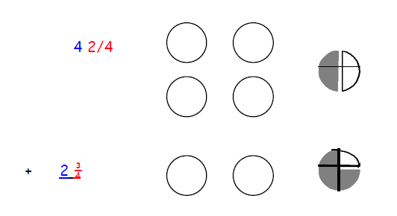
Abstract Thinking
1. What is it?
2. Potential barriers to abstract understanding for students who have learning problems and how to manage these barriers
1. What is it?
A student who problem-solves at the abstract level, does so without the use of concrete objects or without drawing pictures. Understanding math concepts and performing math skills at the abstract level requires students to do this with numbers and math symbols only. Abstract understanding is often referred to as, "doing math in your head." Completing math problems where math problems are written and students solve these problems using paper and pencil is a common example of abstract level problem solving.
2. Potential barriers to abstract understanding for students who have learning problems and how to manage these barriers
Students who are not successful solving problems at the abstract level may:
- Not understand the concept behind the skill.
Suggestions:
- Re-teach the concept/skill at the concrete level using appropriate concrete objects (see Concrete Level of Understanding).
- Re-teach concept/skill at representational level and provide opportunities for student to practice concept/skill by drawing solutions (see Representational Level of Understanding).
- Provide opportunities for students to use language to explain their solutions and how they got them (see instructional strategy Structured Language Experiences).
- Have difficulty with basic facts/memory problems
Suggestions:
- Regularly provide student with a variety of practice activities focusing on basic facts. Facilitate independent practice by encouraging students to draw solutions when needed (see the student practice strategies Instructional Games, Self-correcting Materials, Structured Cooperative Learning Groups, and Structured Peer Tutoring).
- Conduct regular one-minute timings and chart student performance. Set goals with student and frequently review chart with student to emphasize progress. Focus on particular fact families that are most problematic first, then slowly incorporate a variety of facts as the student demonstrates competence (see evaluation strategy Continuous Monitoring & Charting of Student Performance).
- Teach student regular patterns that occur throughout addition, subtraction, multiplication, & division facts (e.g. "doubles" in multiplication, 9's rule - add 10 & subtract one, etc.)
- Provide student a calculator or table when they are solving multiple-step problems.
- Repeat procedural mistakes.
Suggestions:
- Provide fewer #'s of problems per page.
- Provide fewer numbers of problems when assigning paper & pencil practice/homework.
- Provide ample space for student writing, cueing, & drawing.
Provide problems that are already written on learning sheets rather than requiring students to copy problems from board or textbook.
- Provide structure: turn lined paper sideways to create straight columns; allow student to use dry-erase boards/lap chalkboards that allow mistakes to be wiped away cleanly; color cue symbols; for multi-step problems, draw color-cued lines that signal students where to write and what operation to use; provide boxes that represent where numerals should be placed; provide visual directional cues in a sample problem; provide a sample problem, completed step by step at top of learning sheet.
- Provide strategy cue cards that student can use to recall the correct procedure for solving problem.
- Provide a variety of practice activities that require modes of expression other than only writing
*Key Idea
Student learning & mastery greatly depends on the number of opportunities a student has to respond!! The more opportunities for successful practice that you provide (i.e. practice that doesn't negatively impact student learning characteristics), the more likely it is that your student will develop mastery of that skill.

