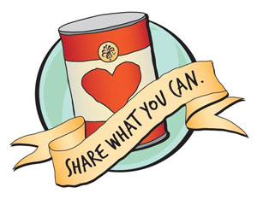
Kids Caring About
Community

BGS Kids
Get The Spirit Of Christmas Giving!

Bring nonperishable food items to school to be used in the Christmas Food Baskets for area friends and neighbors.

Need some ideas?
Here are some items that make meal prep easy:
canned soups and stews, mac & cheese, canned ravioli,
tuna, canned meats

Food Donations Can Be Made In Your Classroom From
December 2 - December 13.
Thank You!!

