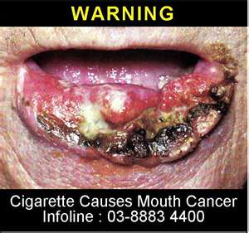

Close to 40,000 Americans will be diagnosed with oral or pharyngeal cancer this year. It will cause over 8,000 deaths, killing roughly 1 person per hour, 24 hours per day. Of those 40,000 newly diagnosed individuals, only slightly more than half will be alive in 5 years. (Approximately 57%) This is a number which has not significantly improved in decades. The death rate for oral cancer is higher than that of cancers which we hear about routinely such as cervical cancer, Hodgkin's lymphoma, laryngeal cancer, cancer of the testes, and endocrine system cancers such as thyroid, or skin cancer (malignant melanoma). If you expand the definition of oral cancers to include cancer of the larynx, for which the risk factors are the same, the numbers of diagnosed cases grow to approximately 54,000 individuals, and 13,500 deaths per year in the US alone. Worldwide the problem is much greater, with over 640,000 new cases being found each year.

http://oralcancerfoundation.org/facts/index.htm