Tech Foundations 4th Block
April 8-17
Rodney Carver

Introduction to Computers

What is a computer?
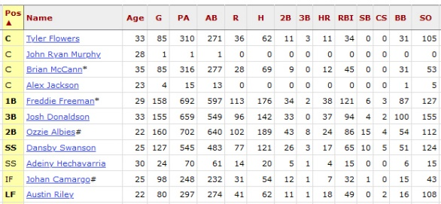
A computer is an electronic machine that can perform tasks by processing data into information. A computer processes raw data from the user and converts it into useful information to be used or stored. Data has little meaning until it has ben organized into information.
Raw Data: Batting statistics
Useful Information: Freddie Freeman is better than Tyler Flowers.
For example, a baseball team will input the hitting data for each of their players into a computer. A computer will use the data to calculate for the manager which players are performing the best.

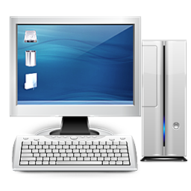
Hardware and Software
A Computer System
A computer system is made up of hardware and software. The physical components associated with a computer system is called hardware. You can touch hardware. Software refers to the instructions that tell the hardware what to do. Unlike hardware, software does not exist in the physical world, it only exists in the computer’s virtual environment.
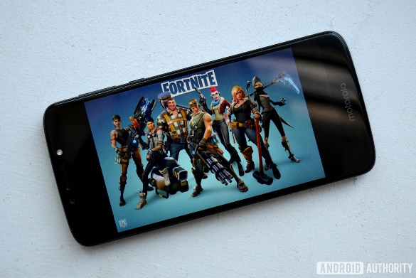
For example, a smartphone is computer.
Phone: Hardware
Fortnite Game: Software
The phone and its physical parts are hardware. They’re made of plastic, metal, and glass.
The apps (applications) that are installed on the device are the software. They are not real items that can be physically touched.
Software is made up of programs. A program is a set of step-by-step instructions that tells a computer how to perform tasks.
A computer programmer is a person who writes programs. Computer users are the people who purchase and use computers to perform tasks.

Information Processing
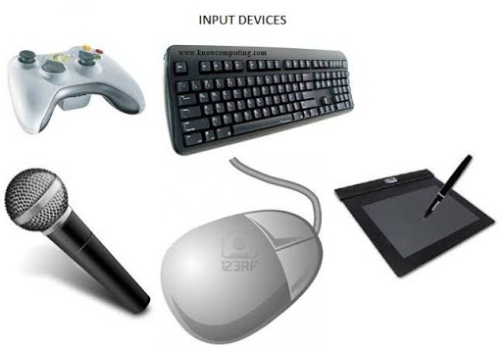
Computer processing is made up of four stages: input, processing, output, and storage.

Input
Input is the data that is put into a computer. Typing on a keyboard is one way to put data into a computer. Clicking a mouse or tapping the screen lets a user give commands to the computer.
A keyboard and a mouse are both examples of input devices: hardware used to put data into a computer.

Processing
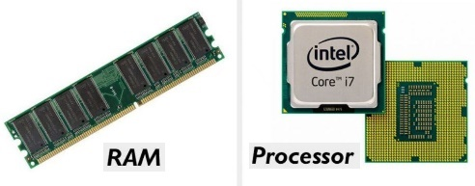
The processor is the hardware that manipulates the raw data into the useful information people want. It’s also called the central processing unit or CPU. The processor is like the brains of the computer. The processor follows the step-by-step instructions that are specified in the computer program. Processing also requires memory.
RAM memory is the temporary memory that holds the data in place while it is being processed by the processor. RAM stands for random access memory. Information stored in RAM is lost when the application is closed or when the computer is turned off.

Output
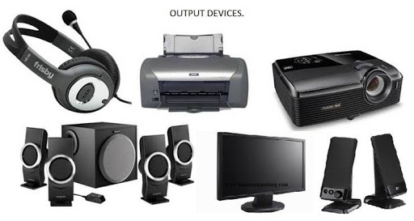
Output is the information that comes out of the computer after it has been processed. Output devices are hardware components that show users the processed information. Examples of output devices are a monitor and printer. A monitor shows information to the user on a screen. A printer puts information on to paper.

Storage
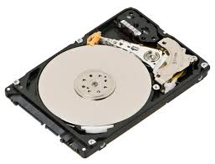
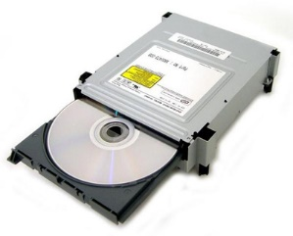
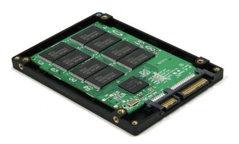
Since RAM memory holds data only temporarily, secondary storage is needed for information that must persist even after the computer is turned off. Computer storage is any means by which a computer can save and retrieve information. A storage device is the hardware that reads and writes information on to storage media. Storage media is the hardware that holds the information.
Disk Drive with Hard Disk CD Drive with CD Solid State Drive with Flash Memory
For example, a hard disk drive (HDD) stores information on a hard disk.
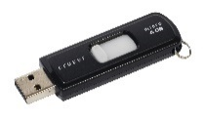
A CD burner stores information on a compact disc (CD).
USB flash drives and solid state drives (SSD) stores information on flash memory.
USB Flash Drive

Operating System Software.
The operating system (OS) is system software that manages the computer hardware and resources. It serves as the interface between the computer and the user. Usually, the operating system uses a graphical user interface (GUI) which provides visual elements such as images and buttons to interact with the user.
Microsoft Windows is an example of a common operating system. The Windows Operating System places each active application in its own window frame for the user to access easily. The active window refers to the window that is currently being used. Windows can be maximized to fill the entire screen or minimized to be hidden in the taskbar without closing the application.
Some components of the Windows operating system include a customizable desktop which is a workspace containing a user’s preferred applications and documents. A taskbar containing shortcuts and open applications is usually at the bottom of the desktop. The start menu or button in the bottom left corner of the desktop acts as a starting point to navigate to all of the computer’s resources. The control panel allows users to customize the operating system’s settings.
A computer cannot operate without an operating system. It must be installed before the computer can be used.

Application Software
A computer app, or application software, is a collection of programs used to perform specific, related tasks on a computer. The user decides what tasks they would like to do on the computer and installs a corresponding application to preform those tasks. Application software can only be installed after the operating system software is already installed.

Word Processing
Word Processors lets users create and edit text documents such as reports, letters, and brochures. One example of word processing software is Microsoft Word.

Electronic Spreadsheets
Spreadsheet software is made up of columns and rows and is used for performing calculations based on numerical data and mathematical formulas. An electronic spreadsheet may be used to track a store’s inventory and sales, compute student averages like a grade book, or calculate an employee payroll based on workers’ hours and wages. Microsoft Excel is an example of a spreadsheet application software.

Presentation Software
Presentation software is used to create an electronic, interactive slide show about any topic. Presentation software can be used to accompany any type of group presentation such as class report for a school project, a sales pitch for businesses, or song lyrics for a sing-a-long. Mircosoft PowerPoint is one example of presentation software.

Binary Code
A computer is an electronic device, meaning it runs on electricity. Think of a light bulb. It is also an electronic device. A simple light bulb has two states: on and off. These two states can be represented as the binary digits 0 and 1. A light bulb that is off can be represented by the number 0, and when it is on, it becomes the number 1. In computing, a binary digit is called a bit and is the smallest unit of data on a computer. Now imagine 8 light bulbs in a row. These bulbs can form 256 different combinations with each bulb is either on or off. In computers, 8 bits is called a byte.
Computers use binary code to convert bits of electricity into meaningful information. For example, when the letter “H” is pressed on the keyboard, 8 signals are sent from the keyboard to the CPU as input. Some of those 8 signals contain electricity and some do not which can be visualized by having some light bulbs turned on and some kept off. The CPU, acting as the brains of the computer, can determine which signals are off and which ones are on and assign a 0 or 1 to each signal resulting in a pattern like this: 01001000. This pattern is compared to a binary code chart to determine that the electrical signals represent the capital letter H. It takes 8 bits, or one byte, of information to represent a letter of the alphabet. The CPU can now send the letter H to an output device or storage device.
Millions of bytes of data are transferred inside a computer all the time and are stored on storage devices. Approximately 1,000 bytes is called a kilobyte. 1,000 kilobytes is called a megabyte. 1,000 megabytes is called a gigabyte. And 1,000 gigabytes is called a terabyte.
Magnetic media such as hard disks use magnets to represent 0 and 1 when storing data because magnets have a distinct north and south pole that can be detected and decoded by a disk drive.
Optical media such as a CD or DVD use holes or burn marks to represent binary digits. The data can be detected by the CD/DVD drive by shining a laser on to the disc and looking for a reflection.
Flash media inside flash drives and solid state drives contain floating gates that are suspended in insulation. The gates can be open or closed by flashing them with electron gun. The drive can read which gates are open or closed to represent binary digits.
Flash media used in solid state drives (SSD) is often preferred to magnetic media used in hard disk drives because SSD drives do not contain moving parts making them faster and usually more reliable. However, the cost to manufacture an SSD is usually higher than the cost of an HHD of the same capacity.

Computer Information Processing
Define or Answer all of the following using complete sentences.

- Write a sentence that defines computer.

- Write a sentence to name the parts to Information processing cycle (4 parts).

- Explain the difference between data and information using a complete sentence.

- Explain the difference between software and hardware using a complete sentence.

- Discuss computer input in complete sentences.

- Write a sentence to name some input devices

- Write a sentence to describe Central Processing Unit

- Tell what RAM is and what it stands for using complete sentences.

- Write a sentence defining computer Output.

- Write a sentence to name some output devices

- Write a sentence to describe computer Storage.

- Write a sentence to name some storage devices

- Write a sentence to tell what a Bit is

- Use a sentence to describe Binary Code

- Write a sentence to define Byte

- Write a sentence to define Kilobyte

- Write a sentence to describe the difference between a Megabyte and Gigabyte.

- Explain how magnetic media store information and give one of magnetic media using complete sentences.

- Explain how optical discs store information and give one example using complete sentences.

- Explain how flash memory stores information using complete sentences.

- Write about the advantages of flash memory using complete sentences.

- Explain the difference between a solid state hard drive and a traditional hard drive using complete sentences.

Computer Software
Define or Answer all of the following using complete sentences.
A complete sentence has a subject and a verb.

- Define Computer using a complete sentence:

- Write a sentence to define Computer Program:

- Explain the difference between hardware and software in your own words:

- Write a sentence to define Operating system Software

- Write a sentence to define Application Software

- Use sentences to define word processing

- Give one example of word processing software using a complete sentence.

- Use sentences to name 3 specific examples of what can be created using Word Processing

- Write a sentence to define Spreadsheet software

- Give one example of Spreadsheet Software

- Name 3 real-world examples of how spreadsheet software can be used in real life situations.

- Write a sentence to define Presentation software.

- Write a sentence to name one example of Presentation Software

- Write a sentence to name 3 examples of where presentation software can be useful in the real world.

Windows Operating System

- A(n) _______________ is an electronic machine that carries out instructions stored in memory to perform a task.
- A(n) _______________ is a set of computer instructions.
- The program that controls the allocation of computer hardware and allows the user to communicate with the computer is called the _______ ________
- Windows is the name of the ___________ ___________ software for desktop computers made by Microsoft.
- The _______________ at the bottom of the Windows desktop contains icons for running applications, the Start Menu, Search Box, Taskbar button area, and the Notifications.
- ____________ Means to hide an open window to the Taskbar without closing the Application.
- You can enlarge a window to fill the entire desktop by using the ____________ button.
- Dragging the title bar of a window all the way to the edge of the Desktop will cause the window to fill ________ of the screen.
- An _____________ _______________is special software that controls the allocation of computer hardware and allows you to communicate with the computer.
- Name 3 different operating systems: ________ ____________ _______
- The ______ ______ allows you to change your operating system settings in Windows.
- The ____________ window is the window you are currently using or that is currently selected
- A user interface that displays graphics in addition to text when it communicates with the user is called a(n) __________ ___________ __________.

