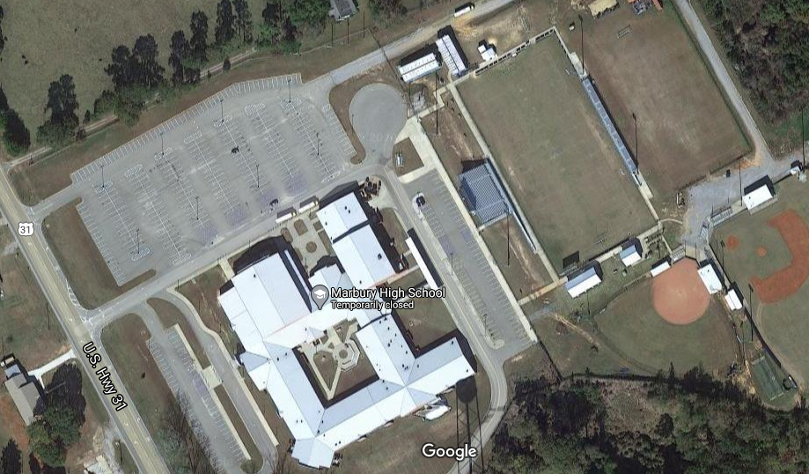
P.O.E
New Field House
Student Seating in Chairs
Stage
P.O.E.
P.O.E
Parent Parking
Student Parking
Parent Parking
*Graduation will be held at Marbury High School on June 3rd at 6PM. Graduation will occur on the football field.
*Chairs and the stage will be rented from an outside vendor.
*The area around the new fieldhouse will be blocked off so that spectators cannot congregate behind the stage. This area will be clearly marked and blocked off.
*Students will enter the football field following the path that is marked on the map.
*Students will be given 10 tickets for Graduation. Every person (regardless of age) that enters the stadium must have an official MHS Graduation ticket.
* Tickets will be given to students after practice on June 3rd.
* Gates will open at 4:30.
*Prior to the ceremony, students will be placed in the gym to help with social distancing. Students will arrive at 5 and the ceremony will begin at 6.
* All spectators will be required to wear a mask as they enter the stadium.
*Graduates will be required to wear masks as they enter the stadium and keep masks on until they sit in their seats.
*Graduates’ chairs will be spaced out 6 feet apart to help with social distancing.
*Hand sanitizing stations will be at both points of entry and along the sidewalk in front of the bleachers.
*The MHS faculty will be in chairs behind the student seating area.
*The date of Graduation may be adjusted, based on the weather forecast. Please make plans NOW to prepare for these changes.

Important Dates/Information for Seniors:
Friday, May 14th: Senior meeting at 10:00 AM in the gym. Graduation information/Senior Honors Night/Yearbook Distribution/Exam Information will be discussed. Graduation checklists will be distributed. Attendance will be taken.
Wednesday, May 19th: Ms. Beeson will distribute all pre-sold yearbooks.
Thursday, May 20th: Seniors can buy extra yearbooks from 9-11 AM.
Friday, May 21st: Senior Exit Questionnaire (for Honors’ Night) is due to Mrs. Hicks.
Sunday, May 23rd: Baccalaureate 2:00 @ Boone’s Chapel
Monday, May 24th: Senior Day. Breakfast (provided by parents) and yearbook signing will occur until 9 AM. Senior Sunset will be held that evening on the football field.
Final Exam Information: Exams can be taken at school or online through Schoology. All exams must be taken in accordance to the schedule below:
Tuesday, May 25th: 1st, 3rd, and 5th period exams
Wednesday, May 26th: 2nd, 4th, 6th period exams
Thursday, May 27th: 7th and 8th period exams
Friday, May 28th: Make-ups for exams.
Chromebook Returns: All students must return their Chromebooks. If a senior needs his or her Chromebook for finals, the Chromebook should be returned no later than Friday May 28th. Seniors can turn in Chromebooks from May 21st-May 28th.
Textbook Returns: All students must return all textbooks. If a senior needs textbooks for finals, then the last day to turn in textbooks is Friday, May 28th. Seniors can turn in textbooks at any time before May 28th.
Friday, May 28th: Chromebooks and textbooks are due, and all fees must be paid. All checklists must be completed and turned in!
Thursday, June 3rd: Graduation day! Practice (mandatory for all participants) will be at 9AM. All participants will meet in the gym at 9. Tickets will be given to all seniors after practice in the front hall by the gym. Graduation checklists will be required to be completed prior to participation in Graduation. All participants will meet back at school, in the gym, at 5 PM. No parents will be allowed in the gym. The program will begin promptly at 6:00 P.M.
Frequently Asked Questions Regarding Graduation:
- What is the dress code for Graduation? Girls wear dark dresses or pant suits and dark dress shoes. Boys wear dark pants, shirt and tie, with dark dress shoes.
- Can I design my own cap for Graduation? Yes, but Mrs. Jerkins has to approve the design.
- How many people can I have attend Graduation? 10. Everyone entering the stadium must have a ticket, regardless of age.
- Do we have to wear masks? All spectators must wear a mask as they enter the stadium. MHS will only have a limited amount of masks to pass out, so spectators need to bring their own masks. Students will be provided a mask when they arrive to the gym at 5PM. Students wear masks until they sit in their chairs on the football field.
- Will Lifetouch be taking pictures? Yes.
- Will the event be live-streamed? We are planning on livestreaming the event through the school Facebook account. If this is not possible, the event will be recorded and added to YouTube.
- What about Graduation Cords? Cords are to be ordered/handled by the individual club sponsors. We will recognize traditional, educationally based cords at graduation.

