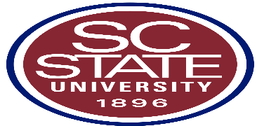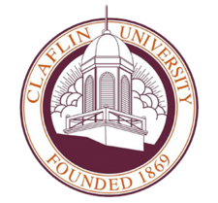

Scholarship Information 2019-20
The Hampton Wildlife Fund is offering four scholarships: The Harry Hampton Scholarship is a 4 year $5,000 a year scholarship for students who wish to further their education in the natural resources discipline such as wildlife biology, fisheries biology, forestry or marine science. The recipient will receive the harry Hampton Scholarship for four years as long as he or she maintains a GPR of 2.5 or above for a given academic year.
The Wallace F. Pate Scholarship is a one year $2,500 scholarship for students who wish to pursue a degree in the natural resources discipline such as wildlife biology, fisheries biology, forestry or marine science.
Note: Natural resources students may apply for the Hampton and Pate scholarships together on one application, but are eligible to be awarded only one. Agriculture, general biology, pre-medical biology and veterinary science are Not eligible curricula.
The David M. Cline Scholarship is a one-year $2,000 scholarship for students who wish to pursue a degree in law enforcement/criminal justice/forensic science.
The James O. Thomason Scholarship is a 4 year $2,000 a year scholarship for students who wish to pursue a degree in print or photo journalism, advertising, public relations or mass communications. The recipient will receive the James O. Thomason Scholarship for as he or she maintains a GPR of 2.5 or above for a given academic year. Applicants are also required to submit a topical essay (criteria and application). The deadline for submission for all scholarships is January 31, 2020. Each application must be accompanied by high school transcripts SAT/ACT scores and essays. Applications can be send via email at jim.goller@hamptonwildlifefund.org by writing to the address below or by phone at 803 600-1570.
The Lyceum Program @ Clemson University- offers an education aimed at shaping student’s minds and character. Students that are accepted into this program receive $10,000 scholarships to Clemson University. If interested please email Lyceum@clemson.edu or call 864 656-2133.
USDA/1890 Scholar Program Opportunity Announced-The United States Department of Agriculture (USDA), along with SC State University 1890 Research & Extension Program, is now accepting applications for the USDA/1890 National Scholars Program. Selected scholars are awarded full tuition and fees. The scholarship covers books, room and board. High school seniors entering their freshman year of college. College sophomores, and juniors are eligible to apply as well. High school applicants must have a GPA of 3.0 or higher; a minimum SAT score of 1080, or minimum ACT score of 21 and have been accepted to an 1890 institution. The applicant must major in agriculture or an agriculture related field. College applicants are required to have a GPA of 3.0 or higher to apply only and major in agriculture or agriculture-related field. All interested applicants must complete their 2020 college application by January 31, 2020.
Junior Service league, Inc. is offering a scholarship to a graduating senior. The selection committee will rank applications based on the following criteria: (1) service to school or community; (2) need, (3) scholastic achievement and (4) character. Applications are due on January 31, 2020. Please stop by the guidance office to pick up an application, if interested in applying.
Ron Brown scholarship is open to all graduating seniors. This scholarship seeks to identify students who make significant contributions to society. Applications must excel academically, show exceptional leadership potential and make an impact on their communities through service to others. If selected 20 or more students are designated to receive 10,000 annually for four years for a total of four years, totally $40,000. Recipients may use this scholarship at any four year accredited college/university within the United States. This scholarship is not limited to any specific career field or academic discipline. Students must be a US citizen or permanent residents. If interested, stop by the guidance office for an application. Submission deadline is January 9, 2020 is the final deadline for submission of this application. For more information go to info@www.ronbrown.org .

