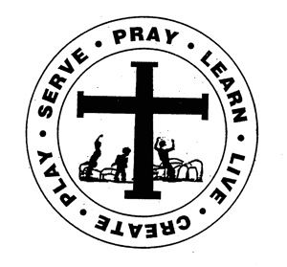
St. Edward Catholic School
Fr. Todd Petersen, Pastor * Jaci Garvey, Principal
210 W. 4th Street * Minneota, Minnesota 56264
Phone:(507) 872-6391 * Fax: (507) 872-5263
Email: jgarvey@stedscatholicschool.com
Website: www.stedscatholicschool.com

February 11, 2021

Our next school Mass is on Ash Wednesday, February 17th at 10:30 am. The staff will be leading us.

Parent/teacher conferences are being held either in person or via Zoom today from 3-6 pm. If you are unable to attend today, please contact your child’s teacher to make arrangements for another day.

There will be no school on Monday, February 15th for President’s Day.

The next education committee meeting will be held on Tuesday, February 16th at 6 pm. We will be sending a zoom link for the meeting.

We will be celebrating our February and July birthdays on Thursday, February 18th with birthday lunch.

We will be having a dress up day on Friday, the 19th. It will be “Spirit Day”.

NWEA – Did you know

Promptness
Work Day

May God Bless,

Mrs. Garvey

