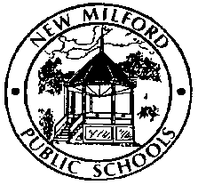
HOME LANGUAGE SURVEY

New Milford Public Schools
50 East Street
New Milford, CT 06776
Phone: (860)354-3235 Fax: (860)355-4966

Welcome to our school!
We have a few questions about languages spoken at home. We are required by the US Department of Education to ask for this information because it will help us know how we can best support your child. The language information also helps us know how we can best communicate with you. Please share with us about the language(s) spoken by your family and in your home.
-------------------------------------------------------------------------------------------------------------------------------------------------------------------------------------------------------------------------------------------------------------------------------------
Student Information
Student first name: Student last name:
Country of birth:
Date of birth:
Date first enrolled in any US school:

1) What is the primary language used in the home, regardless of the language spoken by the student?

2) What is the language most often spoken by the student?

3) What is the language the student first acquired?

4) What language do you prefer for written communication from the school?

5) Will you require interpretation/translation at Parent-Teacher meetings?

____________________________________________________
Parent/guardian name (please print)

_________________________ ________________________
Parent/guardian signature Date

Thank you for answering the questions. We look forward to working with your child!

