Title I Parent & Family Resource Center
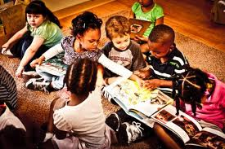
Welcome to the Pine Bluff School District Title I Parent and Family Resource Center where we focus completely on your student’s success, and the incredible power you have as parents, guardians and families to help your child achieve success.

We are here to help you be an even more involved parent because you are the most important person in your child’s life no matter what their age! As President Barack Obama said, “In the end, there is no program or policy that can substitute for a parent. Responsibility for our children’s education must begin at home.”

Research shows that one of the best tools for student success depends on family and community engagement. Every child benefits from strong partnerships between home, school, and the community.

Parents, teachers really want and need your help. As part of our family outreach for student success, we provide parenting workshops for parents and professional development workshops for administrators and teachers to promote family and parental engagement in the schools. We provide many ways to get involved.

We offer:
- ACT Aspire parent workshops in numeracy and literacy
- Educational materials & resources correlated to Common Core State Standards
- Free books & pamphlets in the areas of parenthood, student learning, adolescent behavior and topics important to raising a child to reach his or her potential. We’re a central resource for the latest research, available in convenient and easy-to-read pages and packets.
- Parent resources (books, videos, CDs, etc.)
- Test preparation Services (GED, SAT, ACT, PSAT, GRE, Driver’s Education)
- Refrigerator curricula for common core
- Handouts on topics such as Helping with Homework, Study Tips, Organizational Skills, etc.
- PALs Learning Packs (Parent Assisted Learning Modules in Math & Language Arts for grades K-8
- Summer Learning Packs
- Thirty station community computer lab to help parents break the digital divide. We’ve got the computers, and we will help teach you how to use them. Our lab help parents sharpen computer skills and better help to guide your children’s online learning resources.

Come see why our Parent Center is devoted to student academic success. Also, check out these educational websites:
- Khan Academy
- PBS Kids
- Fun Brain
- Bedtime Math
- ABC mouse
- Brain Pop
- Future Learn
- Starfall
- How Stuff Works

After all, you, as parents, are your child’s first teacher. With your involvement, and our programs to assist you, imagine what heights your child can reach!”
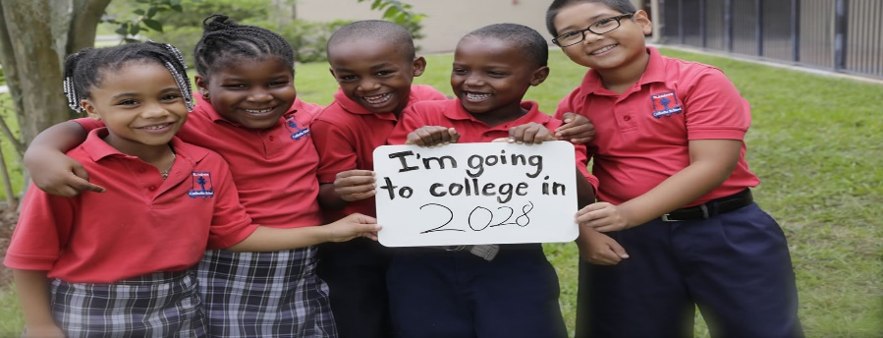

Contact
Freddie B. Jolivette, Coordinator
Freddie.jolivette@pinebluffschools.org
Wilma Allen, Secretary
Wilma.alllen @pinebluffschools.org
Title I Parent & Family Resource Center
1215 West Pullen Street
Jordan-Chanay Administrative Center
Pine Bluff, AR 71601
870-850-2008/2009
Fax: 870-543-4364
Hours of Operation: M-F 8:00 a.m.-4:30 p.m.
Tues. & Thurs.-4:30 p.m.-6:30 p.m.
2nd & 4th Saturday-9:00 a.m.-12:00 noon

