Did You Know???
Ensuring that your child(ren) are fully rested and receive adequate and quality sleep each night is one of the most important things that you can do to help your child be successful in school! When children are well rested, they are also better able to manage their feelings, think clearly, and make good choices. Having the ability to demonstrate these skills will increase academic success

Bedtime Routines
Bedtime routines help your child fall asleep, stay asleep, and wake up well rested in the morning!
!!! Important Parts of a Bedtime Routine: Bathing or washing up Brush Teeth Pajamas Small snack and drink of water Read or listen to Read someone else read a story Talk about the day and end on a positive note
How much sleep does my child need???

Kids age 6-12 years need 9-12 hours of sleep per day.

Kids age 13-18 years need 8-10 hours of sleep per day.

TIPS FOR GOOD SLEEP

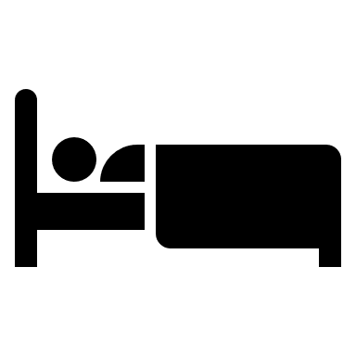
Keep the bedroom quiet and at a comfortable temperature…not too hot, not too cold.

Set bed and wake up times at the same time each day, including weekends.

Set bed and wake up times at the same time each day…including weekends.

Make sure kids are active during the day so they can fall asleep at night.
Avoid large meals and caffeine before bedtime.
Remove electronic devices from the bedroom…this includes t.v.’s, cell phones, computers, and other handheld devices.

Sleep Chart Guidelines:

 | Wake up time | Hours of sleep | Bedtime
Kids age 6-12 years  (need 9 to 12 hours sleep per night) | 7:00 am | 9 hours | 10:00 p.m.
 | 7:00 a.m. | 10 hours | 9:00 p.m.
 | 7:00 a.m. | 11 hours | 8:00 p.m
 | 7:00 a.m. | 12 hours | 7:00 p.m.
Kids age 13-18  (need 8-10 hours sleep per night) | 7:00 a.m. | 8 hours | 11:00 p.m.
 | 7:00 a.m. | 9 hours | 10:00 p.m.
 | 7:00 a.m. | 10 hours | 9:00 p.m.

