Name _____________________ Block_______ Date _________

Study Guide
Growth and Cell Division
Cell Division Overview:
1. Cells have periods of formation, growth, development, and death called ___________ _ _______________.

2. Most of the life of any eukaryotic cells is spent during _________________, which is a period of ________________ and ________________________.

3. _________________--structure in the nucleus that contains hereditary material (DNA).

4. During interphase, a cell ____________________ its chromosomes and prepares for cell division.

Mitosis:
5. ________________-- process in which the nucleus divides to form two identical nuclei.

6. Mitosis occurs __________________ interphase.

7. Remember “PMAT”.

8. __________________ is the 1st stage; nucleus and nuclear membrane _________________.

9. __________________ is the 2nd stage; pairs of chromatids line up across the _____________ of the cell.

10. _________________ is the 3rd stage; each pair of chromatids ___________________ and move to opposite ends of the cell.

11. _________________ is the 4th stage; a new _________________ forms in each cell; cells begin to separate which is called _______________________.

12. As a result of mitosis, each body cell produces _______ chromosomes which means they are (haploid / diploid).

13. Mitosis allows for growth and _________________ worn out and damaged cells.

14. How many cells are produced at the end of mitosis? __________

Meiosis:
15. As a result of meiosis, each sex cell produces ____________ chromosomes which means they are (haploid / diploid).

16. ______________________________ occurs when an egg cell and sperm cell come together.

17. ______________ are formed in the male reproductive organs.

18. Eggs are formed in the _______________ reproductive organs.

19. The new cell that forms from fertilization is a __________________.

20. Following fertilization, _______________ begins to ensure that a new organism grows and develops.

21. In what phase does crossing over occur? ___________________ Why Is it important?

______________________________________________________________________________

22. How many cells are produced at the end of meiosis II? ____________

23. Define karyogram (karyotype): _____________________________________________________________________________

24. What is nondisjunction? _______________________________________________________

25. Name 3 disorders caused by nondisjunction. ______________________________________,

______________________________________, _______________________________________

26. What is a normal karyotype for a male? __________________ Female? ________________

Asexual Reproduction:

27. _______________ reproduction is when a new organism is produced from _______ parent organism.

28. The 3 types of asexual reproduction are ________________, __________________, and _________________________.

Vocabulary to know:
cell cycle meiosis Karyotype Trisomy
prophase interphase Nondisjunction Monosomy
metaphase asexual reproduction chromatid Turner’s Syndrome #
anaphase budding centromere Down syndrome #
telophase binary fission spindle fibers Klinefelter’s syndrome #
cytokinesis regeneration centrioles Patau’s Syndrome #
mitosis chromosome haploid/diploid Edward’s Syndrome #
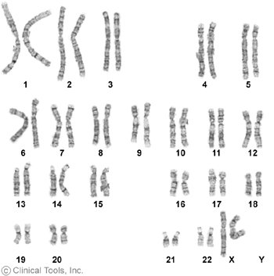
Karyotype Identification
Karyotype | #1
Number of chromosomes
Sex of individual
Normal? Yes or no.
If abnormal, what abnormality?
If abnormal, what chromosome pair?
If abnormal, what syndrome?

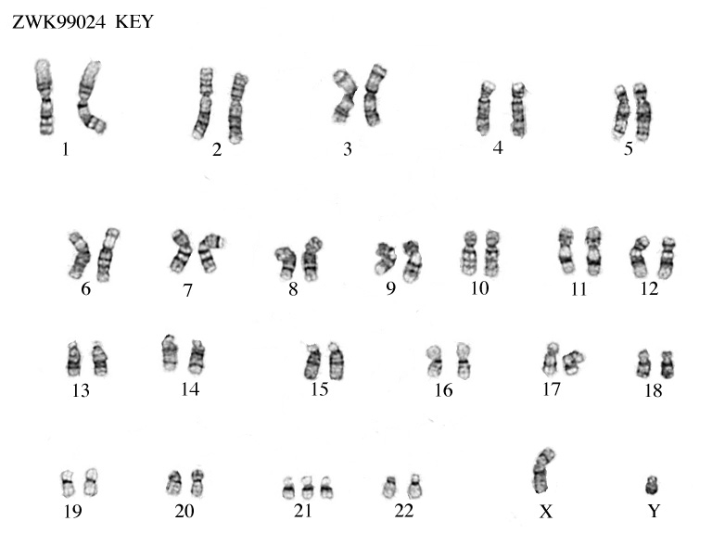

Karyotype | #2
Number of chromosomes
Sex of individual
Normal? Yes or no.
If abnormal, what abnormality?
If abnormal, what chromosome pair?
If abnormal, what syndrome?

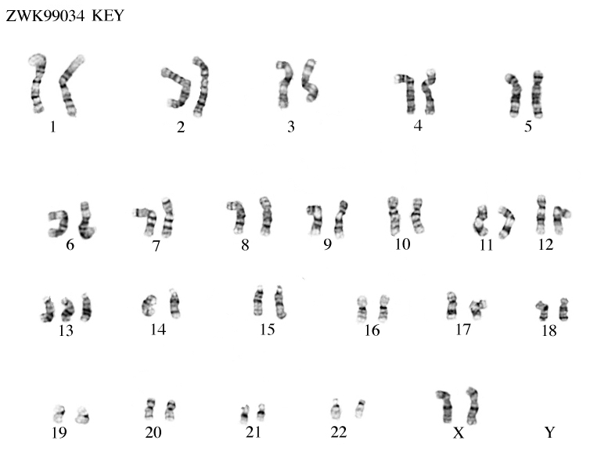

Karyotype | #2
Number of chromosomes
Sex of individual
Normal? Yes or no.
If abnormal, what abnormality?
If abnormal, what chromosome pair?
If abnormal, what syndrome?

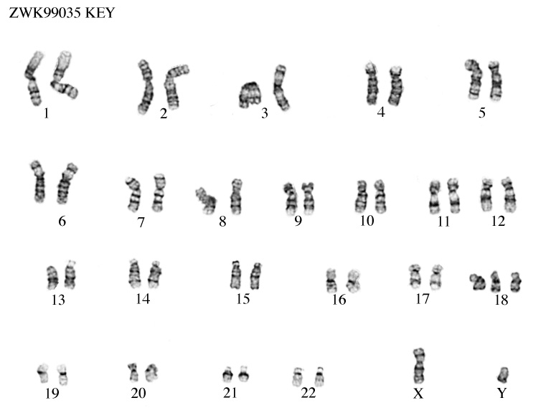

Karyotype | #1
Number of chromosomes
Sex of individual
Normal? Yes or no.
If abnormal, what abnormality?
If abnormal, what chromosome pair?
If abnormal, what syndrome?

Karyotype | #1
Number of chromosomes
Sex of individual
Normal? Yes or no.
If abnormal, what abnormality?
If abnormal, what chromosome pair?
If abnormal, what syndrome?

