Mrs. Burns’ English Learners
Weekly Lesson/Activities
May 11 – May 15, 2020
Monday | Speaking | iCook  Become a chef for the day! A Chef (\ ’shef \ is someone who cooks for a living, especially in a professional kitchen.  Think about your favorite food. Research how it is made. Talk about the food with your parents.  For example:  I love pizza because it is very hot and tasty. Pizza has many toppings. My favorite topping is pepperoni. Pizza is made out of pizza dough. To make pizza dough, you will need…(talk about the ingredients).  If pizza is not your favorite food, maybe you like hamburgers, tacos, tamales, hotdogs, cookies, brownies, hummus, manakeesh, and so on!  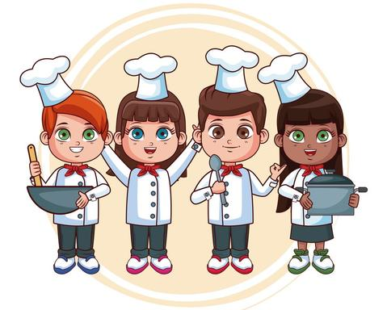
Tuesday | Writing | iCook  Write a complete recipe for one of your favorite dishes. Include the ingredient list and all of the directions to follow. Draw a picture to go along with the recipe. Share it with your family. Better yet, make it and take a picture of your masterpiece!  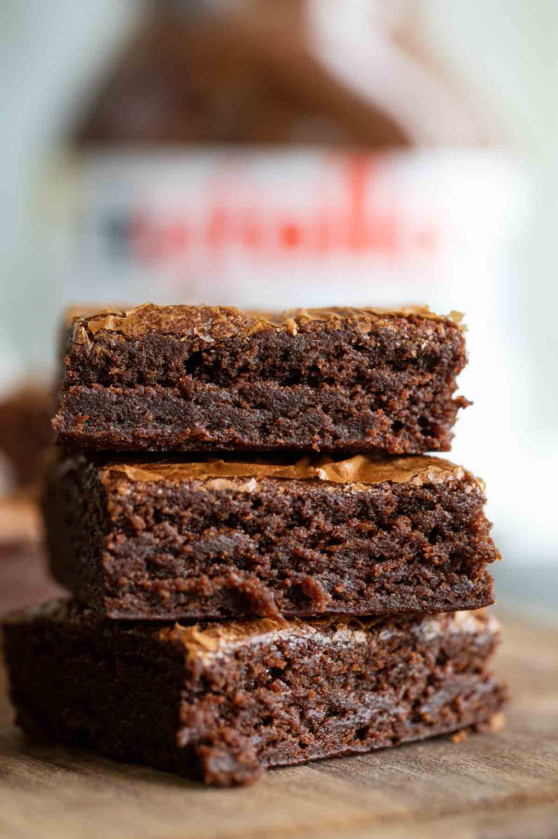  Here is an example recipe for Nutella Brownies:  Ingredients  - 1 cup (8oz/240g) Nutella  - 2 eggs (or egg substitutes for brownies)  - 10 tablespoons all-purpose flour  Instructions  - Put the Nutella, eggs and flour in a large bowl and mix until all ingredients are combines. The batter should be thick and shiny.  - Line an 8 x 12 in. baking tray with parchment paper. Pour the batter into your tray. Bake at 350F for 20-25 minutes.  - Remove from the oven and allow to cool fully before slicing. Enjoy!
Wednesday | Listening | Follow these links for this week’s listening practice:  https://www.esl-lab.com/intermediate/baking-cookies/  https://www.esl-lab.com/intermediate/dinner-recipes/
Thursday | Reading | Read your favorite story to your family. If you do not have a book at home, you can find one at this link: https://storyweaver.org.in/  Take turns retelling the story.
Friday | Fun Day! | Visit https://pbskids.org/ for 15 – 20 minutes of fun!

