352 – 138 = ?  A) 164  B) 226  C) 214  D) 490 | 15 + 22 + 18 + 31 = ?  A) 76  B) 88  C) 86  D) 154 | Which group of numbers show counting by 10?  A) 10, 20, 25, 30,45  B) 37, 47, 57, 67, 77  C) 45, 55, 60, 65, 75  D) 33, 43, 50, 63, 70
Micah has the coins below. He spends 23 cents on an eraser. How much does he have left?  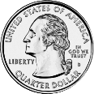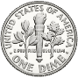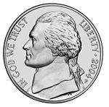  ______ cents | 428 + 247 = ?  A) 675  B) 181  C) 665  D) 706 | Choose two equations that are true.  A) 4 + 3 = 17 - 10  B) 15 – 6 = 5 + 3  C) 8 + 4 = 18 - 6  D) 7 + 2 = 12 - 8
Which statement shows the number 317.  A) 3 tens + 7 ones + 1 hundred  B) 7 ones + 1 ten + 3 hundreds  C) 3 tens + 1 one +  7 hundreds  D) 7 hundreds +  2 tens + 3 ones | How would you use the strategy of place value to solve?  87 – 42  A) 80 – 4 and 40 - 7  B) 87 - 42  C) 80 + 40 and 7 + 2  D) 80 – 40 and 7 - 2 | Which equations have a difference of 7?  A) 3 + 4  B) 14 - 7  C) 5 + 2  D) 13 - 6  E) 16 - 8

