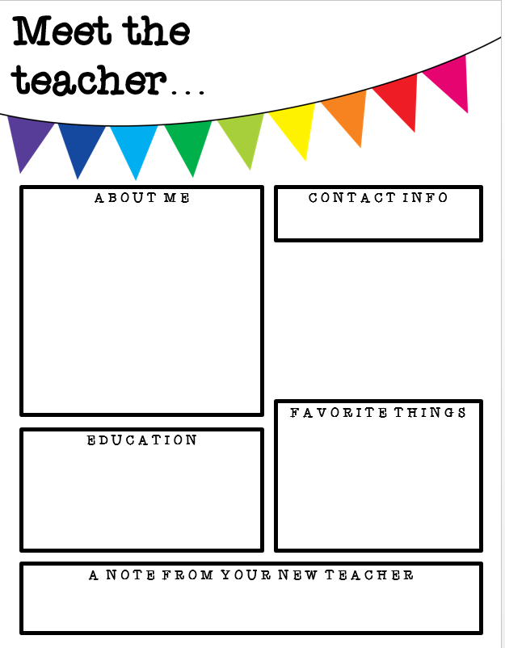

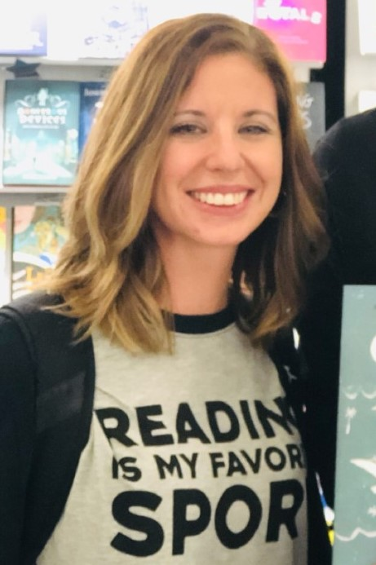

* Air Wick Wall Plug in refills
* Kleenex
* Hand Sanitizer
* Paper Towels
* Empty Spray Bottles (for disinfectant and sanitizer)
* Reward candy (peanut-free please)
* Colored printer paper
* Windex
* Magic Erasers

**Contact Info**

Lindsey Baker

8th grade ELA & Pre-AP Language Arts

662-349-6660

Lindsey.Baker@dcsms.org

Remind Info

Please sign up!

7th Period Only: Pre-AP only:

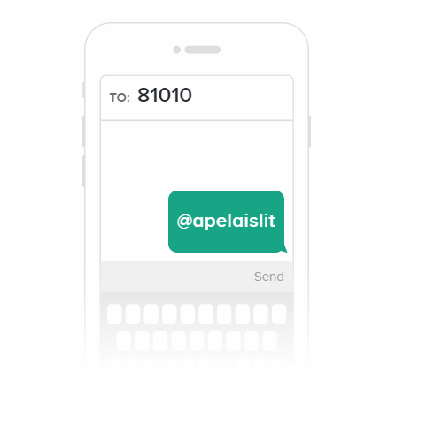

Class Wish List

Visit: <https://www.amazon.com/hz/wishlist/ls/3BD67RI8UTU6D?ref_=wl_share>



Lindsey Baker