### DCPS

May 4th -8th

**Math Skills**

😊Did you get a green light on Reflex today?

This week your teacher will post on their website:

* Word Problem of the Day
* 9 Box Review

Remember you can do this on notebook paper too.

2nd Grade News

**We want to keep things as simple as possible for all students. We have created the 3 R’s. This is what your child with internet at home can do every day.**

**3 R’s: Read/Reflex/ReadingEggspress**

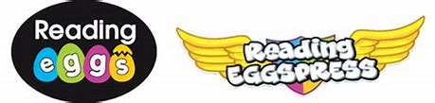

Reading Eggspress. This week we have books for you to read and online quizzes to complete.

Fiction Book: The Birdhouse that Jack Built

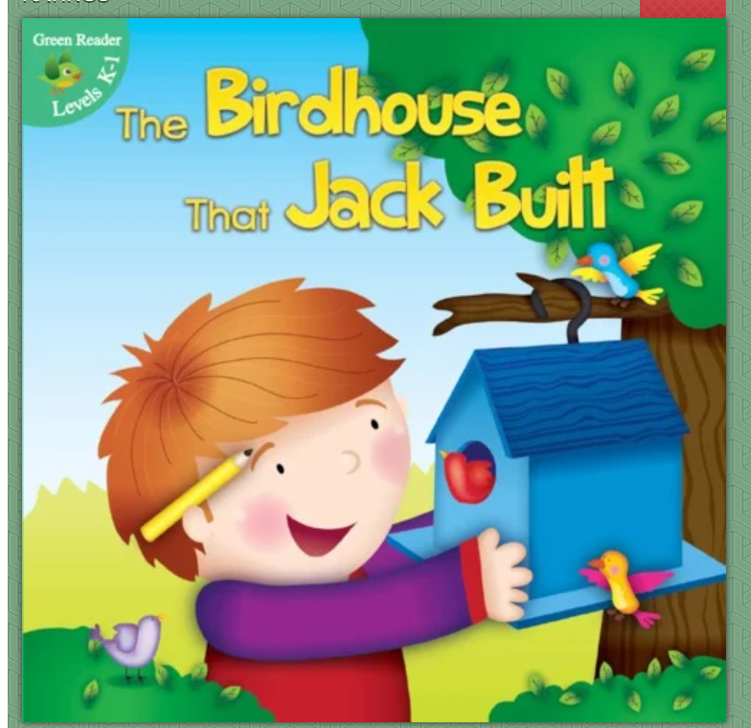

Non-Fiction Book: How to Build a Birdhouse

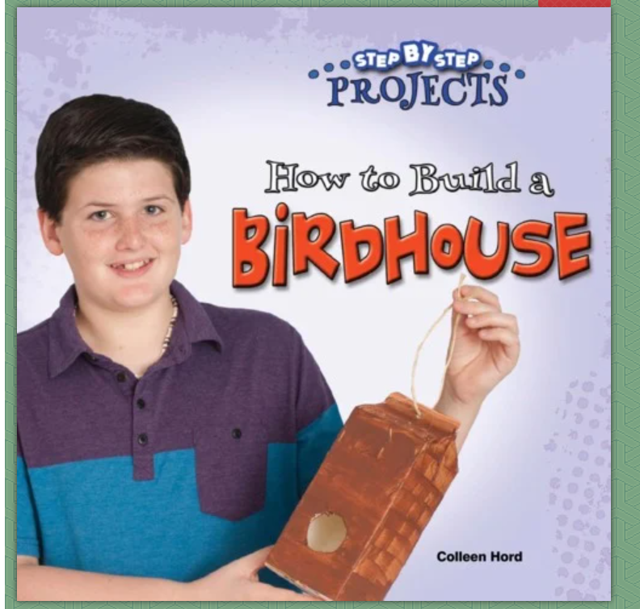

 Writing Prompt

Visit: <http://youtu.be/WdgLSiHDsAY> (Picture Story Sequence)

Use the two books to create your own “How to” and give the steps to building a birdhouse. Use your own illustrations.

Or…In the story, The Birdhouse that Jack Built the characters used teamwork. Write about a time you used teamwork with your friends or classmates. Be sure to include an opening, 3 details, and a closing.

Videos for kids:

<https://youtu.be?nAfm7ErYLXg>: On YouTube: Baby Birds Hatching To Leaving the Nest

<https://youtu.be/Xp19mQsODWs>: On YouTube: How to Build a Birdhouse

<https://youtu.be/pCZtp9uws>: On YouTube: How to draw baby birds with shapes!

<http://youtu.be/jFOld-hH9y4>: On YouTube: All About Birds for Children

**Comprehension Questions Parents Can Ask:**

1. **Why are birdhouses important?**
2. **The author uses steps in the text. How is that helpful?**
3. **There is a glossary at the end of the text. What is its purpose?**

**Comprehension Questions Parents Can Ask:**

1. **Why is Jack an important character?**
2. **How do the characters solve the problem?**
3. **How do you know this is a fiction story?**

**Remember me**

**Please remember these are only suggestions to help maintain information that was previously taught in class. Your child can always choose a different book or activity from home to complete.**

**Website/Facebook:**

Please look at your teacher’s website for more links and information. We have also created a DCPS 2nd Grade Facebook group that you can follow for more ideas and websites.

## Phonics