ocean
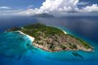
world
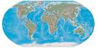
fish
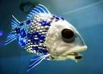

crab
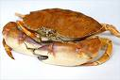
shell
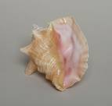
seaweed
