PARENT ACCESS TO SKYWARD

Parents – if you have logged into Skyward and set up your parent access account, please disregard this message.

Parents who have not set up their parent access accounts, please complete the following steps:

- On the right side of the Brimfield website you will find a drop down labeled QUICKLINKS (click the drop down arrow and select SKYWARD PARENT PORTAL

- Your user name will be: Firstname.Lastname (this will not change) Example: John.Doe

- Your temporary password will be: brimfield#309 (you will be asked to change this at your first login) Please create a password that you will remember.

- Click the GREEN SIGN IN BUTTON
Welcome to Skyward. You will be logged into your family access site. You will see several “tiles” See Example Below:
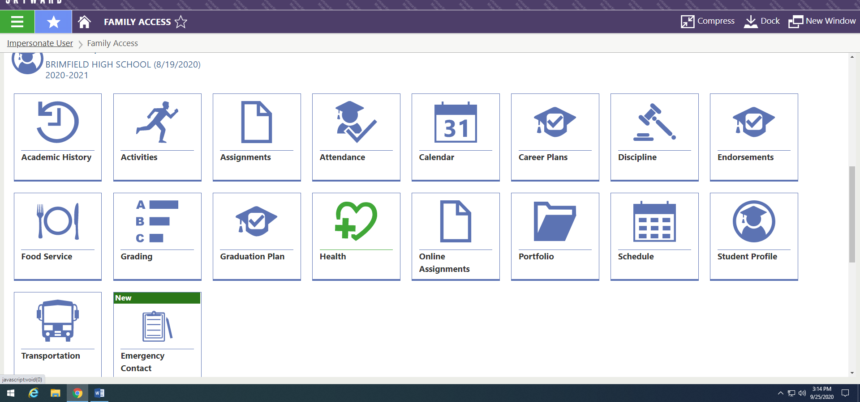

- Click on the emergency contact tile (designated by a Green tab the saying NEW) Please enter all emergency contact information for your student. You will need to fill this out on each of your students emergency contact tile.

- Click on the student profile tile. Scroll down to YOUR FAMILY INFORMATION and click the EDIT button – this will allow you to update your personal information. Please make sure you add a CURRENT EMAIL ADDRESS

