Hello students and welcome to Marketing Essentials! Marketing has become one of the most important processes in modern life and affects many aspects of a person's life even without him or her noticing. As a consumer, marketing surrounds a person. This course will introduce students to today's fast-paced, rapidly changing and interactive global marketing environment by exposing them to philosophies and strategies as they are used for advertising, selling, and distribution of products. This course will also address ways that marketing satisfies basic marketing concepts through project-based learning.
A quick introduction for me—This is my eighth-year teaching at DeSoto Central and I love it! Marketing is my passion. I received a Bachelor of Business Administration in Marketing from the University of Mississippi (Go REBS) and worked in marketing for a few years after I graduated college. I was led into teaching and feel like I found where I am supposed to be. I ended up receiving a Master of Arts in Teaching from Belhaven and Master of Science in Leadership from Duquesne.
While I have taken many online classes as a student, I do not have a lot of experience teaching online classes so this is something we will navigate together. If you have any questions, comments, or concerns, please reach out to me. You can send me an email at margaret.falatko@dcsms.org.
Work can be typed or handwritten and will be emailed for submission. If you cannot email your work, send me an email or reach out through SchoolStatus and we will figure out a different way to submit. If you handwrite work, you can email a picture. Work is due by Sunday at midnight. A new week starts on Monday. You may send all of your work for the week in one email or send it as you finish it. In the subject line, please put your First Name and Last Name and Assignment Number OR First Name and Last Name and Week Number Assignments. For example, I would type for my subject Margaret Falatko- Assignment 2 or could do Margaret Falatko- Assignments for Week 1. Be sure to confirm the email address before you hit send.
**All PowerPoints mentioned in the assignments are in this document so scroll past the assignments to find them. They are in order of how they are assigned in the document.

Week 1: April 6th-10th
Assignment 1: Writing is a crucial skill for employees. In order to be able to effectively communicate and present the marketing message, people need to be able to write well. Today, you are going to showcase your skills by writing an autobiography. Below are the items that need to be included. Each item should be its own paragraph (5-7 sentences). Be sure to use correct spelling, grammar, capitalization, and punctuation. Also, try to vary your sentence structure and engage the reader.
- Background information about yourself (age/grade, hobbies, interests, etc.)
- Future goals (plans after high school, future career, etc.)
- How Coronavirus has affected you (what you’ve learned about yourself, something positive that has happened, what you are missing the most, etc.)
Assignment 2: In a constantly changing world full of obstacles, it’s imperative to be able to adapt and overcome challenges to be successful. Read the Being Successful PowerPoint. (10 slides total—9 with information and 1 with an example)
Assignment 3: Create a motivational poster. On the poster, include an inspirational quote. The quote can be something that you create or from someone else. If you use a quote from someone else, be sure to give credit to that author. You also need to include at least one picture and color. I’ve included an example of one at the end of the PowerPoint presentation. (Your poster can be done on a computer or by hand.)
Assignment 4: Marketing is all around you whether you realize it or not. First, write your definition of marketing. (Don’t look it up, but just write what YOU think it means.) Using a table like the one below, write down different ways you see marketing in action, an example of a company who could use that form of marketing effectively, and an example of a company who could not use that form of marketing effectively. (I have done an example for you, so try to do five different ones.)
Type of Marketing | Effective Company | Ineffective Company
Ex- Print Advertisement | Ex- Cover Girl | Ex- Google

Assignment 5: Write down as many examples of companies that you think are successful. For each company, explain what makes them successful. Then, explain if marketing has helped in that success, and if so, how. (You should have a minimum of five companies.)

**All work is due Sunday, April 12th by 12:00am CST. Keep in mind this is Easter, so please plan ahead for this week’s work!
Week 2: April 13th-17th
Assignment 1: Read Chapter 1: Marketing PowerPoint. (20 slides total)
Assignment 2: Find two different marketing ads on social media or Google. Describe each ad (or take a screen shot and submit it). For each ad, identify what is being marketed and if it is a need, want, or demand. Describe the strategy being used. Explain if the marketing is effective or not. Use information from the ad to support if it is effective or not.
Assignment 3: You will be writing an analytical paper based on your background knowledge, learned concepts, and research. Identify two businesses that cater to teenagers. One business should sell goods (such as shoes, makeup, baseball glove, etc.) and the other business should sell services (salon, trampoline park, bowling alley, etc.). Below are the components to be analyzed. Each item should be its own paragraph (5-7 sentences). Be sure to use correct spelling, grammar, capitalization, and punctuation. Also, try to vary your sentence structure and engage the reader.
- For Company 1, discuss the background of the company. (What they sell, how long they’ve been in business, who their founder is, what their mission statement is, etc.)
- For Company 1, Explain how the business caters to its customers (with the marketing mix). How effective are those businesses in satisfying their customers’ wants and needs? What could they do to be more effective?
- For Company 2, discuss the background of the company. (What they sell, how long they’ve been in business, who their founder is, what their mission statement is, etc.)
- For Company 2, explain how the business caters to its customers (with the marketing mix). How effective are those businesses in satisfying their customers’ wants and needs? What could they do to be more effective?
- Compare and contrast the two companies, their strategies, and their effectiveness at catering to their customers. Which is company is better and has the advantage? Why? Is there a large advantage or just a small advantage? Why?
Assignment 4: Read Chapter 2: Company and Marketing Strategy. (12 slides total—11 with information and 1 with an example)
Assignment 5: Research and write three different companies’ mission statements. Explain if these statements align with your perception of the company as a consumer and why or why not. Write your own two-sentence mission statement for yourself explaining your purpose.
Assignment 6: Find three companies that have expansive portfolios. Write the company name and examples of five different products that make up their portfolio. For each company, explain which part of the expansion grid they could effectively utilize to continue growing.

**All work is due Sunday, April 19th by 12:00am CST.
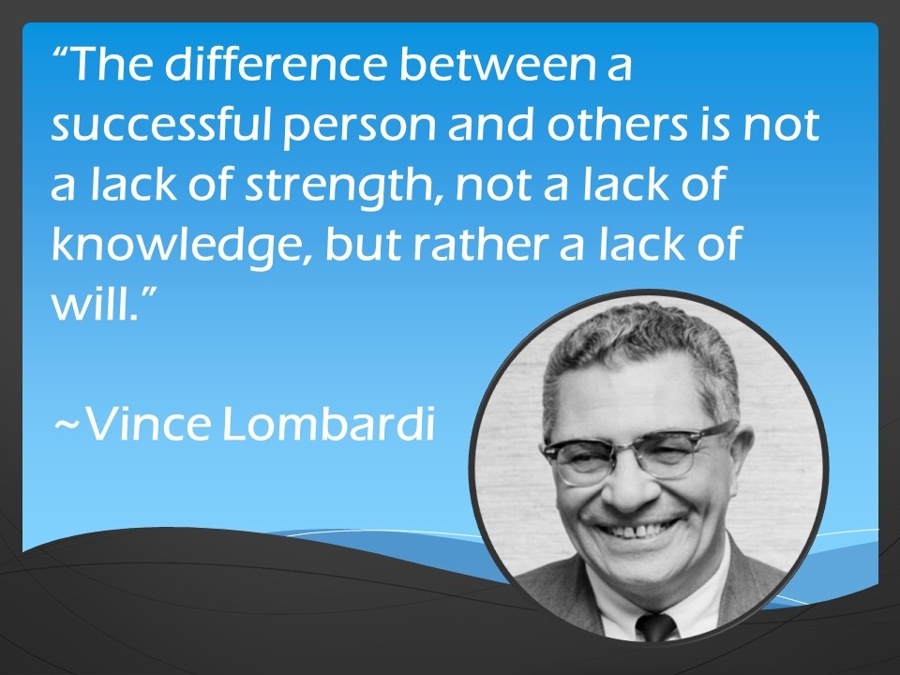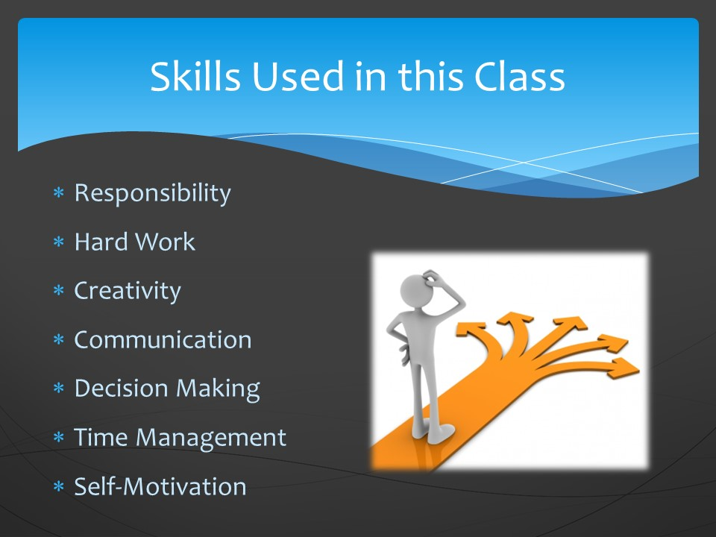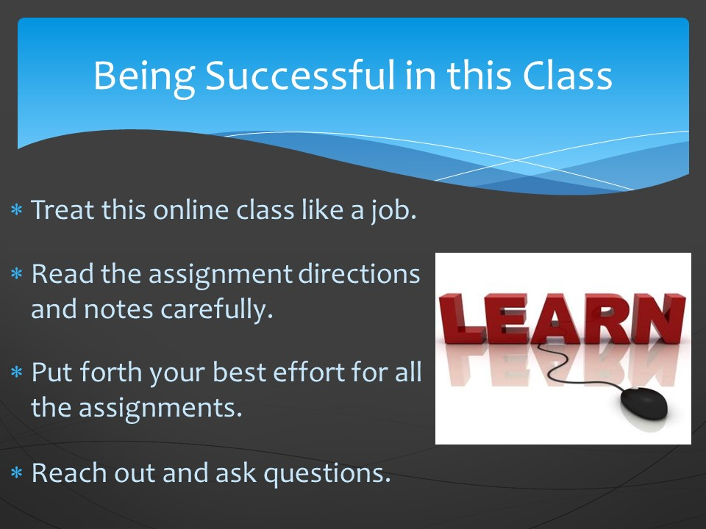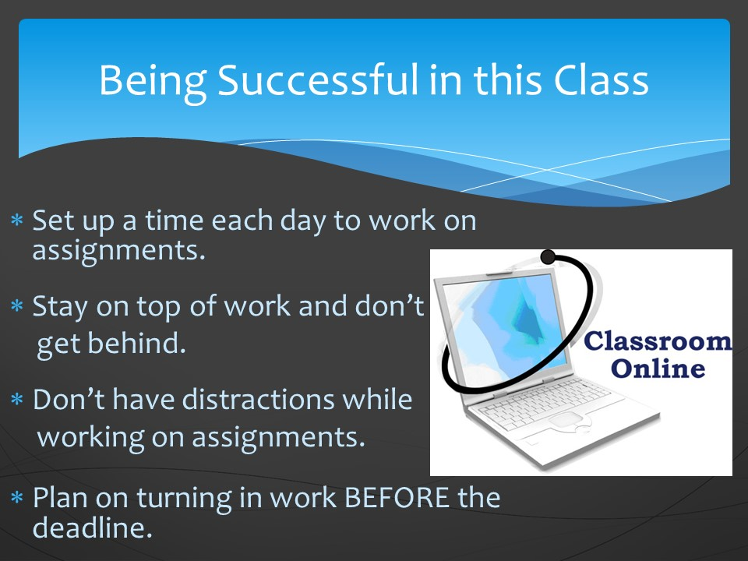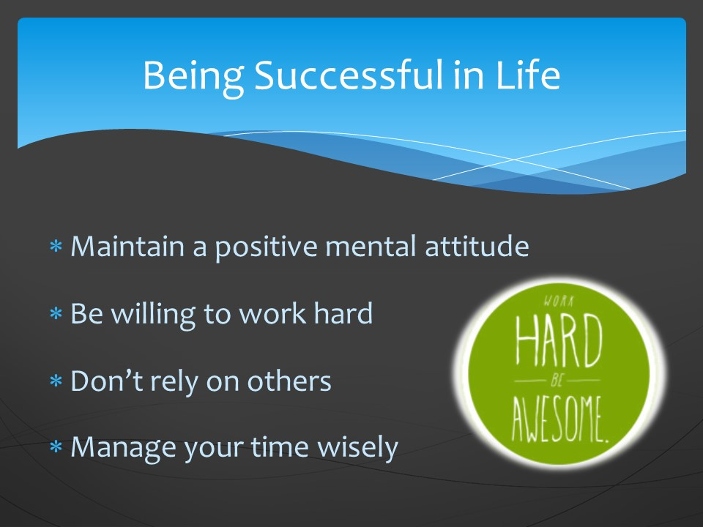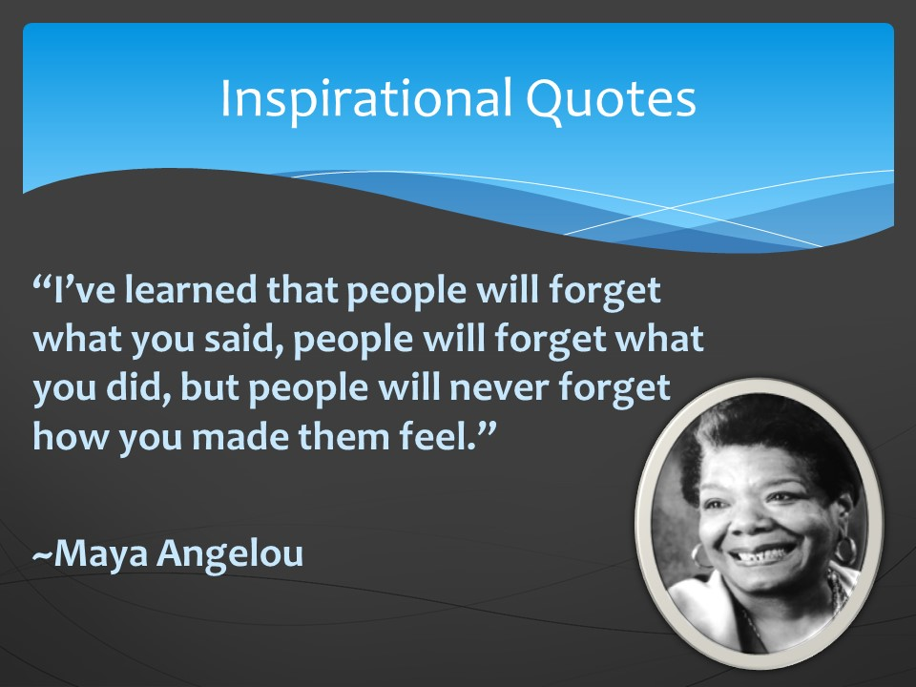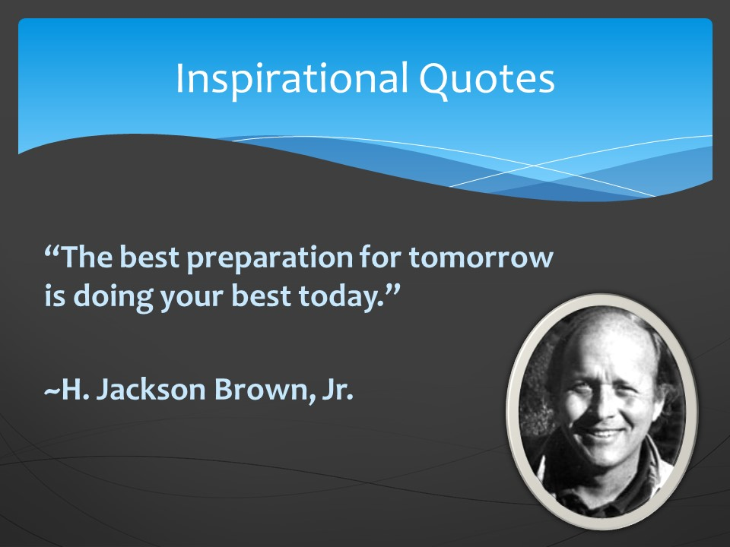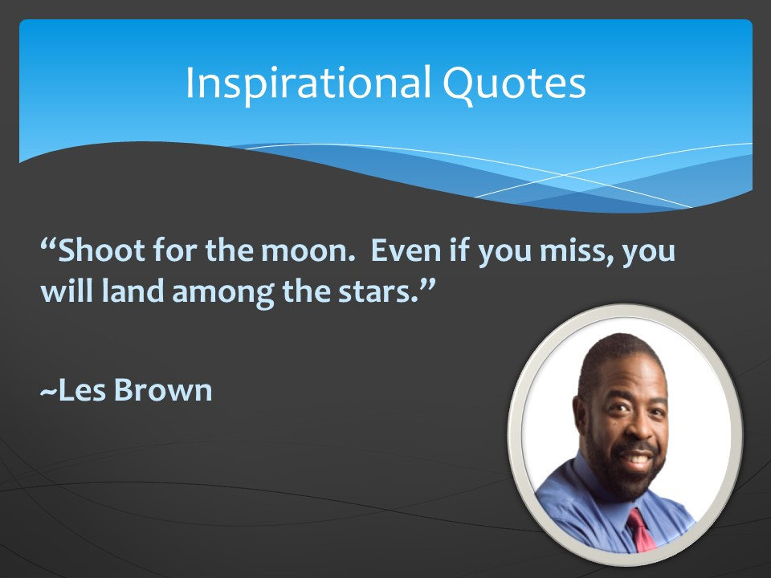
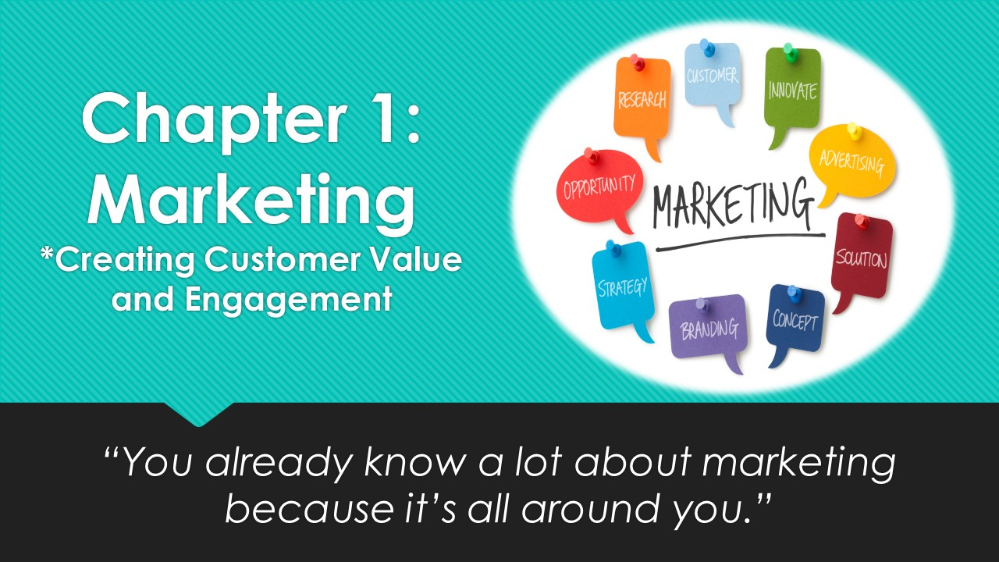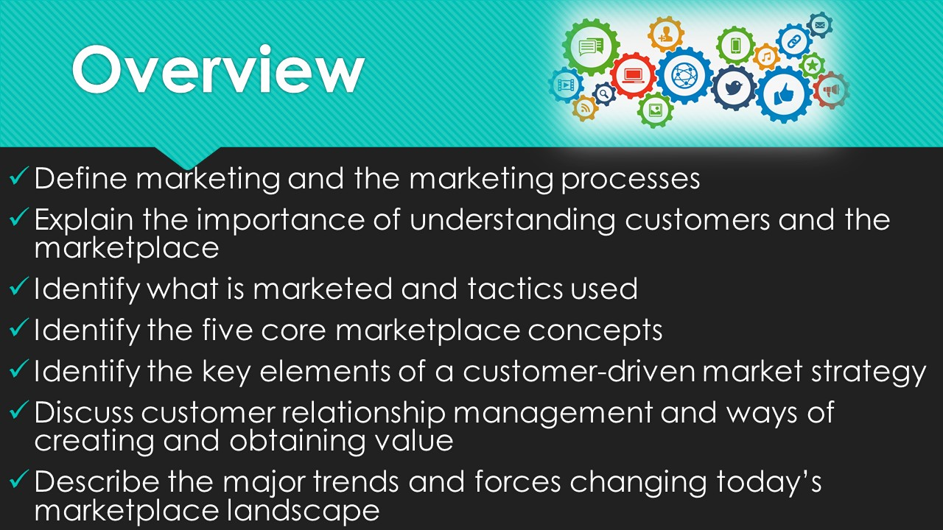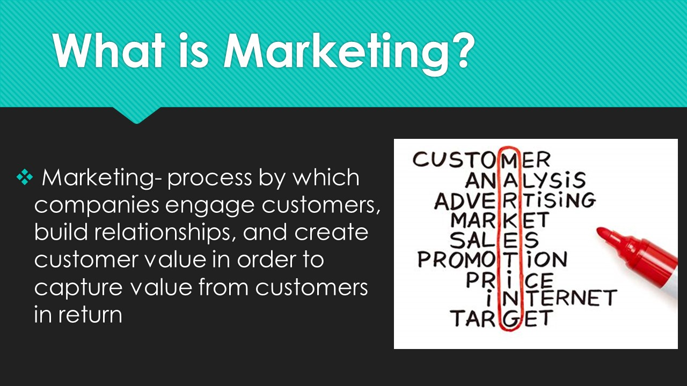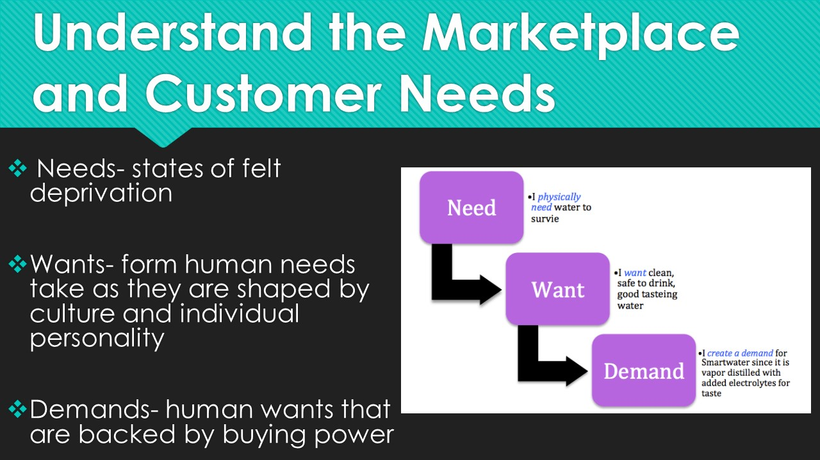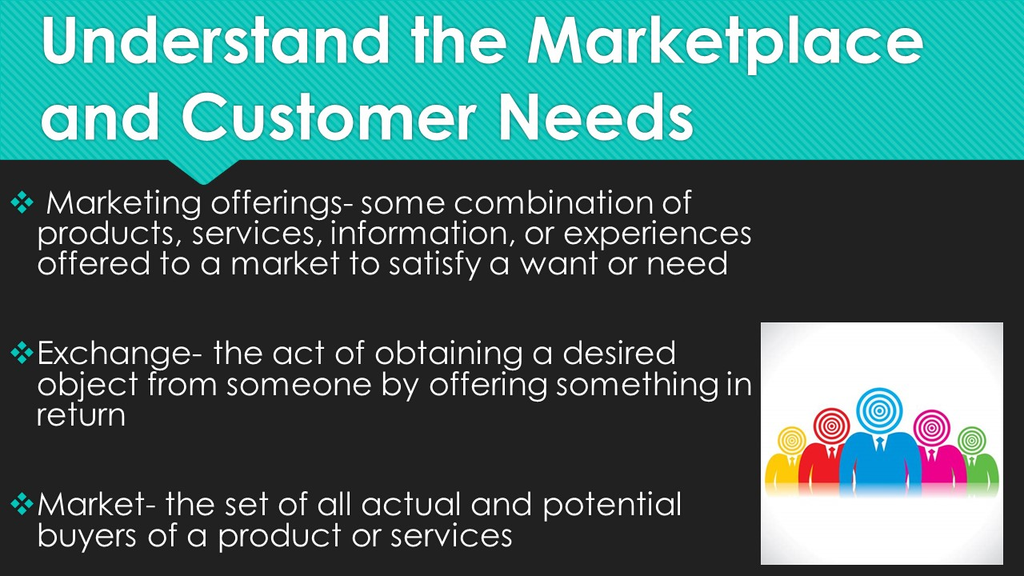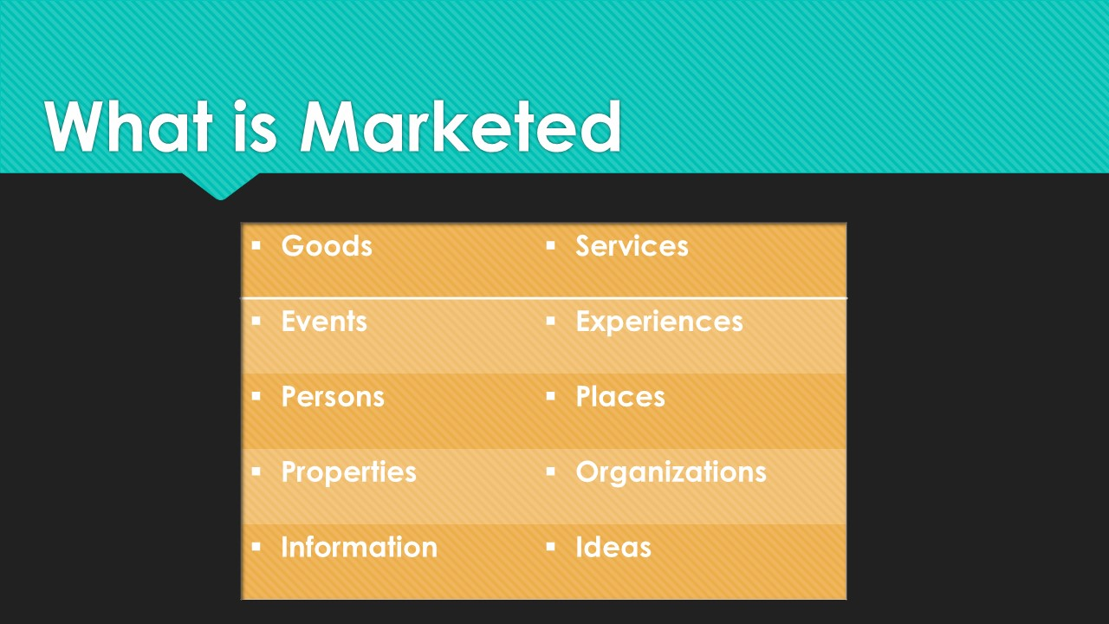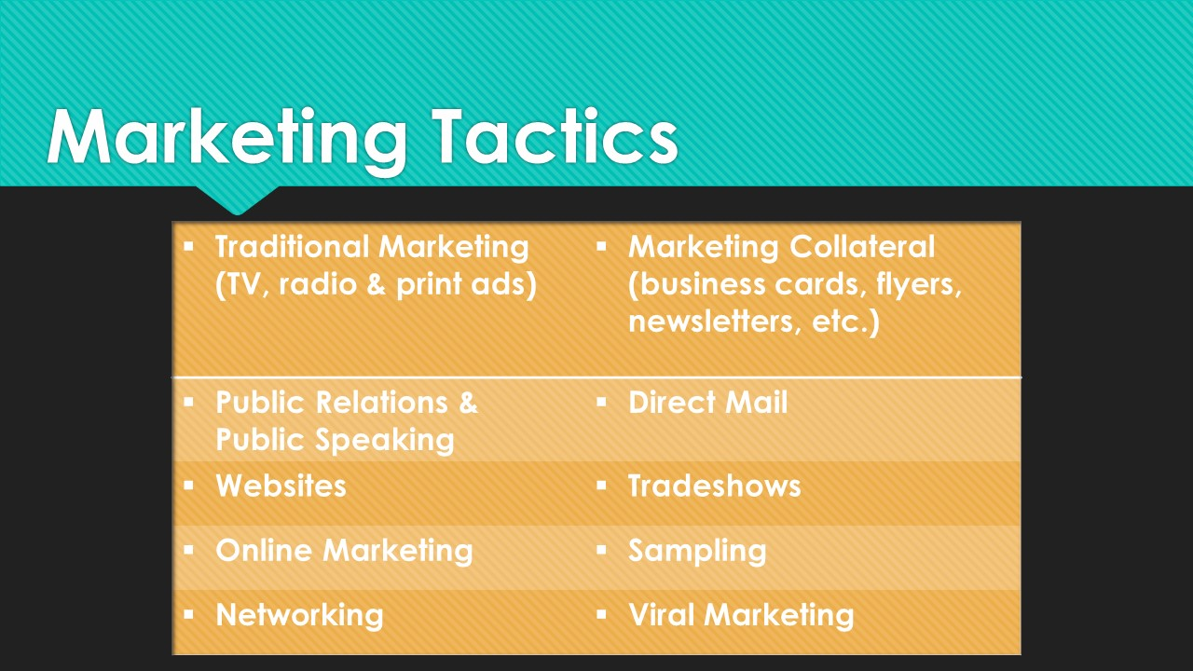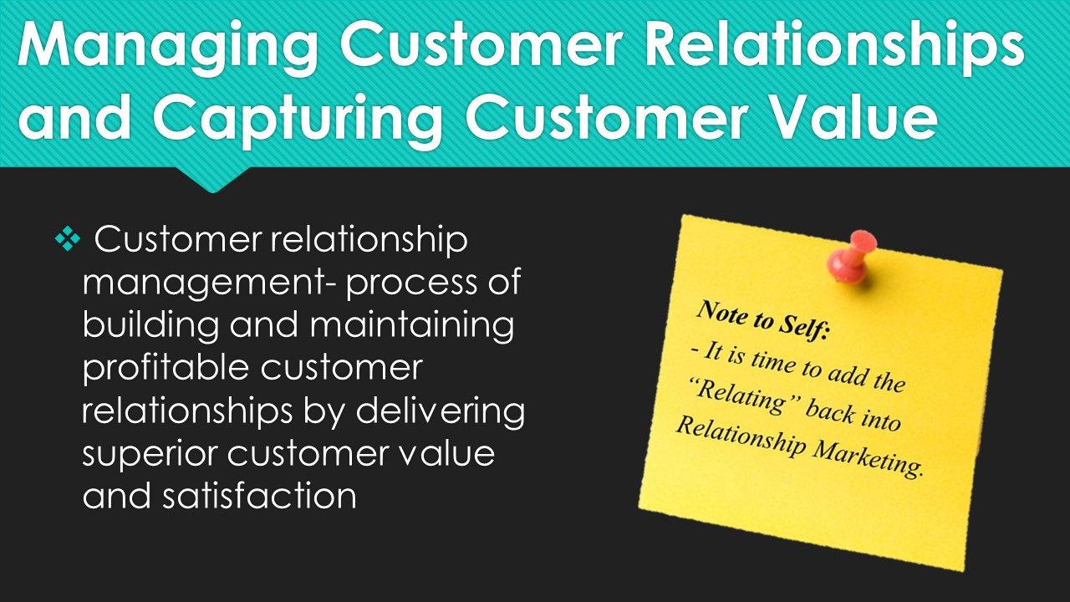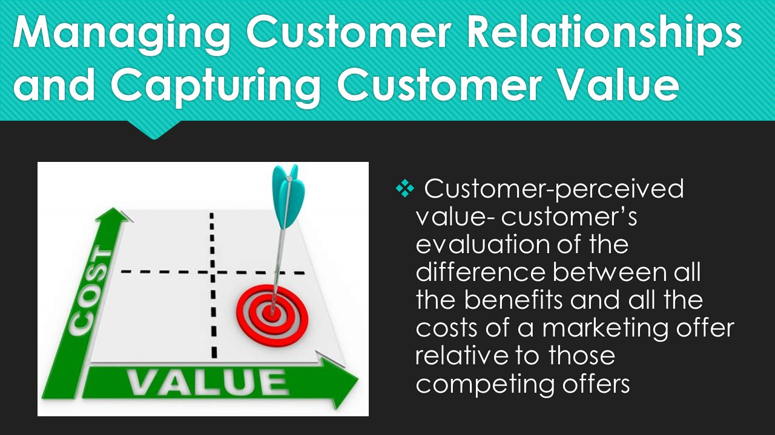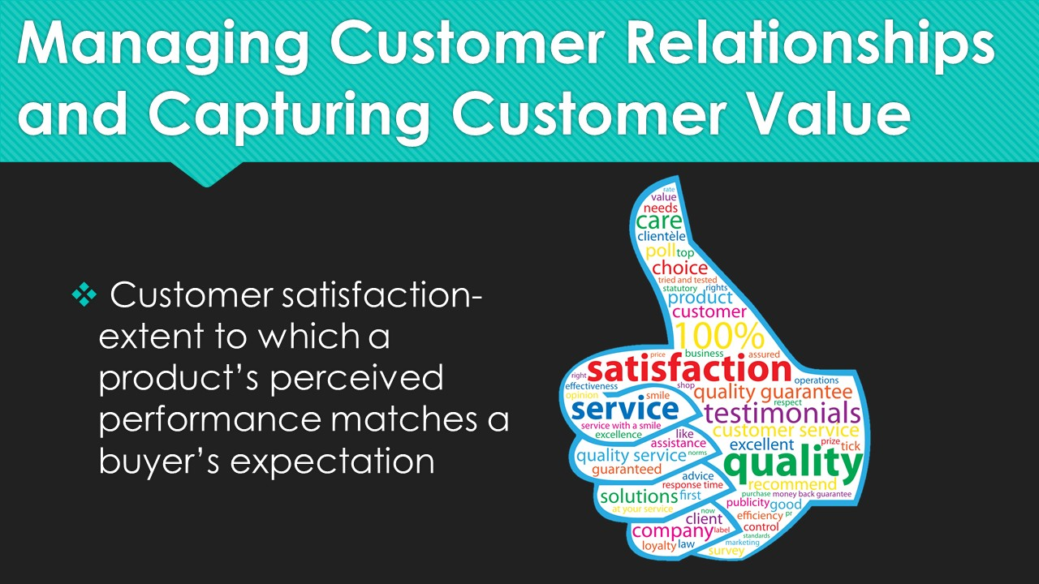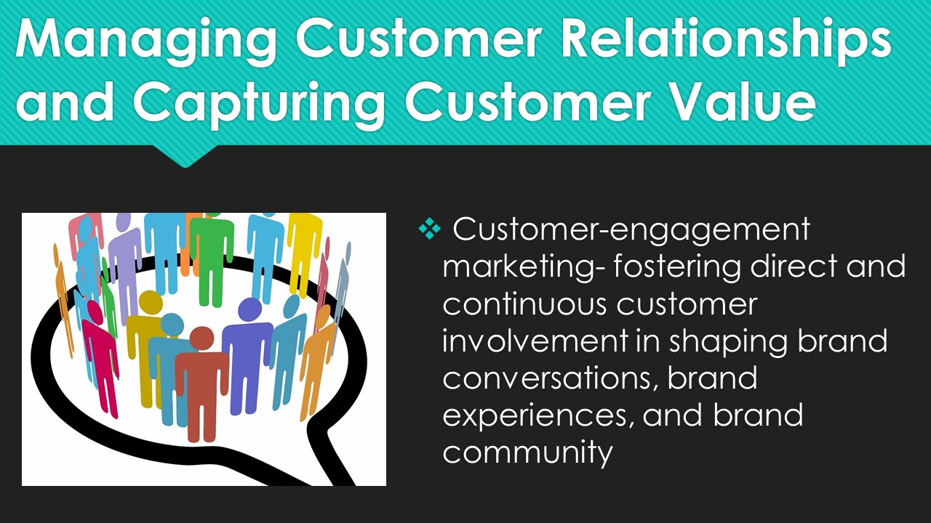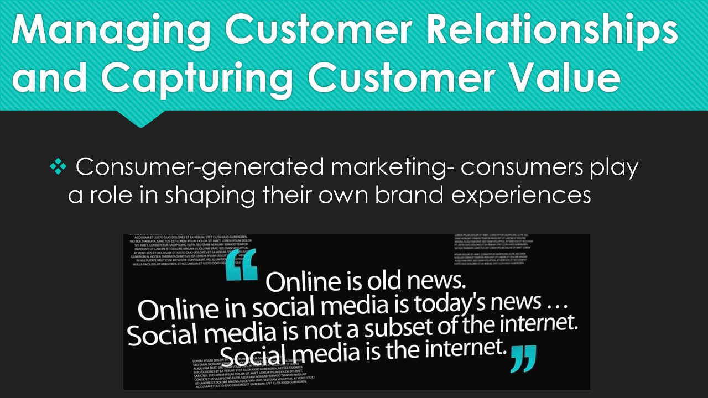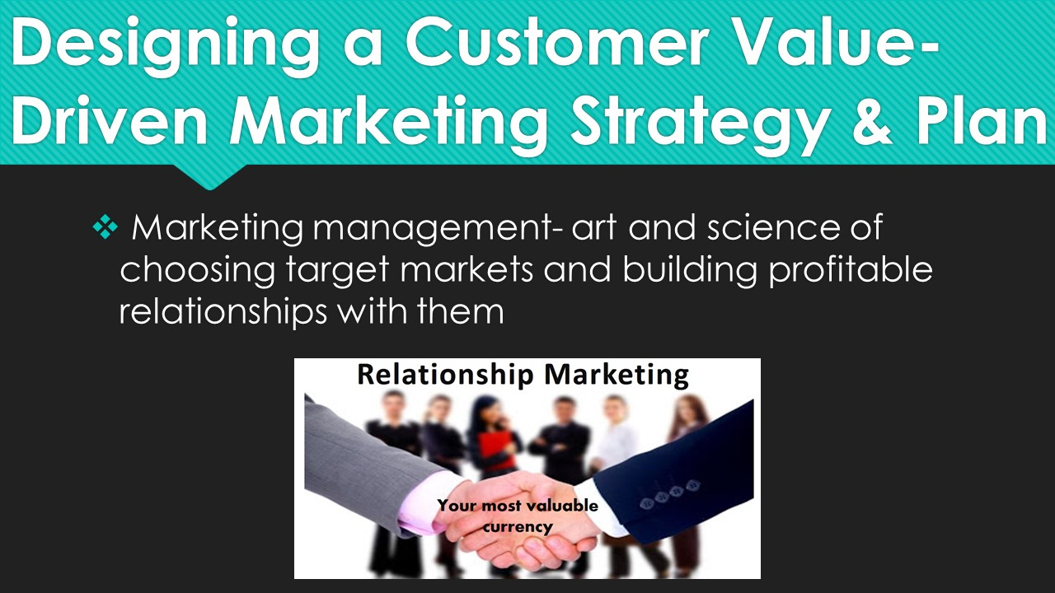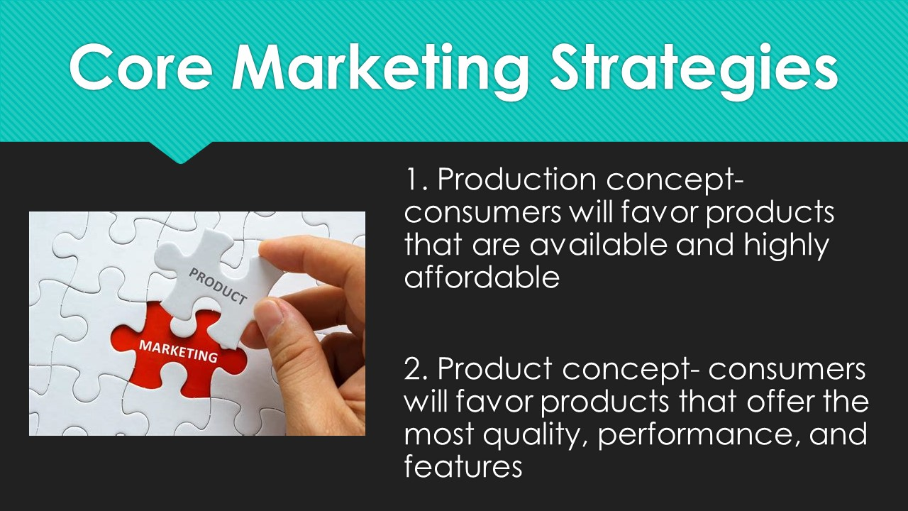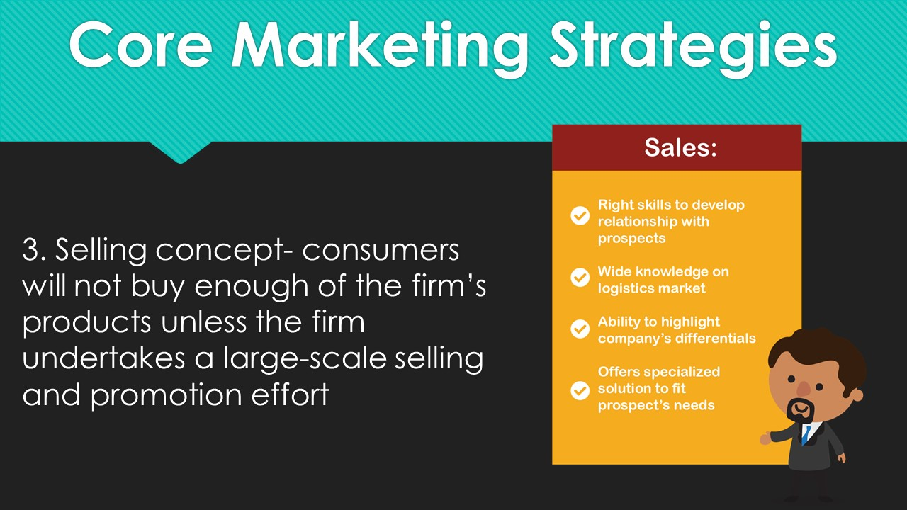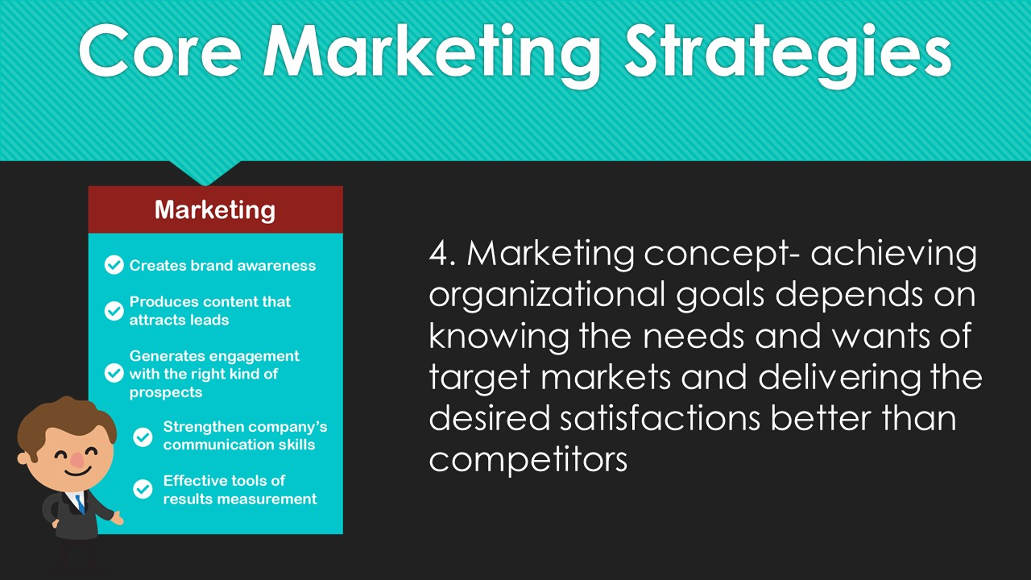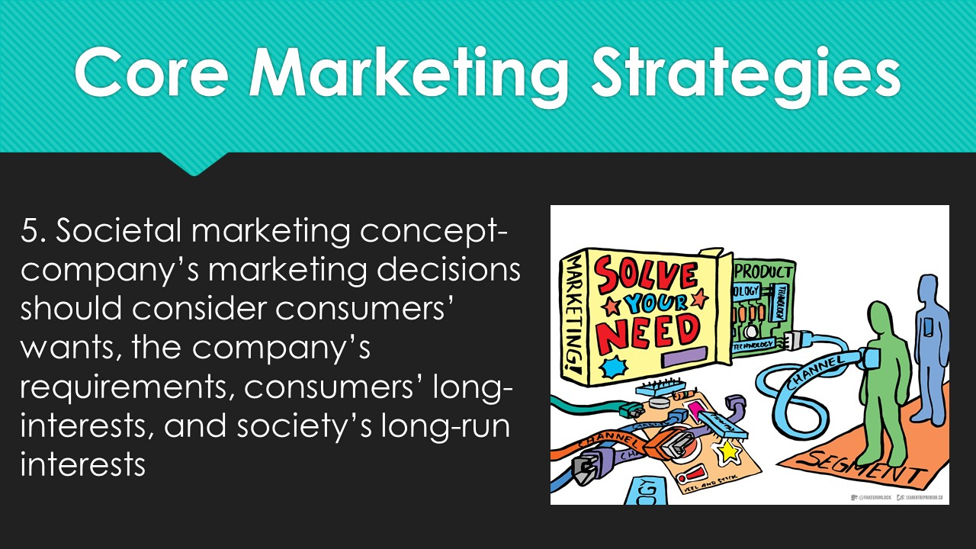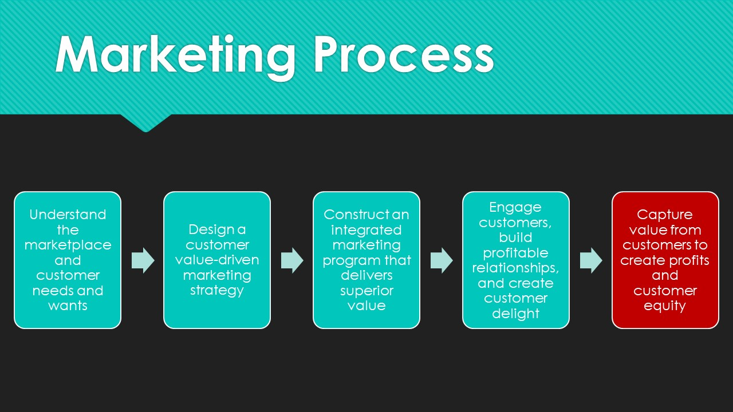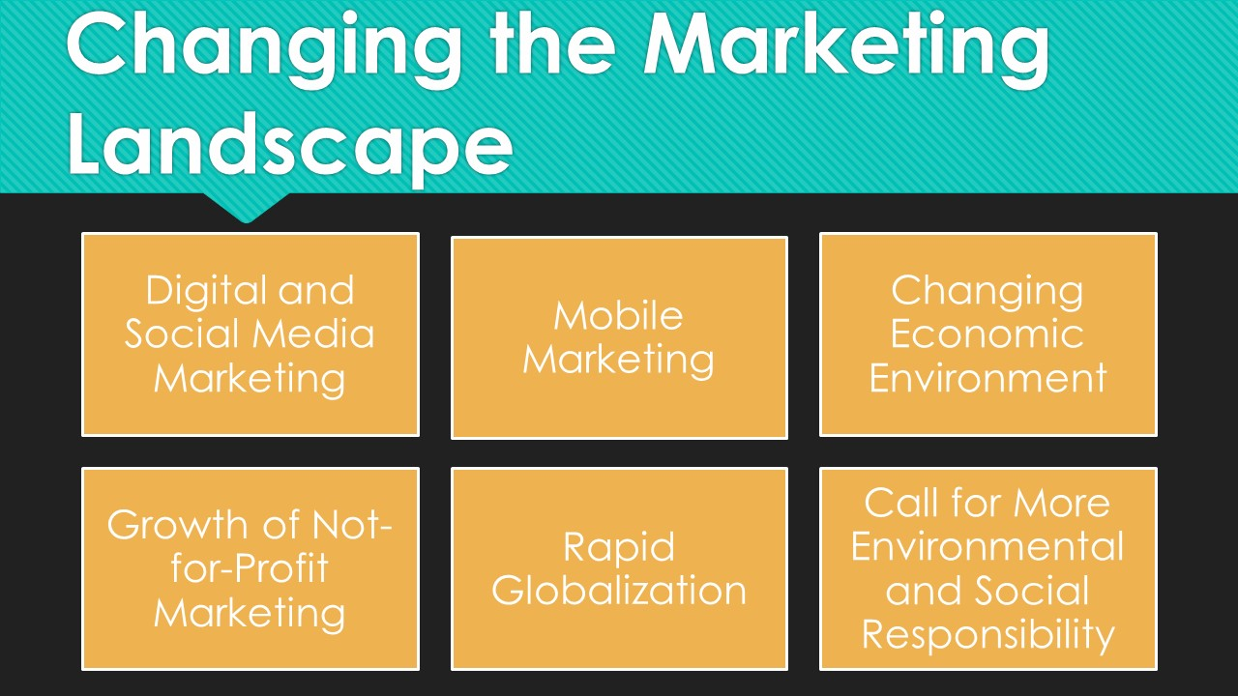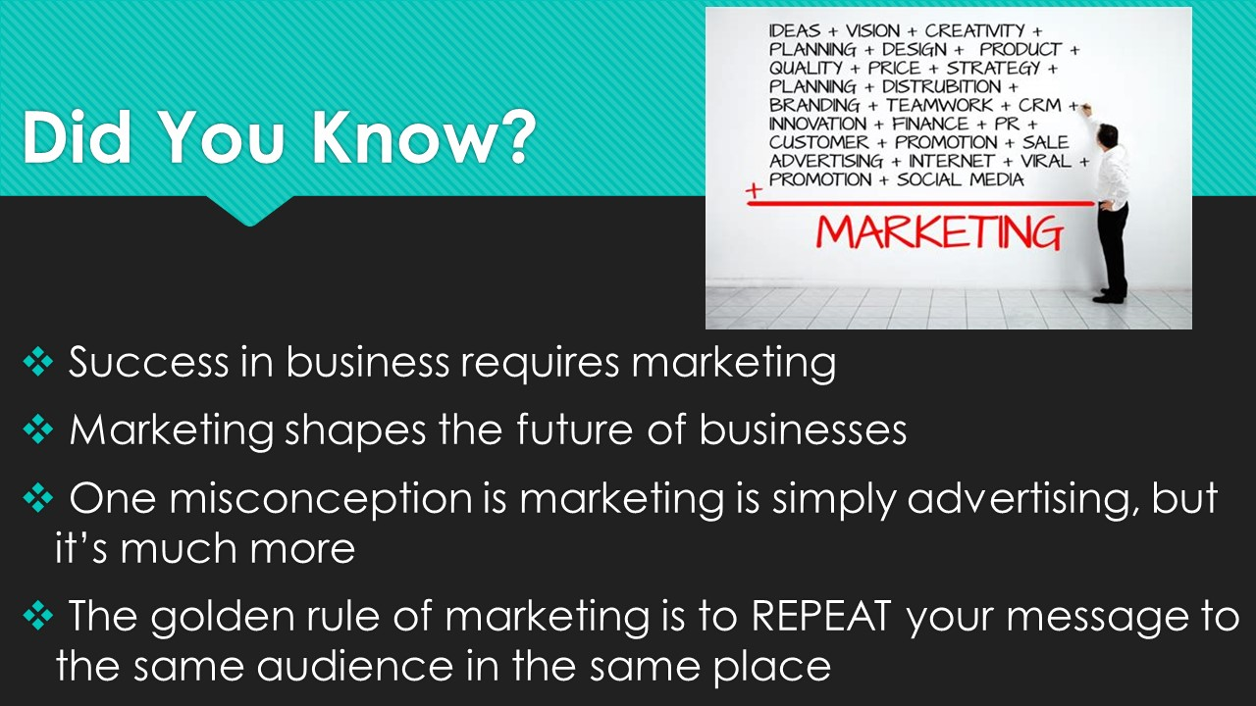

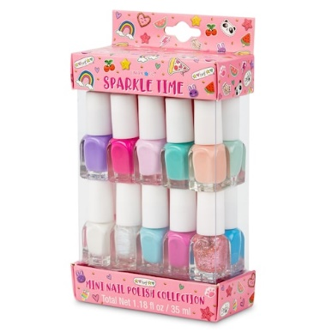
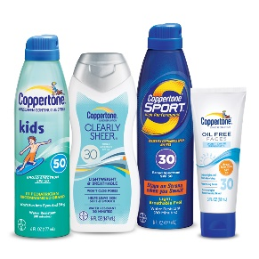
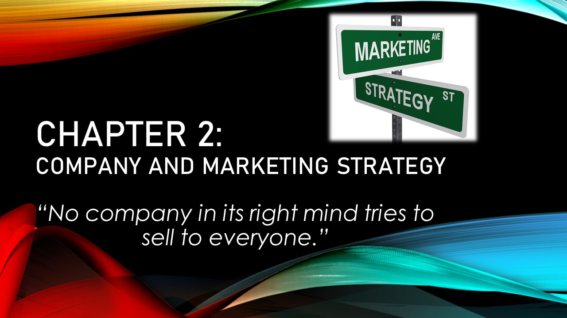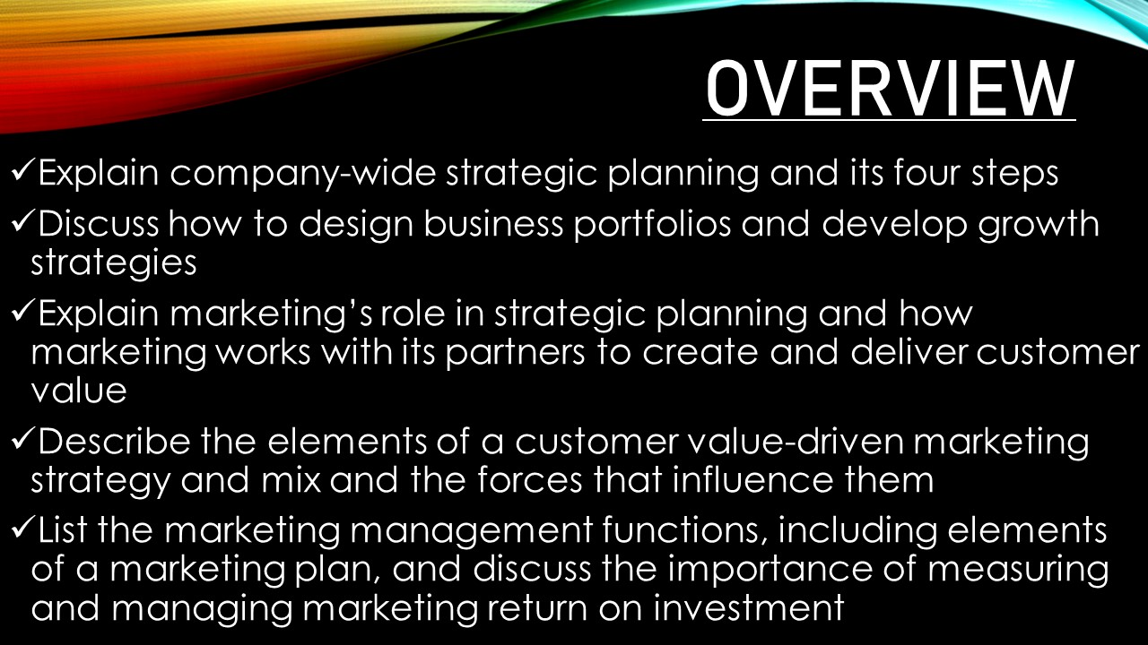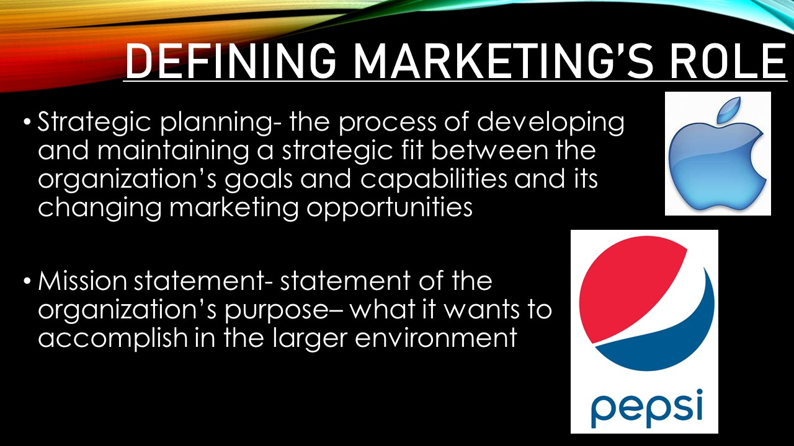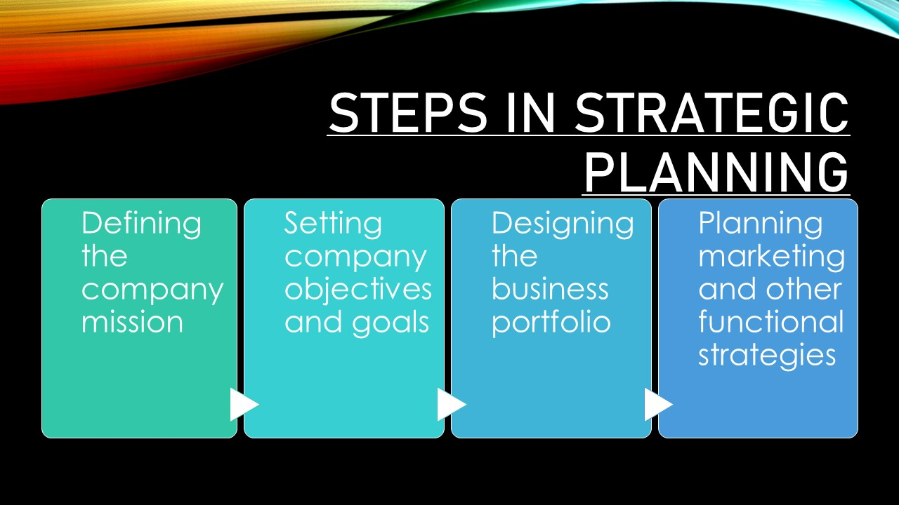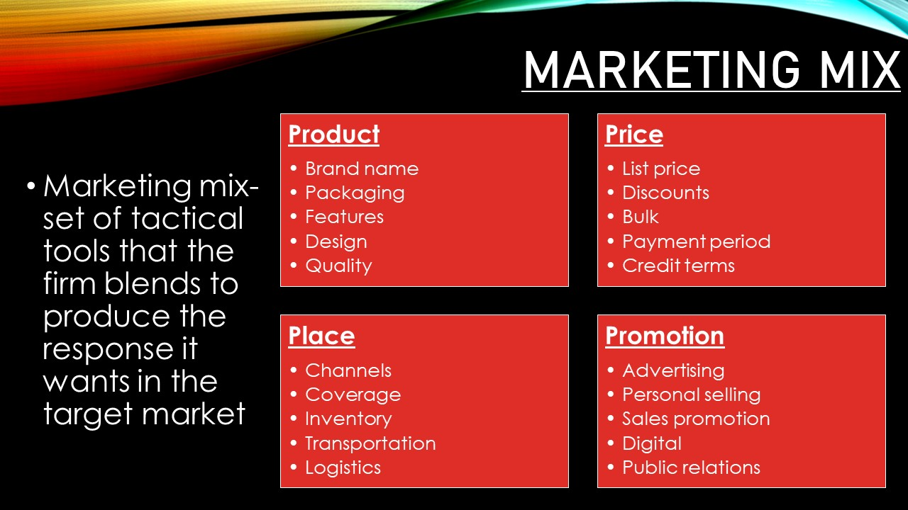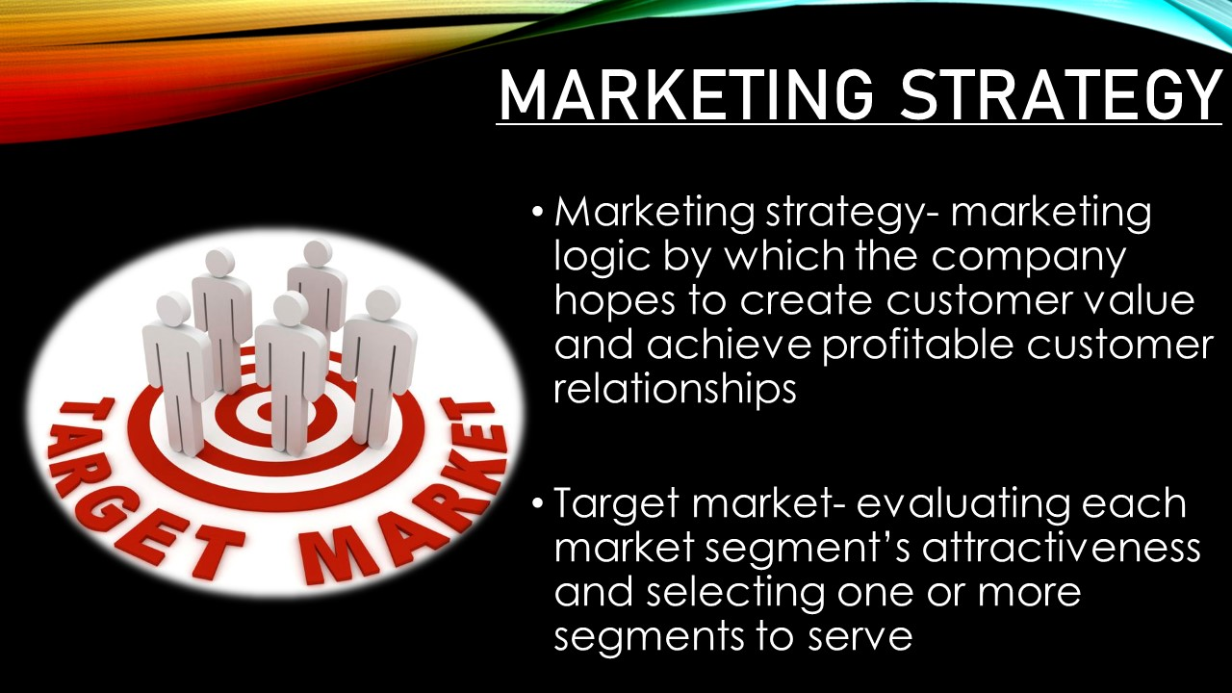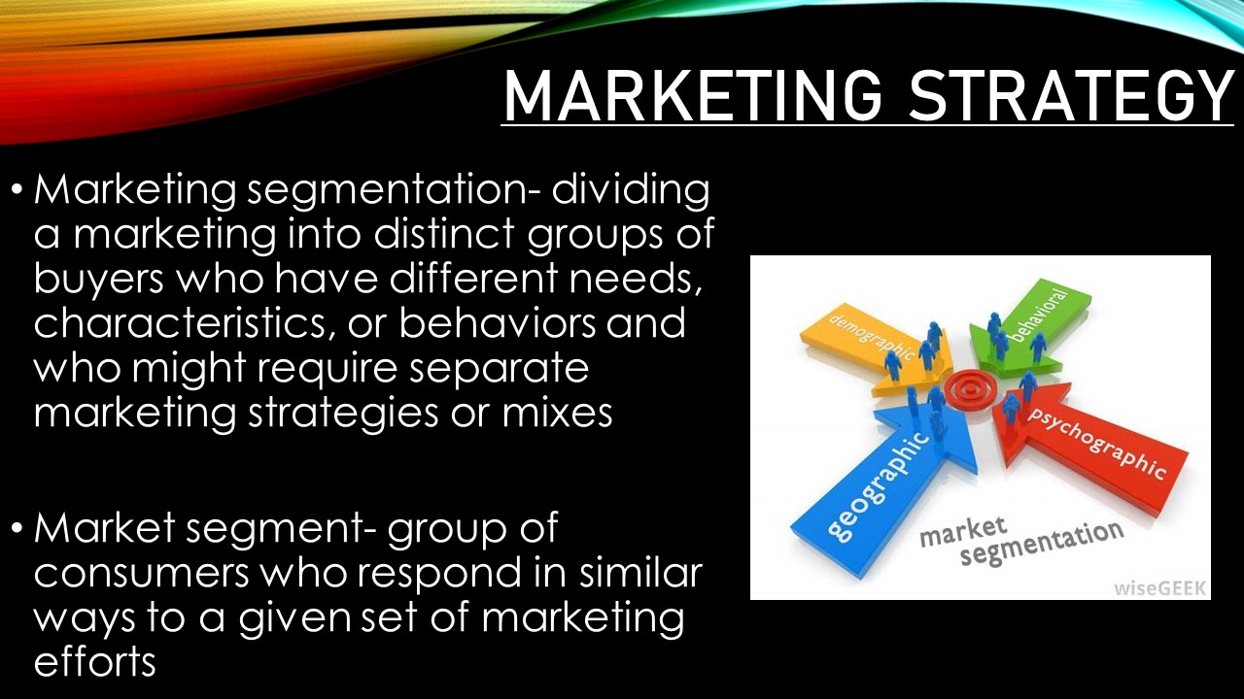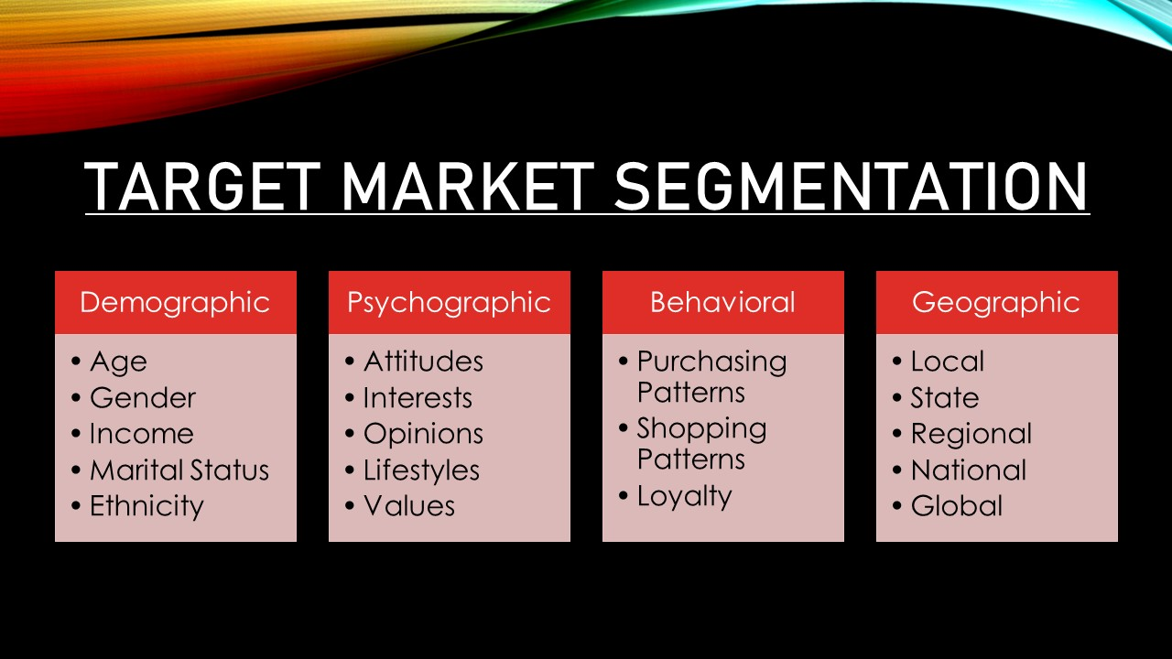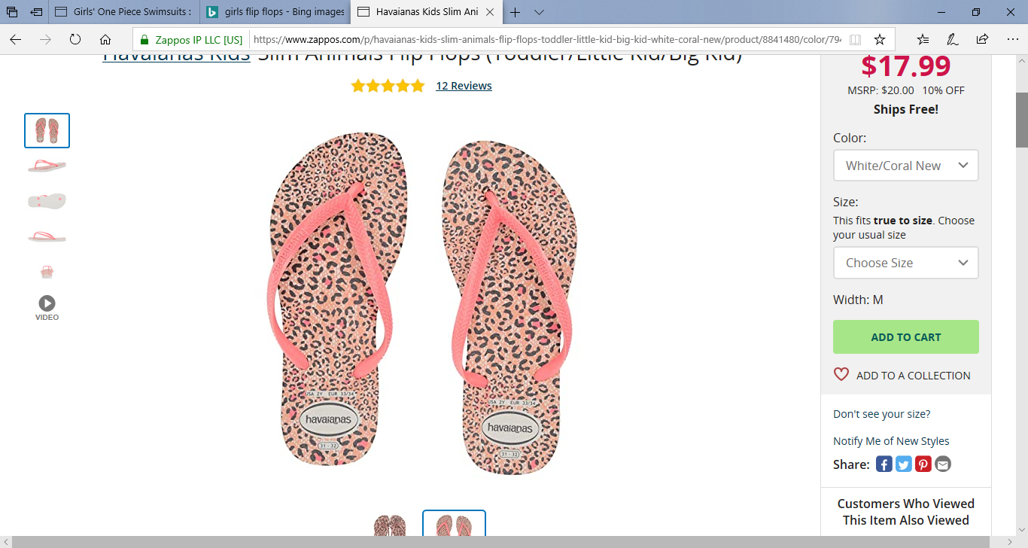
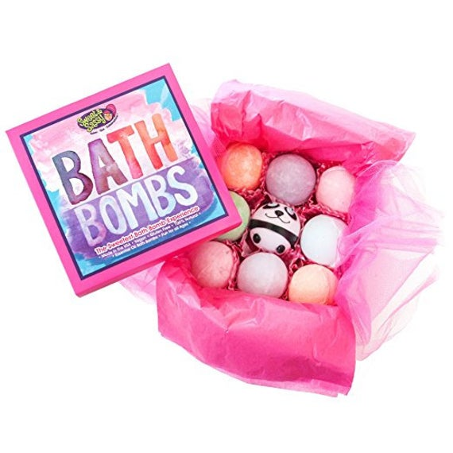
Annabelle- 8-year-old female, loves dolls and gymnastics, lives in Hawaii

