Getting Started with Zoom, A Guide
To start zoom, use the icon on your desktop that says “Zoom.” This will bring up a window like the one below. There is no requirement to sign-in to use the Zoom app to join a meeting, only to host.
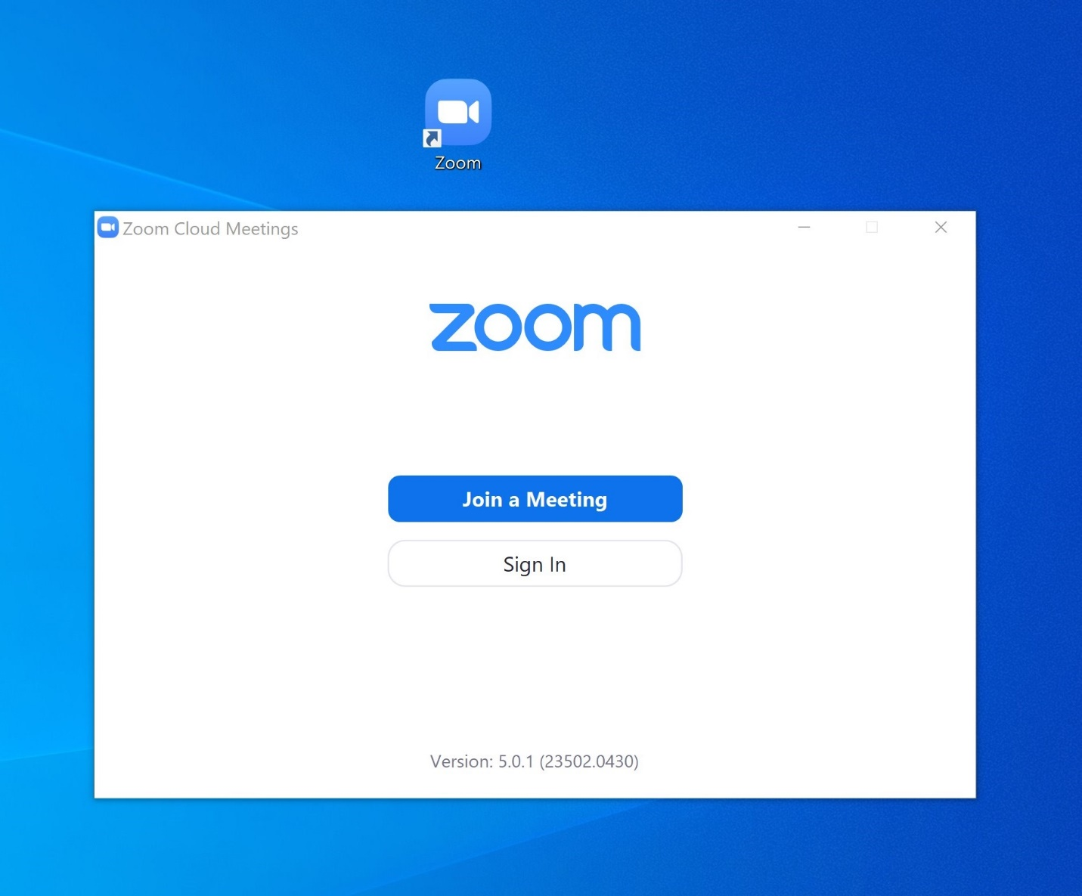
To proceed into a meeting without logging in, click the blue “Join a Meeting” button. You will then be asked for a Meeting ID, Display Name, and some options—See below. Enter the required information: Meeting ID and Display Name and then click “Join”. You will then be prompted to enter a password provided by your teacher. That will put you into a waiting room until the teacher permits your entry.
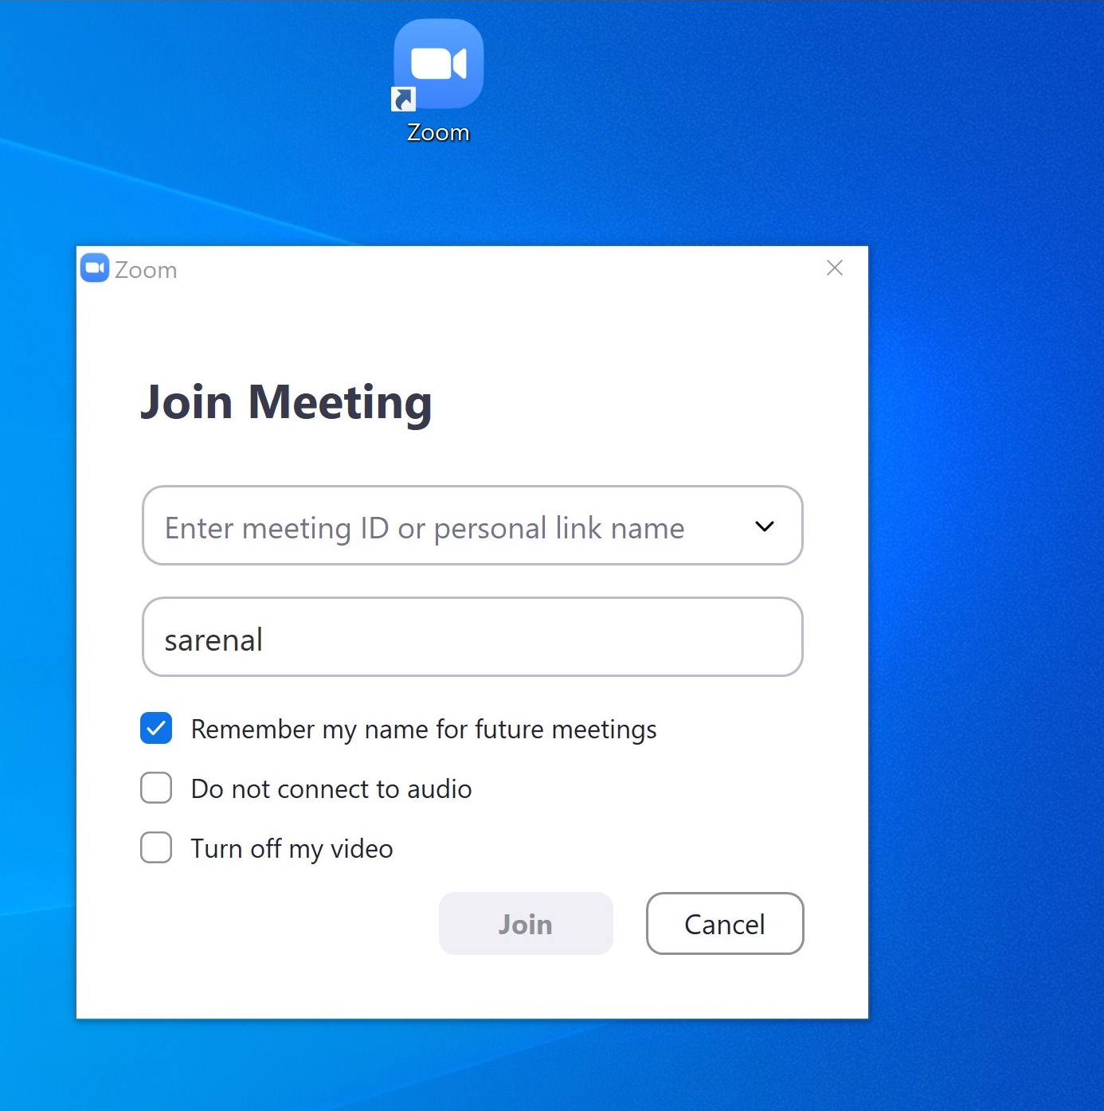
Alternately, if you cannot find the app on your desktop, you can go to a web browser and head to Zoom.com to join a meeting. At the top of the website, on the right-hand side, is a series of links. One of those links should say, “Join a Meeting.” Once you click on that link, you can then enter your Meeting ID and the password, as provided by the teacher.

