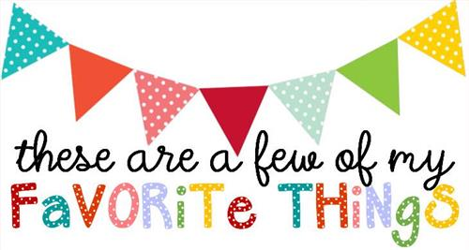

Name: Shannon Hollingsworth
T-shirt Size: Size Large
Birthday: January 20th
Monogram: SRH
Favorite Color: Green, blue, purple
Favorite Flower: Gerber Daisy
Favorite Scent: Not picky about smells. I love candles and wax scent bars!
Favorite Candy: Peanut M&Ms
Favorite Drink: Vibe Nutrition Tea, Coffee, and Water
Favorite Food: Mexican Food
Favorite Snack: Cheese Its and Popcorn
Favorite Fruit: Bananas, Watermelon, Pineapple, Grapes
Favorite Restaurant: Outback and Subway
Favorite Places to Shop: Old Navy, Target, Marshalls
Things I collect: Disney, Candles, DSU Gear and Decor.
Favorite Author/Book Series for my own personal reading: Mysteries and Thrillers
Wish List for Classroom: Post It Notes, Individually wrapped candies for students treats and rewards, or card stock

