SS8H9a Describe the impact of events leading up to American involvement in World War II; include Lend-Lease and the bombing of Pearl Harbor.
LEND-LEASE ACT
In 1939, Germany’s Adolf Hitler invaded Poland. Great Britain and France then declared war on Germany beginning World War II. The United States did not want to become involved in WWII as the economy was still recovering from the Great Depression. However, there was a growing fear that Germany would conquer Europe, which was a threat to U.S. security. To help out the Allied Powers without sending US troops into battle Franklin D. Roosevelt persuaded Congress to pass the Lend-Lease Act. The purpose of this act was to provide economic and military aid to the Allied Powers (countries fighting against the Axis Powers of Germany, Italy, and Japan) and they would repay America after the war. The United States provided $50 Billion dollars worth of military supplies such as tanks, airplanes, guns, and ammunition, along with foods and other needed materials. The Lend-Lease Act also helped jumpstart the US economy, which ended the Great Depression era. Once Japan bombed Pearl Harbor the United States officially declared war on the Axis Powers and entered WWII.

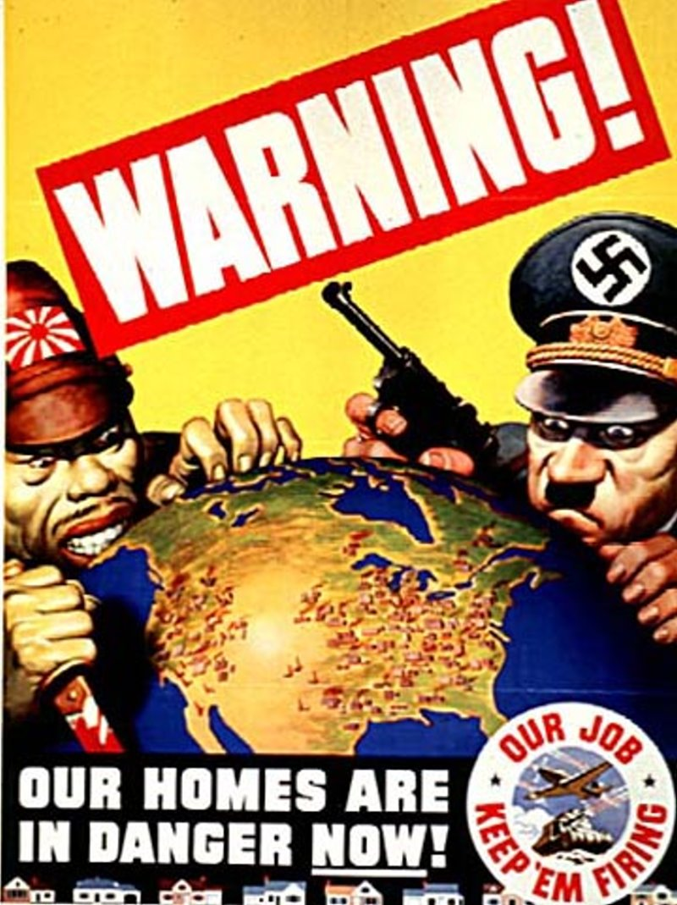
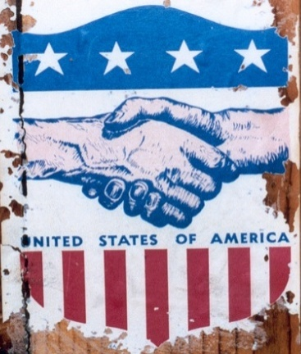
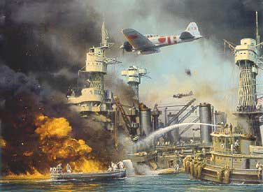
PEARL HARBOR
At the same time Germany was invading European countries, Japan was trying to conquer Asia and the Pacific Ocean territories. When Japan invaded China the United States stopped trading steel and oil. This is called an embargo, when one country refuses to trade goods with another country as a form of punishment. Japan saw the United States as a threat to their desire to conquer Asia and the Pacific. In the early morning on December 7, 1941, Japan launched a surprise attack on the US naval base located at Pearl Harbor, Hawaii. There were 353 Japanese fighter, bomber, and torpedo planes that attacked US battleships, cruisers, destroyers, and air fields. There were 3,684 US casualties (2,402 killed, and 1,282 wounded), while only a combined 65 Japanese soldiers were killed or wounded. President Franklin D. Roosevelt urged Congress to declare war on Japan and the United States began fighting in World War II. By 1945, both Germany and Japan surrendered and would eventually become allies with the United States as both countries became democratic.

SS8H9b Evaluate the importance of Bell Aircraft, military bases, the Savannah and Brunswick shipyards, Richard Russell, and Carl Vinson.
MARIETTA - BELL BOMBER AIRCRAFT
With the help of President Roosevelt, the federal government created Bell Aircraft which produced 663 B-29 bombers that helped the United States win World War II. The manufacturing plant turned rural Cobb County into a thriving industrial region in Georgia. Marietta, Georgia began to experience a lot of economic and population growth because of Bell Aircraft as thousands of jobs were created. It also proved that the South could be an industrial region of America. After WWII, the plant shut down, but in 1951 Lockheed-Georgia (now called Lockheed-Martin) bought the company and still produces airplanes for the US military today.

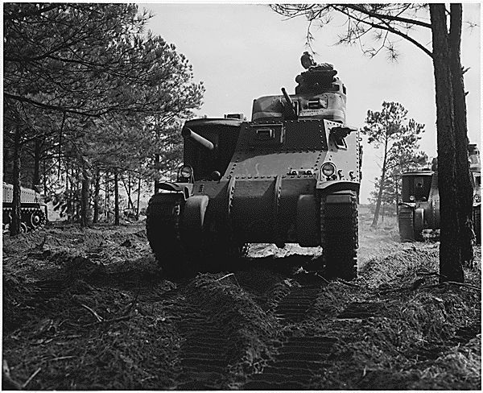

RICHARD RUSSELL
Former Georgia Governor, served as Georgia US Senator for 38 years. He helped pass FDR’s New Deal programs through Congress and he was a big supporter of the US military. Richard Russell helped Georgia increase its military bases that would help train soldiers for World War II. He also helped create the National School Lunch Program as well as the CDC (Center for Disease Control) which is one of the best high-tech laboratories in the nation, located in Atlanta. Richard Russell used his political experience to help Georgia.

CARL VINSON
US House of Representative from Georgia for 50 years. Member of the Naval Affairs Committee and is known as “the father of the two-ocean navy” because he convinced the US government to build up its naval forces and shipyards in both the Pacific and Atlantic oceans. Like Richard Russell, Carl Vinson was a respected and experienced Congressman who helped the United States during WWII while also providing thousands of jobs for Georgians.

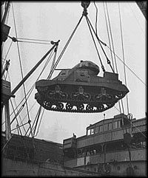

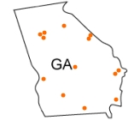
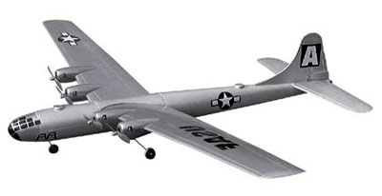

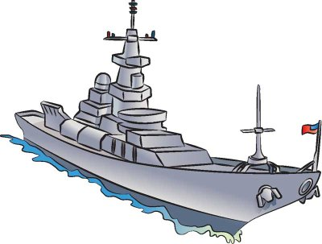

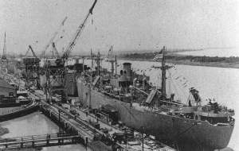

MILITARY BASES IN GEORGIA
Just as in World War I, Georgia helped train many soldiers, sailors, and aviators during World War II. Fort Benning (Columbus), Fort Gordon (Augusta), Fort Stewart (Savannah), and Robins Air Force Base were just some of the many training facilities that brought jobs and businesses for local area civilians. Today, these bases are still important for the US military and local economies.

SAVANNAH & BRUNSWICK SHIPYARDS
As Marietta’s Bell Aircraft produced B-29 bombers the port cities of Savannah and Brunswick manufactured 180 “Liberty Ships”. These US naval ships helped the US win World War II, and they also provided thousands of jobs for Georgia citizens along the coast. US Representative Carl Vinson of Georgia is credited for bringing the military industry to Savannah and Brunswick.

SS8H9c Explain the impact of the Holocaust on Georgians.
THE HOLOCAUST: LESSONS TO BE LEARNED
In 6th and 7th grade you learned about World War II and the Holocaust. It is estimated that over 6 million Jews died while imprisoned in concentration camps. The main reason for learning about the Holocaust in 8th grade Georgia Studies class is to remind students about the dangers of intolerance (not accepting others because of ethnic or cultural differences). We have already learned that even prior to the Holocaust Jews have been discriminated against in Georgia, such as the 1913 Leo Frank case. We study history to learn about the past – to continue progressing forward and eliminating some of the mistakes people have made against others. In 1986, the Georgia government created the Georgia Commission on the Holocaust to promote tolerance. This is from their website, “The Georgia Commission on the Holocaust was established to teach the lessons of the Holocaust to present and future generations of Georgians in order to create an awareness of the enormity of the crimes of prejudice and inhumanity and a vigilance to prevent their recurrence.”

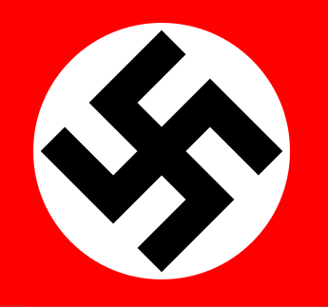
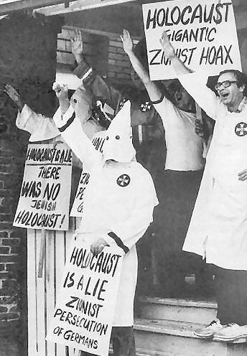

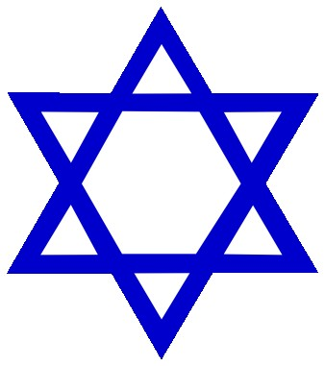
SS8H9d Discuss President Roosevelt’s ties to Georgia including his visits to Warm Springs and his impact on the state.
FRANKLIN D. ROOSEVELT
HELPS GEORGIA

Historians credit Warm Springs, Georgia and the Little White House as the location where President Roosevelt came up with his New Deal policies that helped the United States recover from the Great Depression. Warm Springs was a small rural community that consisted of hard working people that did not have the luxuries of the standard of living of those who lived in urban areas. New Deal Programs such as the REA (rural electrification administration) made it affordable for rural residents to have electricity. The AAA (agricultural adjustment act) increased profits for poor farmers, and the CCC (civilian conservation corps) provided thousands of jobs for Georgia’s unemployed workers. One of their projects was creating Franklin D Roosevelt state park, the largest state park in Georgia. Georgia helped Roosevelt, and Roosevelt helped Georgia recover from the Great Depression.

GEORGIA HELPS
FRANKLIN D. ROOSEVELT

Warm Springs has attracted visitors since 1832 and developed into a small rural community in West Georgia.

From www.gastateparks.org
“Franklin Delano Roosevelt built the Little White House in 1932 while governor of New York, prior to being inaugurated as president in 1933. He first came to Warm Springs in 1924 hoping to find a cure for polio that had struck him in 1921. Swimming in the 88-degree, buoyant spring waters brought him no miracle cure, but it did bring improvement.”

Franklin D. Roosevelt would fall in love with the small town atmosphere and the people of Warm Springs, Georgia.
He made a total of 41 trips to Warm Springs and created the Roosevelt Institute, a facility that was constructed to provide rehabilitation and treatment for those who suffered from polio. Sadly, Roosevelt died in 1945 at his Warm Springs, Little White House from a stroke while his portrait was being painted.



