7th Grade’s August News
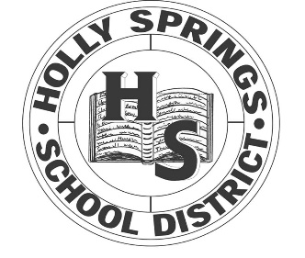HSJH

Upcoming Events

August 8
Student’s first day

September 2
Labor Day Holiday
September 11
Progress Reports sent home

Weekly Reminders:
Monday: Homework
Tuesday: Homework
Wednesday: Quick Quiz
Thursday: Homework
Friday: Test
Grades are updated in Powerschool every 3 days!

Dear Parents,
Welcome to 7th grade! We hope that you have had a prosperous summer with your student. School is back in session and we are looking forward to a fun, educational experience in welcoming your student to middle school. Students should attend school daily, ready to learn, with a positive mindset toward what’s to come. We look forward to each student being successful in their first year of middle school. From small beginnings come great things and in the 7th grade we don’t do easy; we make things happen through hard work and learning. Be sure to check into the awesome things that are going on at Holly Springs Junior High School. Choose from our variety of clubs the school has to offer and ask about PBIS rewards!
Sincerely,
7th grade faculty

Learning Targets

Math: You will need to purchase 2 standard calculators for this school year. Students will need to master 19 skills to have 80% mastery of your standards for 7th grade. Students will be applying and extending previous understandings of addition and subtraction to add and subtract rational numbers; represent addition and subtraction on a horizontal or vertical number line diagram.
Reading: Students will need to read at least 2 AR books by the end of the month. In class students will be studying determining the meaning of words and phrases as they are used in a text, including figurative and connotative meanings; analyze the impact of specific word choice (e.g., alliteration) on meaning and tone.
Writing: We are looking forward to enhancing our writing skills throughout this year, helping our students develop their individual voices in the work they complete. Again, the bar is already high but seventh grade looks to take it even higher in pursuit of mastery.
Science: For the month of August students will be analyzing diagrams to provide evidence of the importance of the cycling of water, oxygen, carbon, and nitrogen through ecosystems to organisms. They also will be analyzing and interpreting data to explain how the processes of photosynthesis, and cellular respiration (aerobic and anaerobic) work together to meet the needs of plants and animals.
Social Studies: Students in this class will be understanding the various roles and expectations of citizens throughout the world and apply that understanding to their role as a citizen of their community, state, and nation.
ICT: Students will continue to practice their keyboarding skills. Students will be tested on how many correct words per minute they can achieve throughout the year. Students will also create powerpoint presentations on a given topic as assigned by Coach Brown.
The mission of Holly Springs Junior High School is to gradually increase academic achievement by providing quality instruction for every student.
The vision of Holly Springs Junior High School is to become an A school through academic excellence.

