STEP ONE: GO TO THE MCPSS.COM WEBSITE
STEP TWO: CLICK ON “OUR STUDENTS” AT THE TOP OF THE SCREEN
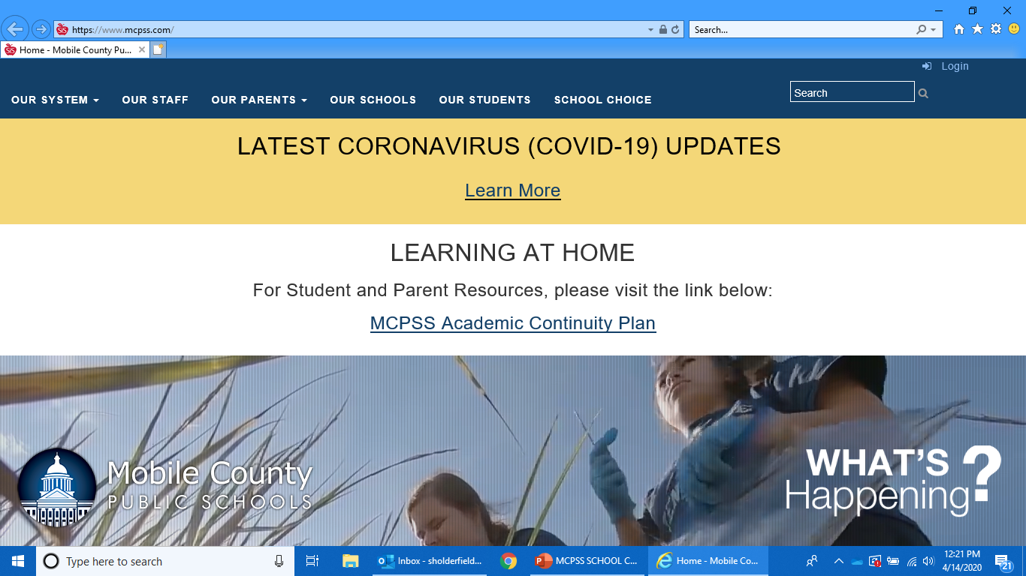
STEP THREE: USING YOUR STUDENT CREDENTIALS, LOG IN (FIRST, MIDDLE, LAST (INITIALS) + LAST 6 DIGITS OF STATE ID) AND YOUR PASSWORD.
Example: username: sdh123456@stu.mcpss.com
Password: ???????????
If you do not know your password call 221-7777, so they can reset it for you.
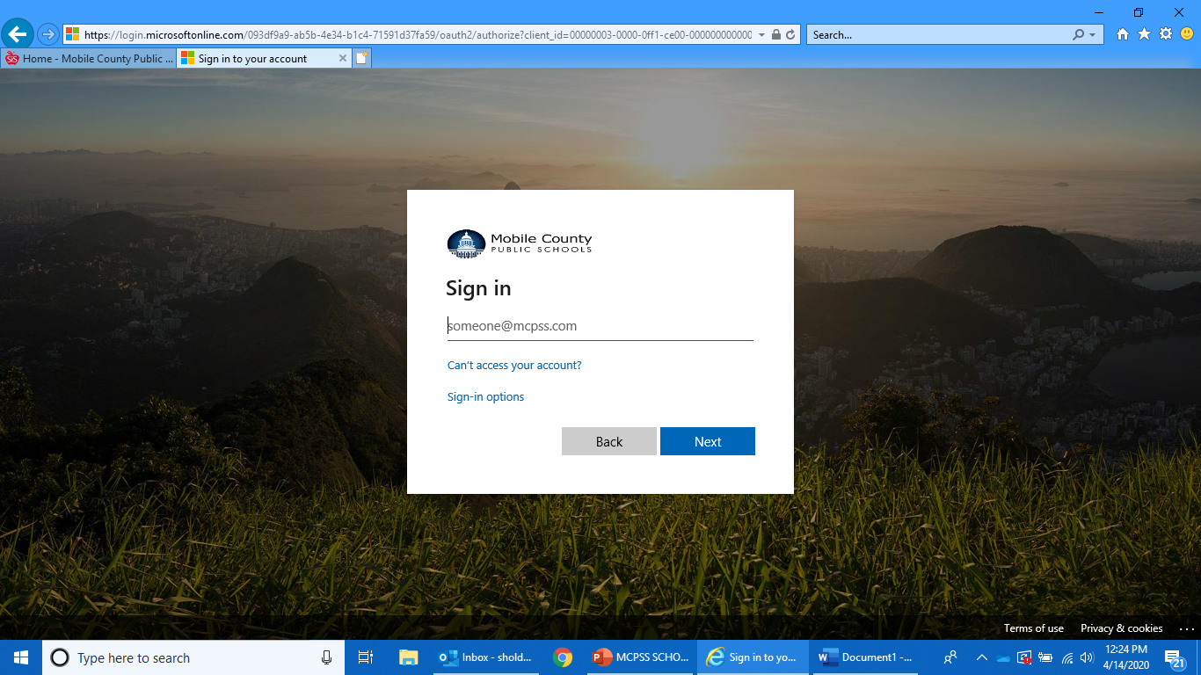
STEP FOUR: After logging in, click on the small windows box of icons in the top left corner.
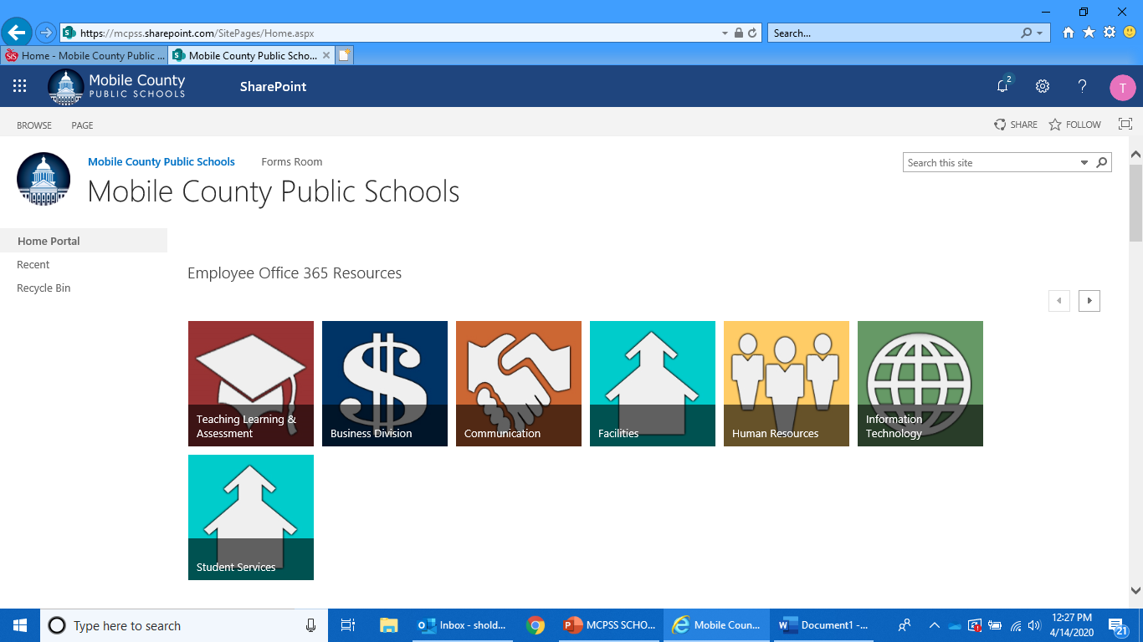
STEP FIVE: . It will then open the app icons. Choose “OUTLOOK.”
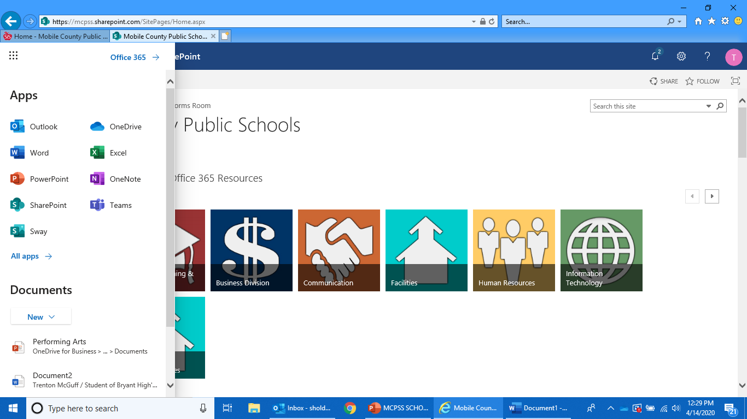
You are now in your student e-mail. Please check this daily. This is where you will receive communications from school personnel.

