Pure Substances vs. Mixtures

- Pure Substances: matter that is always made up of the same combination of atoms.
  - Elements and compounds can both be considered pure substances. Elements will always be made up of the same types of atoms, while compounds will always be made up of the same ratio of elements chemically bound to one another. For example, water will always have two hydrogens and one oxygen. (See examples below)
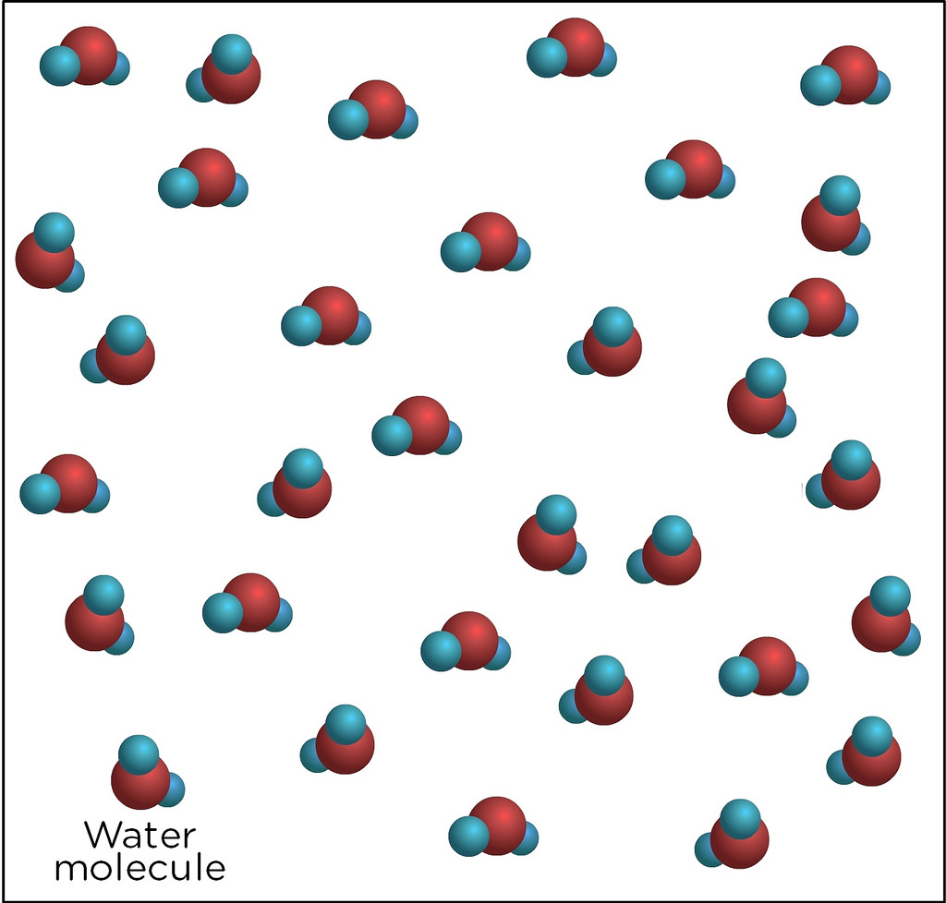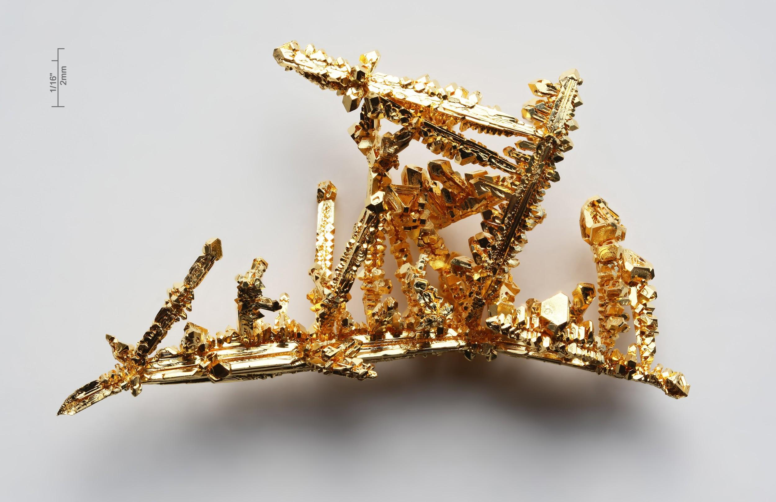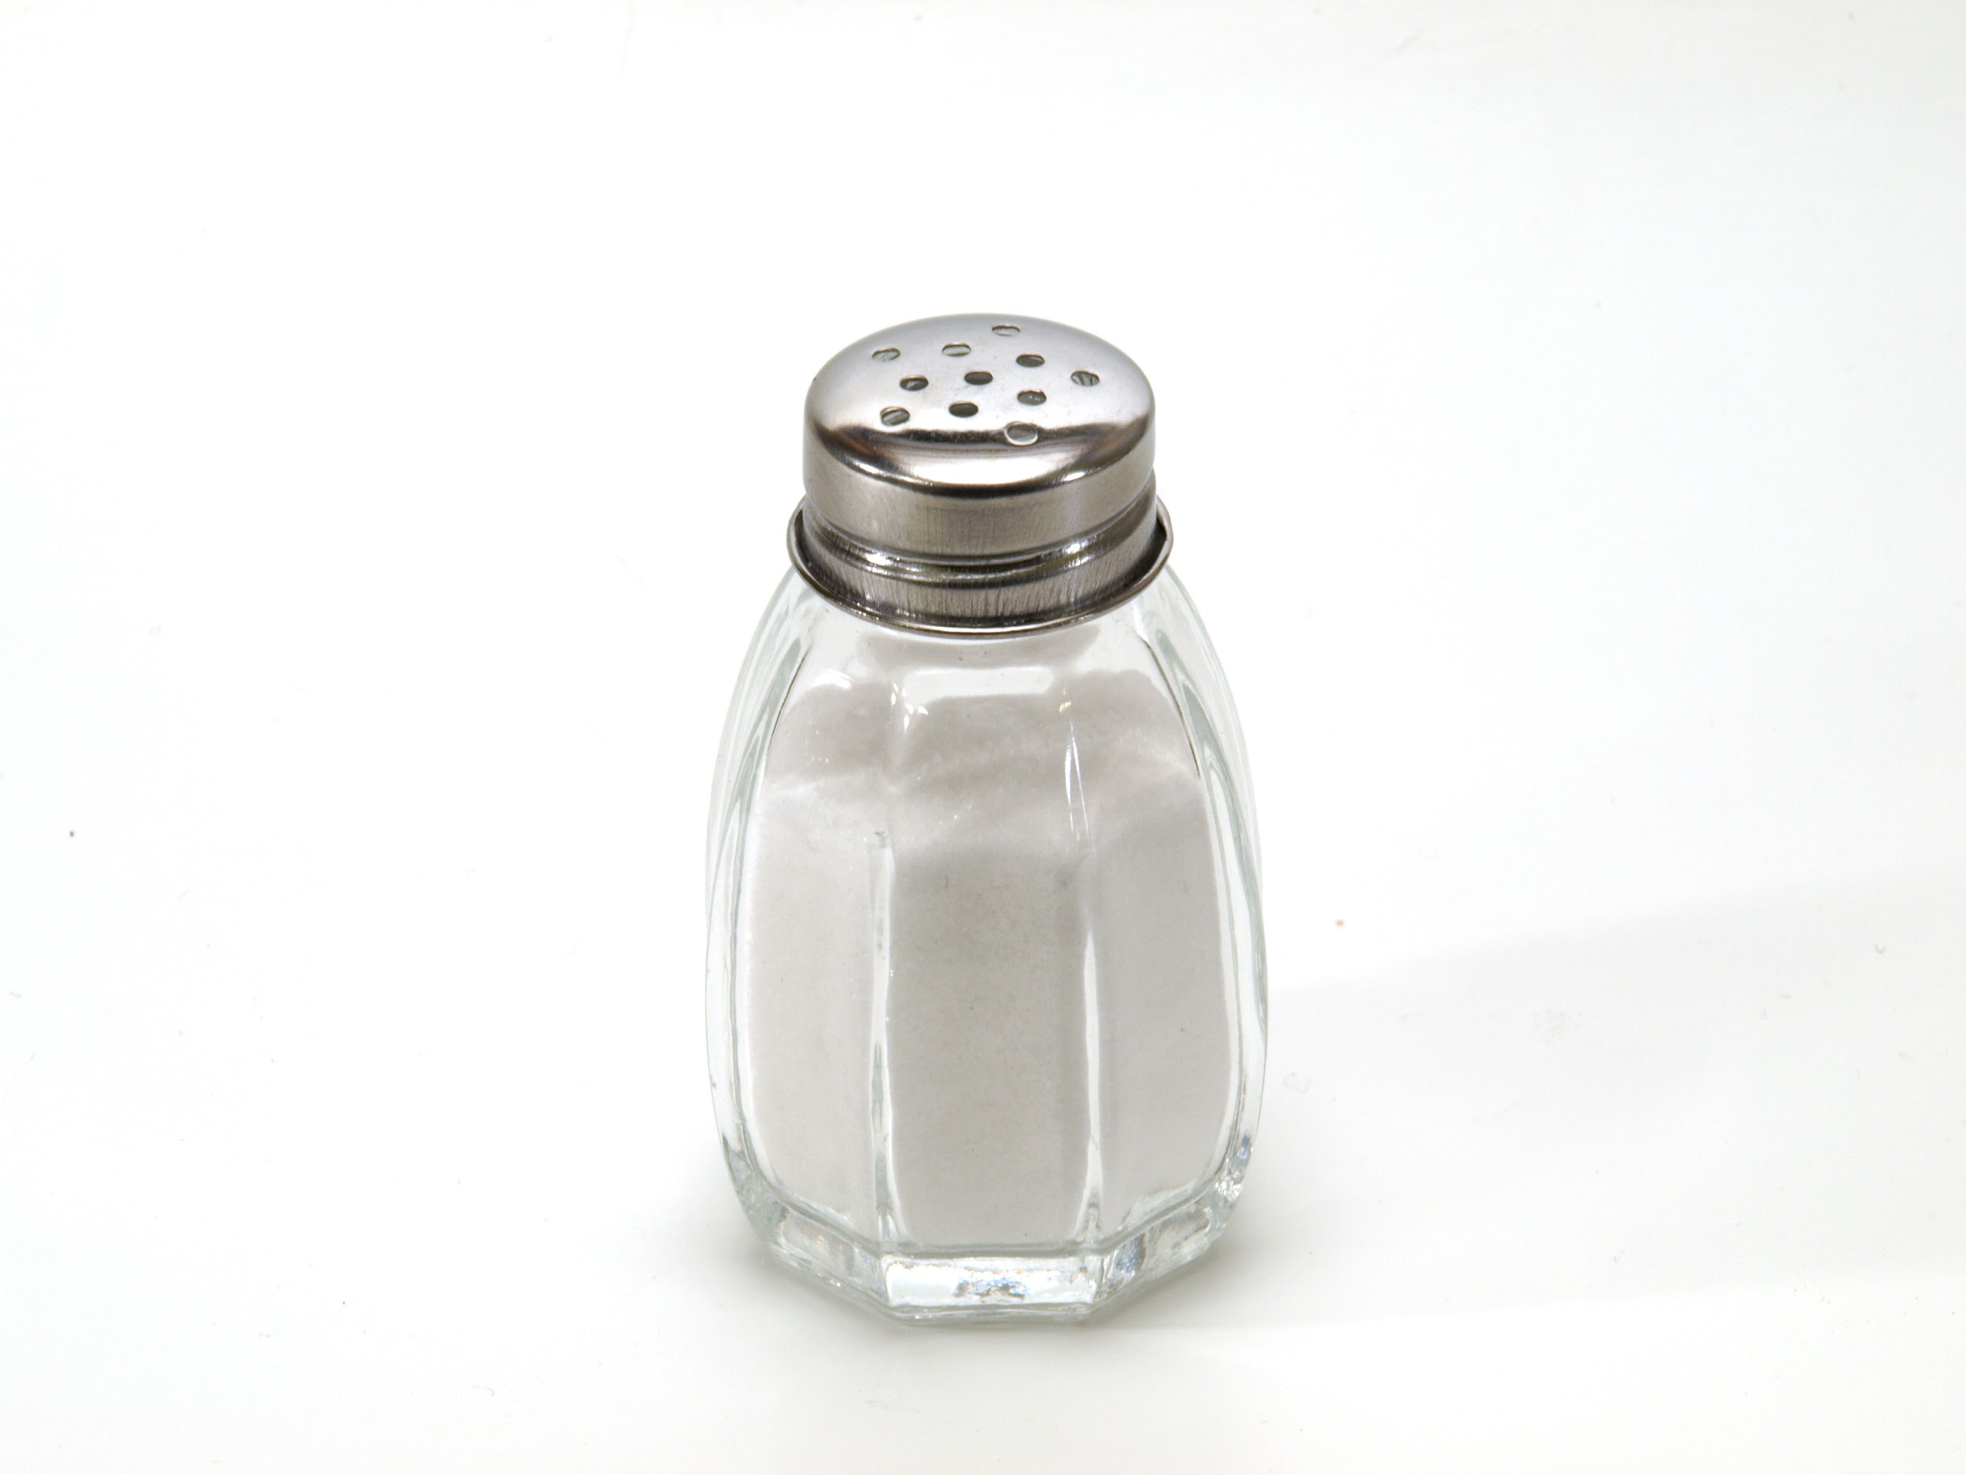
Water molecules Gold Salt (Sodium chloride)

- Mixtures: two or more substances (elements or compounds) that are physically blended together but are not chemically bonded to one another.
  - Mixtures can be solids, liquids, or even gases. (See examples below)

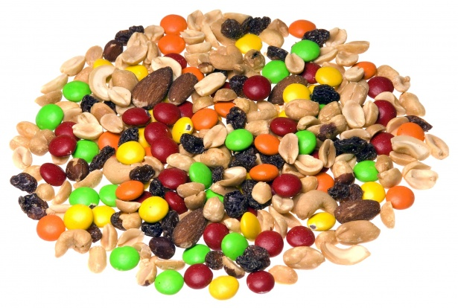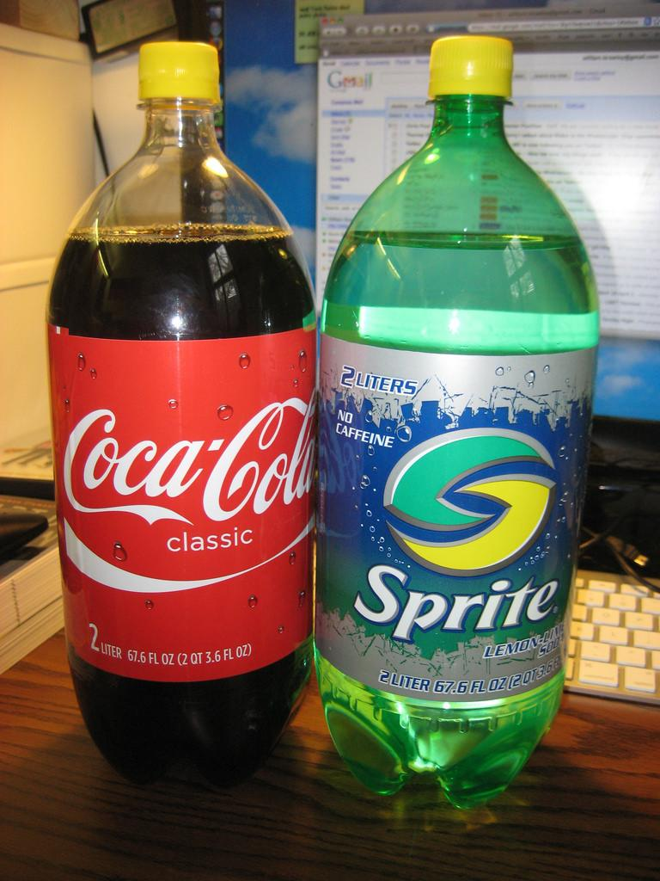
Trail mix (solid) Soda (liquid) Air (gas)

- Types of Mixtures
  - Heterogeneous
    - A mixture in which the substances that make up the mixture are not evenly mixed.
    - The trail mix above is a great example of a heterogeneous mixture because you can easily see the different component of the mixture.
    - If you can see the different components of the mixture (even with the aid of a microscope), it is considered heterogeneous.
  - Homogeneous
    - A mixture in which two or more substances are evenly mixed on the atomic level but NOT atomically bonded together.
    - This type of mixture will look the same throughout, like air or soda, pictured above.
    - Another name for this type of mixture is a solution.
- How are Compounds and Mixtures Different?
  - Compounds are created through the chemically bonding of atoms, a chemical change.
    - When compounds are created, a new set of properties is also created. For example, sodium chloride (table salt) is made with sodium (a metal) and chlorine (a gas). Table salt has none of the characteristics of either sodium or chlorine but instead is a white, crystalline solid.

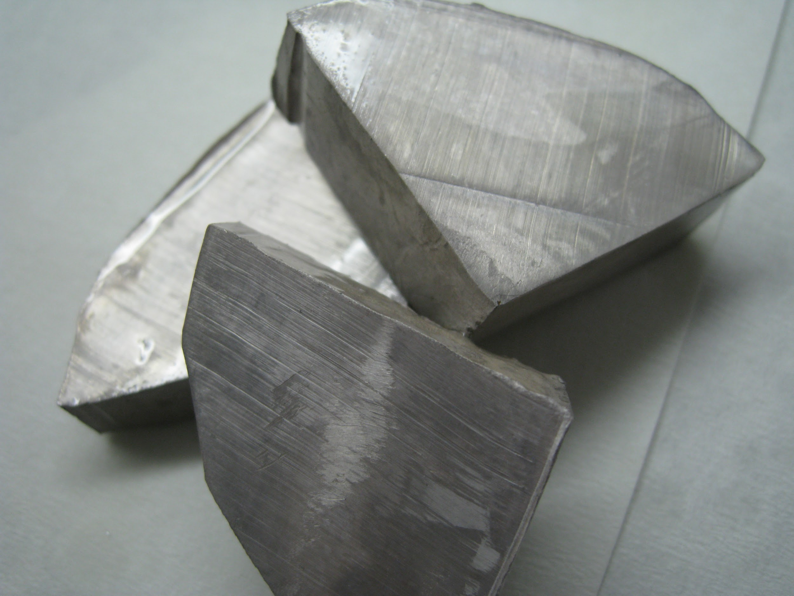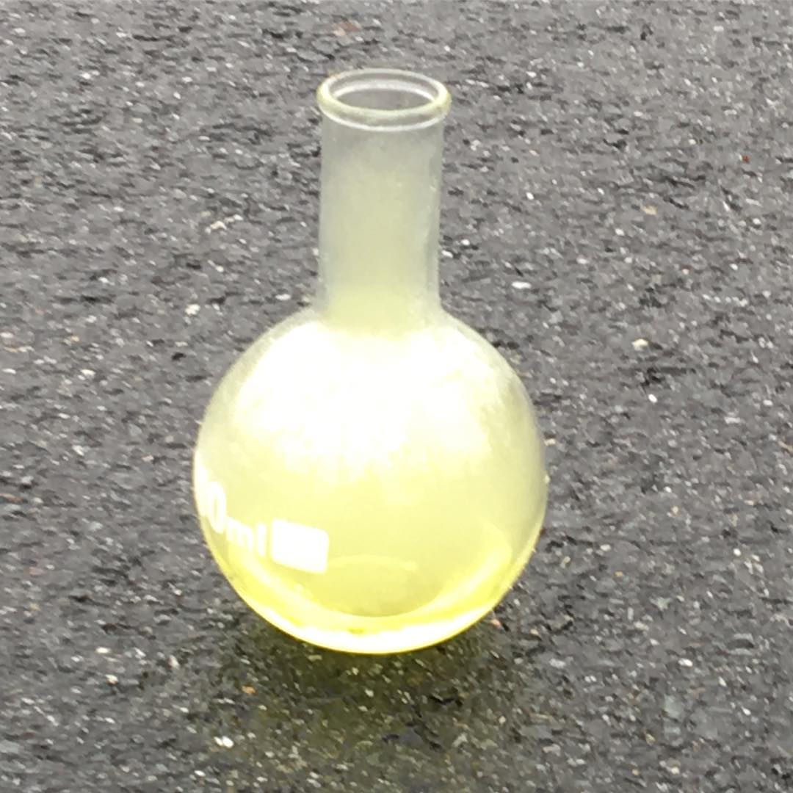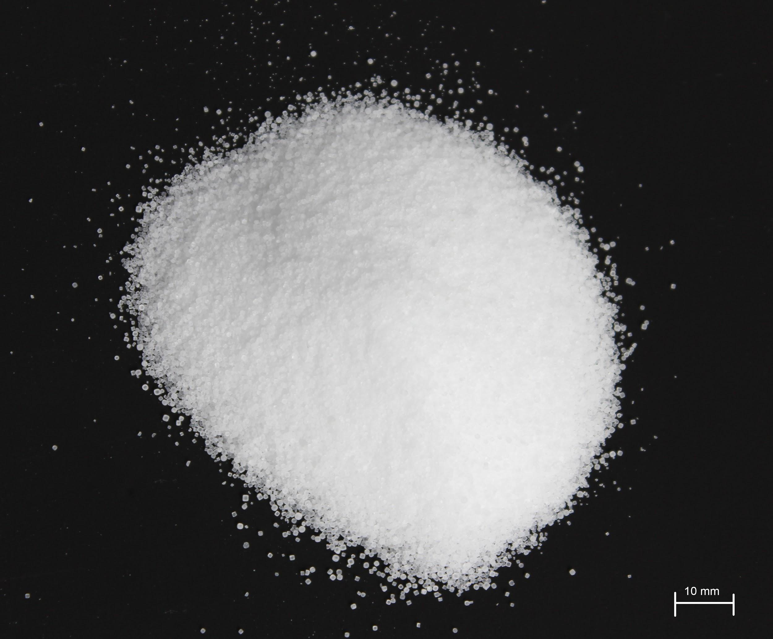
Sodium Chlorine Sodium chloride (table salt)

  - Mixtures are created by mixing, a physical change. The substances that exist before mixing still exist in the mixture.
    - Because the substances that make up a mixture are not changed, some of the properties of each substance will be found in the mixture. For example, if you take the salt from above an mix it with water, you create a salt water mixture. The salt water has properties of both salt (tastes salty) and water (still a colorless liquid)
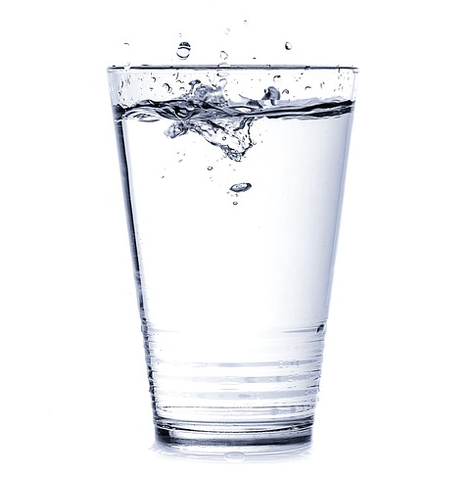
Sodium chloride (table salt) Water Salt Water

  - Mixtures can also be separated using many different processes based on the physical properties of the mixture.
    - You could easily separate the various components of trail mix. Each of these components has properties that set it apart from the other components. M&Ms, for example, are round and colorful while peanuts are oval and tan.
    - Think about the salt water from the above example. How could you separate the salt from the water?

NOTE INTERACTION:

Use the underlined words from the notes and the clues provided below to complete the flowchart.
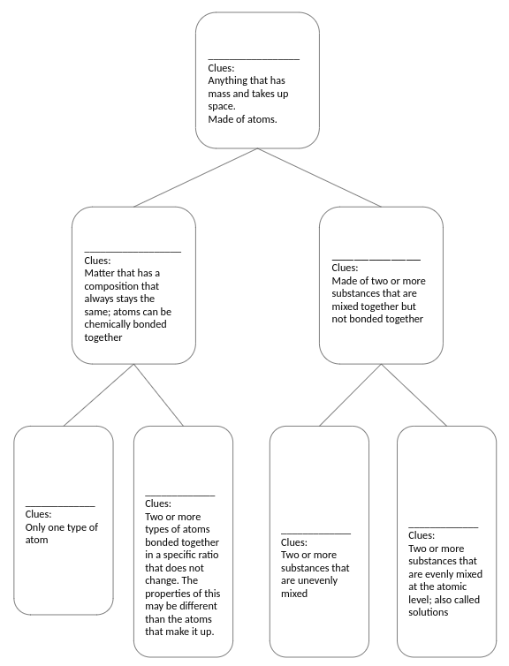

Separation Techniques

- There are a number of ways to separate mixtures using the physical properties of the substances in the mixtures
  - Physical Separation: Using the properties of the components in the mixture to separate them.
    - Consider the trail mix example provided earlier. You could easily separate the different parts of the mixture based on the properties of each piece.
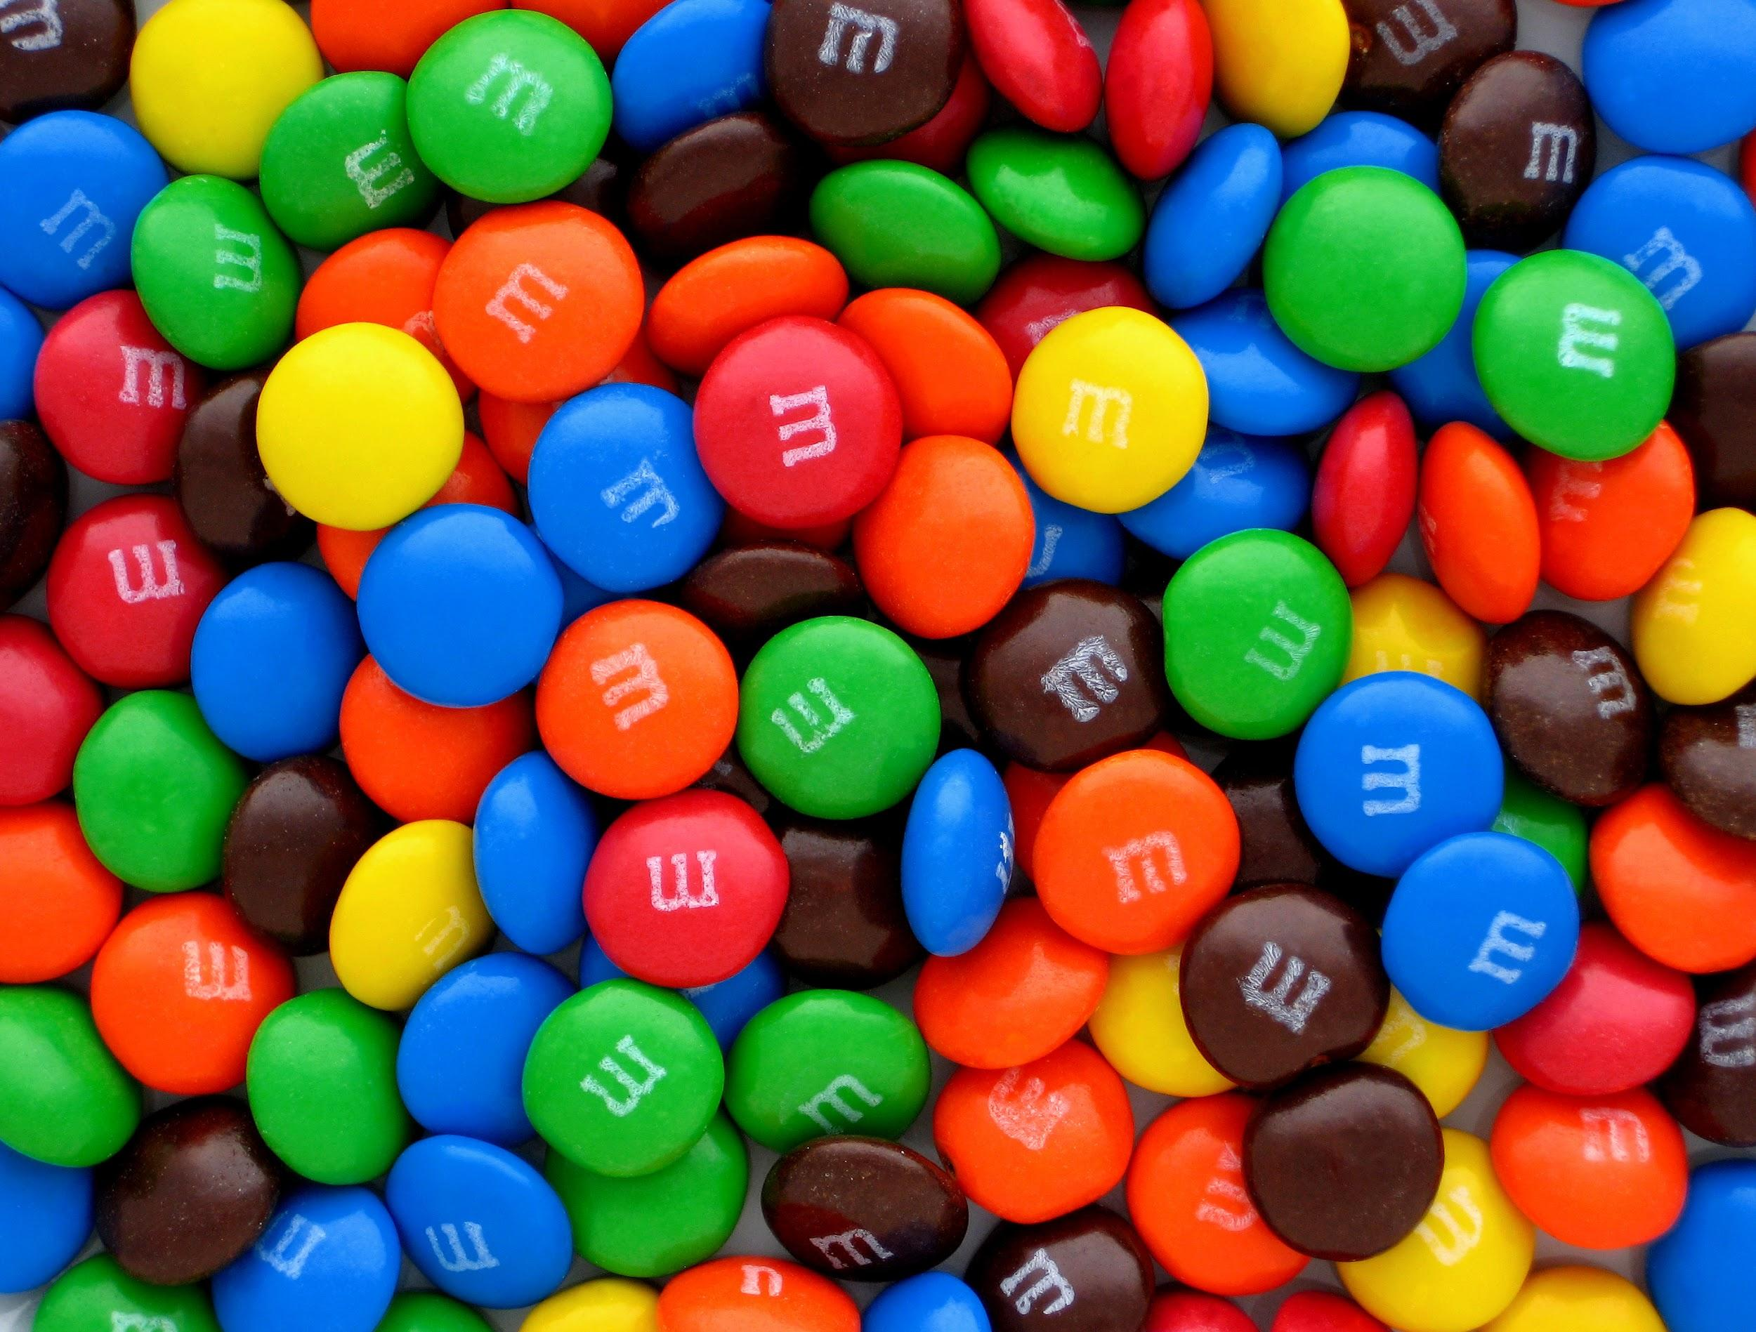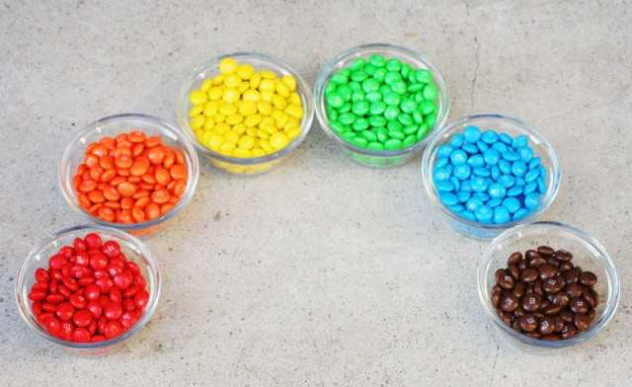
  - Evaporation: Often used to separate a solid dissolved in a liquid such as water
    - One way to separate mixtures, such as salt or sugar water, would be to evaporate the water to leave the salt or sugar.
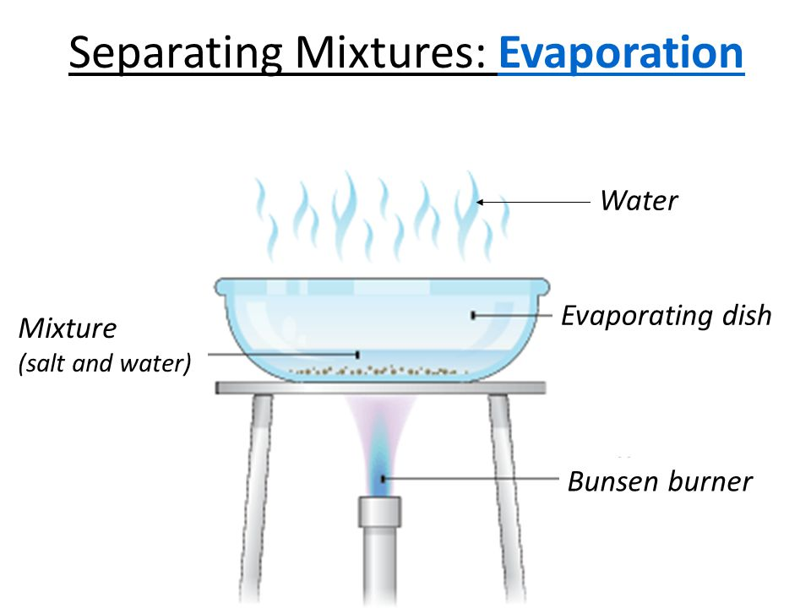
  - Filtering: Used to separate liquids from solids
    - Filtering catches solid particles while allowing liquids to travel through the filter.
    - Filtering can also be used to separate solid particles of different sizes. The filter might allow small particles through but keep large particles out.
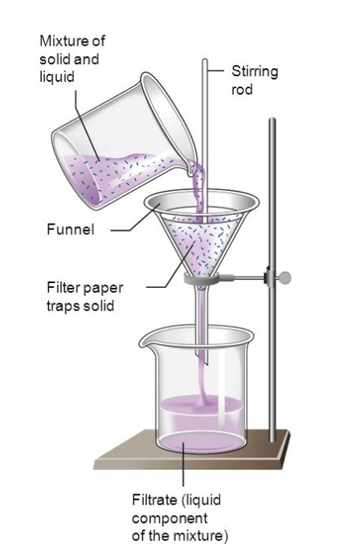
  - Distillation: Used to separate two pure liquids from one another
    - Distillation involves boiling the mixture and condensing the liquid that boils off first. It works because different liquids have different boiling points.
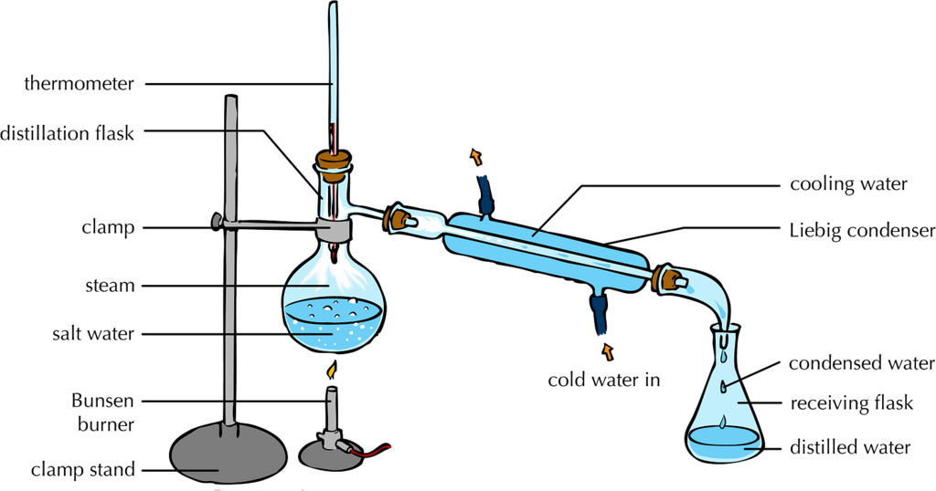

  - Chromatography: Used to separate dissolved substances.
    - Chromatography uses a solvent to move substances up a piece of paper. Different components of the mixture will move at different rates.
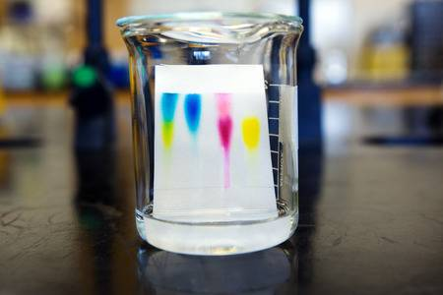

  - Magnetism: to separate magnetic metals from other materials
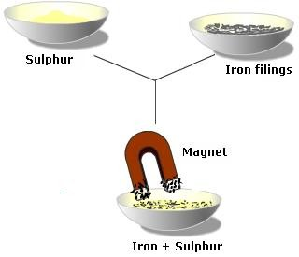

NOTE INTERACTION:
You are cleaning up in the lab and you accidentally spill salt and pepper in a beaker of water. The salt dissolves in the water, but the pepper does not. How could you separate all three components of this mixture?

Solutions

Remember: Solutions are homogeneous mixtures! This means that the particles are evenly mixed on the atomic level.

- Types of Solutions
  - Most people think of solutions as liquids, but they can be solids, liquids or gases.
    - Brass is an example of a solid solution of copper and zinc.
    - Sprite is an example of a liquid solution of water, sugar, other flavorings and preservatives, and gaseous carbon dioxide.
    - Air is an example of a gaseous solution.
  - The state of the solvent determines the state of the solution. If the solvent is liquid, the solution will be liquid.

- Parts of Solutions
  - Solvent: the substance that exists in the greatest quantity in a solution
  - Solutes: all other substances in the solution
    - Air is a solution of many different gases. Because air is 78% nitrogen, nitrogen would be considered the solvent. Oxygen, argon, xenon, neon, hydrogen, helium, krypton, and carbon dioxide would all be considered solutes.
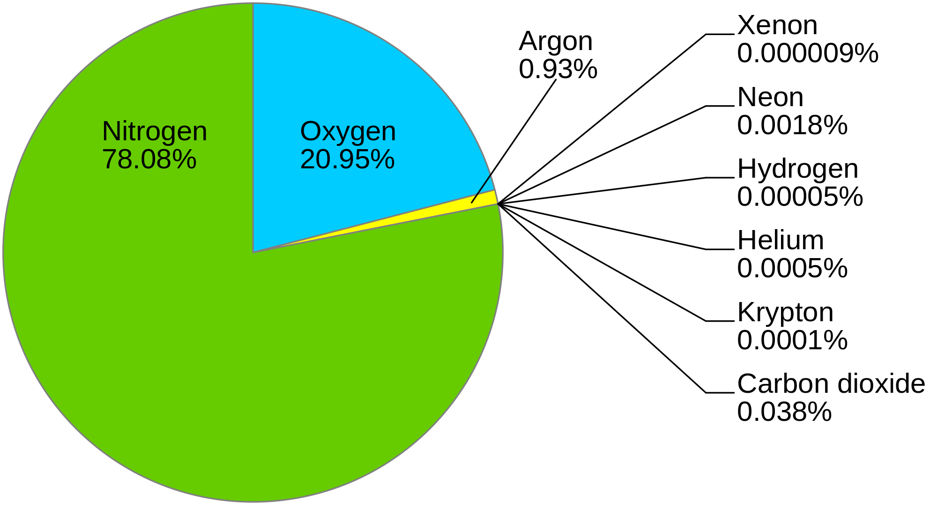
    - Ocean water is a solution of water, salt, and a lot of other minerals. The water would be considered the solvent, and the salt and other minerals would be solutes.
    - When you make hot cocoa, what is the solvent and what is the solute?

- Water is considered a universal solvent because it can dissolve lots of things.
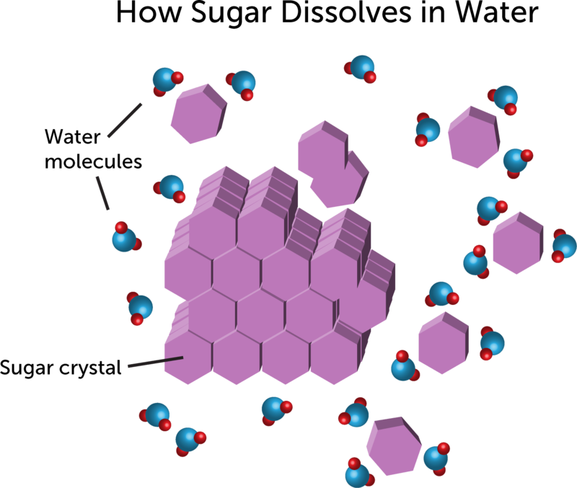
  - When you dissolve sugar in water, does it disappear?
    - NO! The sugar and water mix evenly on the atomic level. If you were to taste the water, you would see that the sugar did not disappear because the solution would taste sweet.

- Concentrations of Solutions
  - Concentration is how we describe the amount of solute in a solvent.
    - Dilute: solutions with a low amount of solute in the solvent are considered dilute. You could consider Kool-Aid made with only one teaspoon of sugar a dilute solution.
    - Concentrated: solutions with a high amount of solute in the solvent are considered concentrated. Think about using 4 cups of sugar in Kool-aid. This would make it very concentrated!
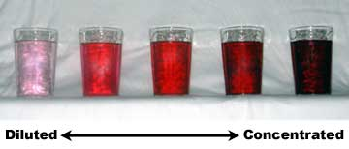
- Solubility
  - Solubility is the amount of solute that can be dissolved in a given amount of a solvent at a specific temperature and pressure. A substance that will not dissolve in a solvent is considered insoluble.
    - Saturated solutions contain the maximum amount of solute the solvent can hold at that specific temperature and pressure. This solution would also be considered concentrated.
    - Unsaturated solutions can still dissolve more solutes at that specific temperature and pressure. Depending on the situation, this solution may be considered dilute.
  - Factors that Affect Solubility
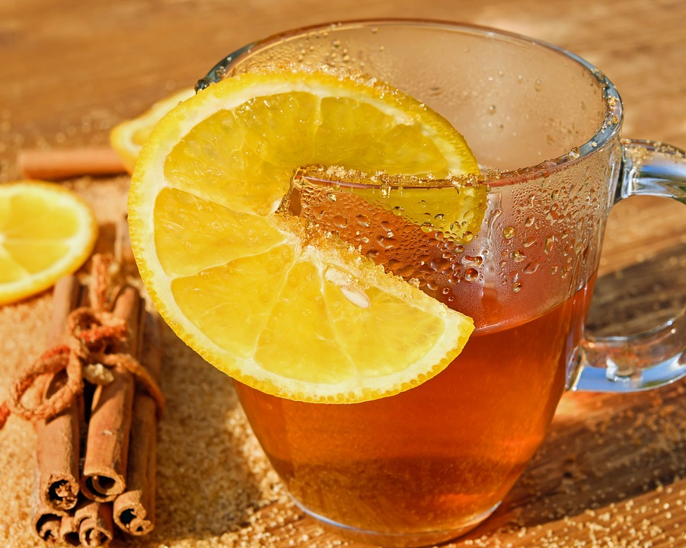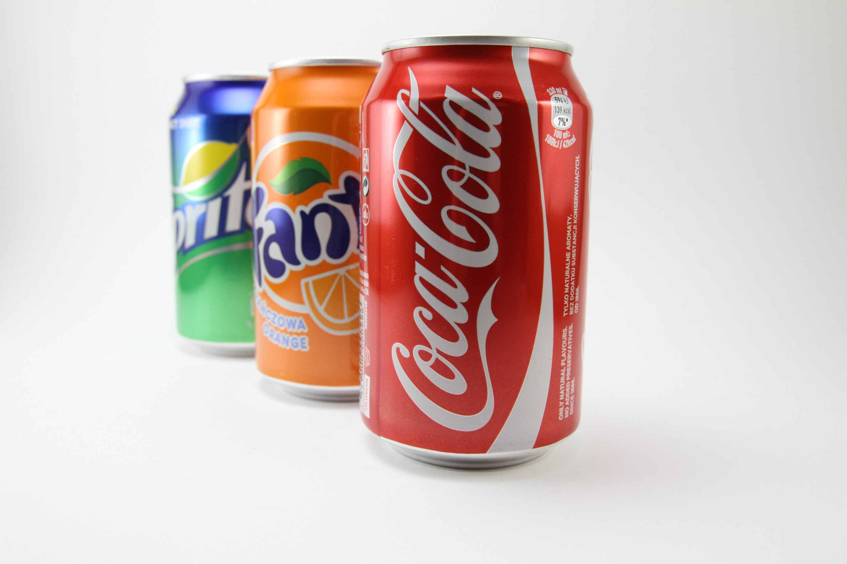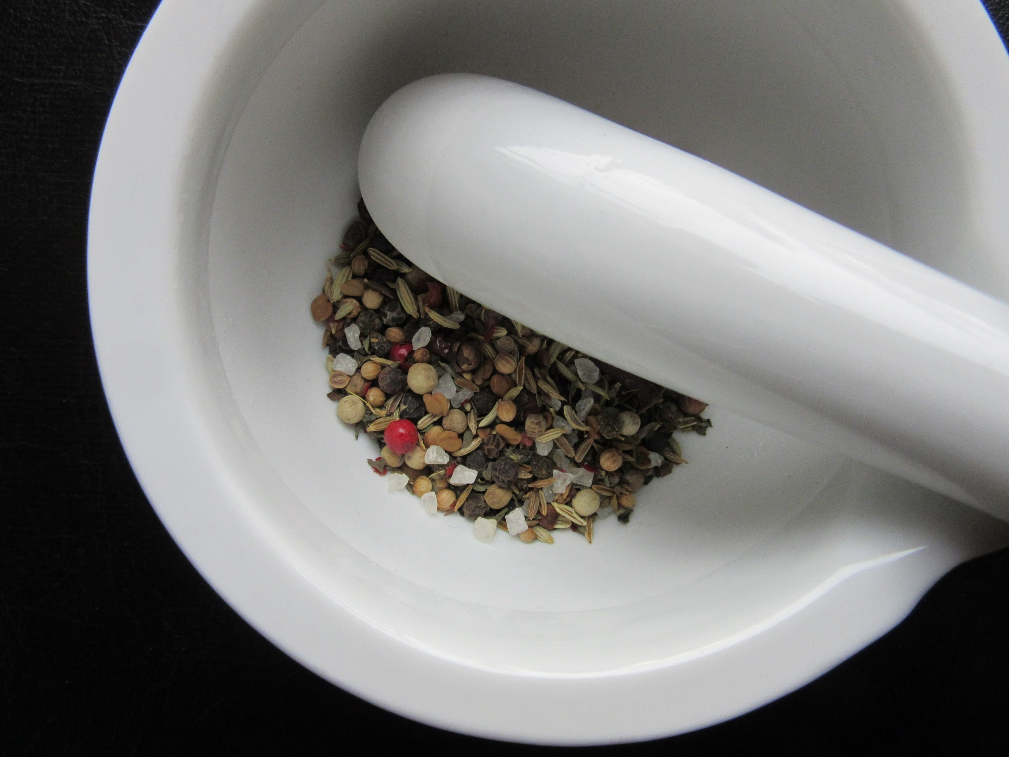
    - Temperature: Some solutes dissolve more easily in warmer solvents while some solutes dissolve more easily in cooler solvents. Think about making sweet tea. The sugar will usually dissolve quicker if you add it when the tea is still hot.
    - Pressure: When you open a can of soda, there is a release of carbon dioxide and the soda fizzes. Inside the can, the gas was under pressure and dissolved in the soda, but when you opened the can, you changed the pressure and the gas was released.
    - Stirring the Solution: By stirring a solution, you increase how quickly the solute will be dissolved.
    - Crushing the Solute: By crushing the solute, you can increase how quickly the solute will dissolve.

NOTE INTERACTION

Identify the solvent and solute(s) in the scenarios below.

Solution | Solvent | Solute
A glass of sugar water
Air (a solution of 78% nitrogen, 21% oxygen, and various other gases)
A solution of 32% ethanol and 68% water
Bronze (a solid solution of 95% copper and 5% tin)

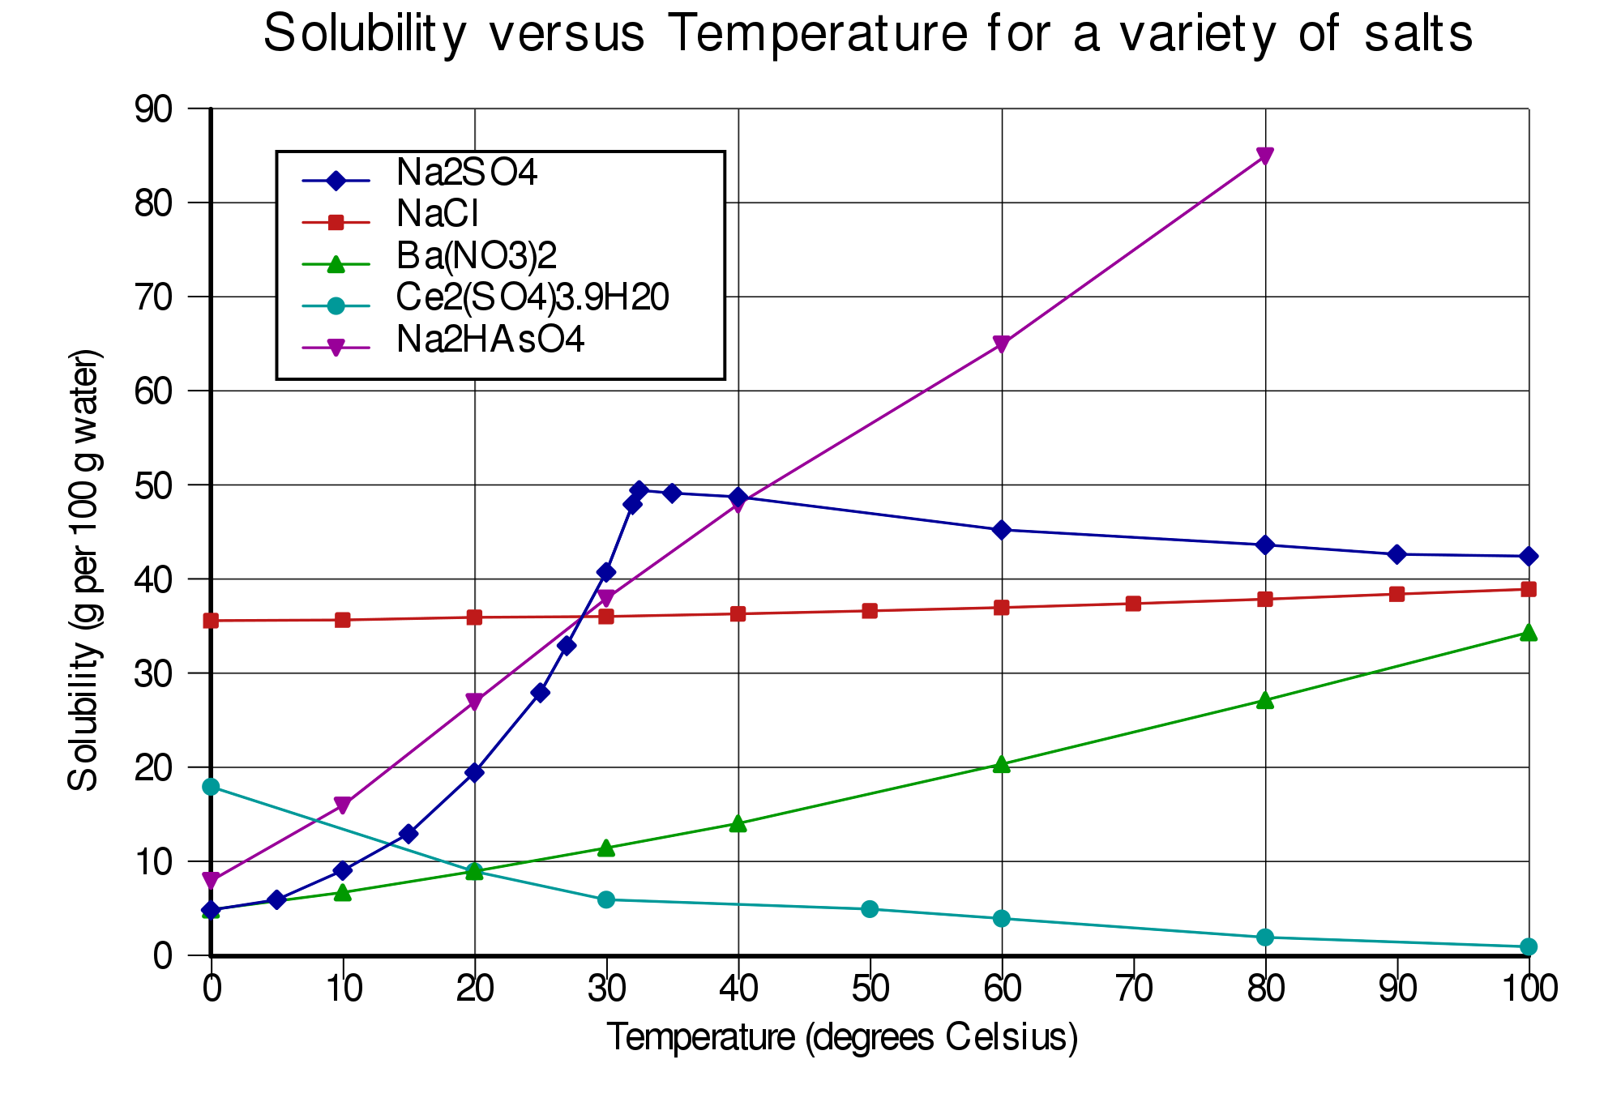
Look at the chart above. What happens to the solubility of Ba(NO₃)₂ when the temperature increases?

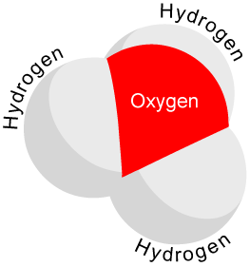
Acids and Bases

- Acid and Base Solutions
  - Acid: a substance that produces a hydronium ion (H₃O⁺) when dissolved in water.
    - Examples: lemon, Coca-Cola, hydrochloric acid, and citric acid
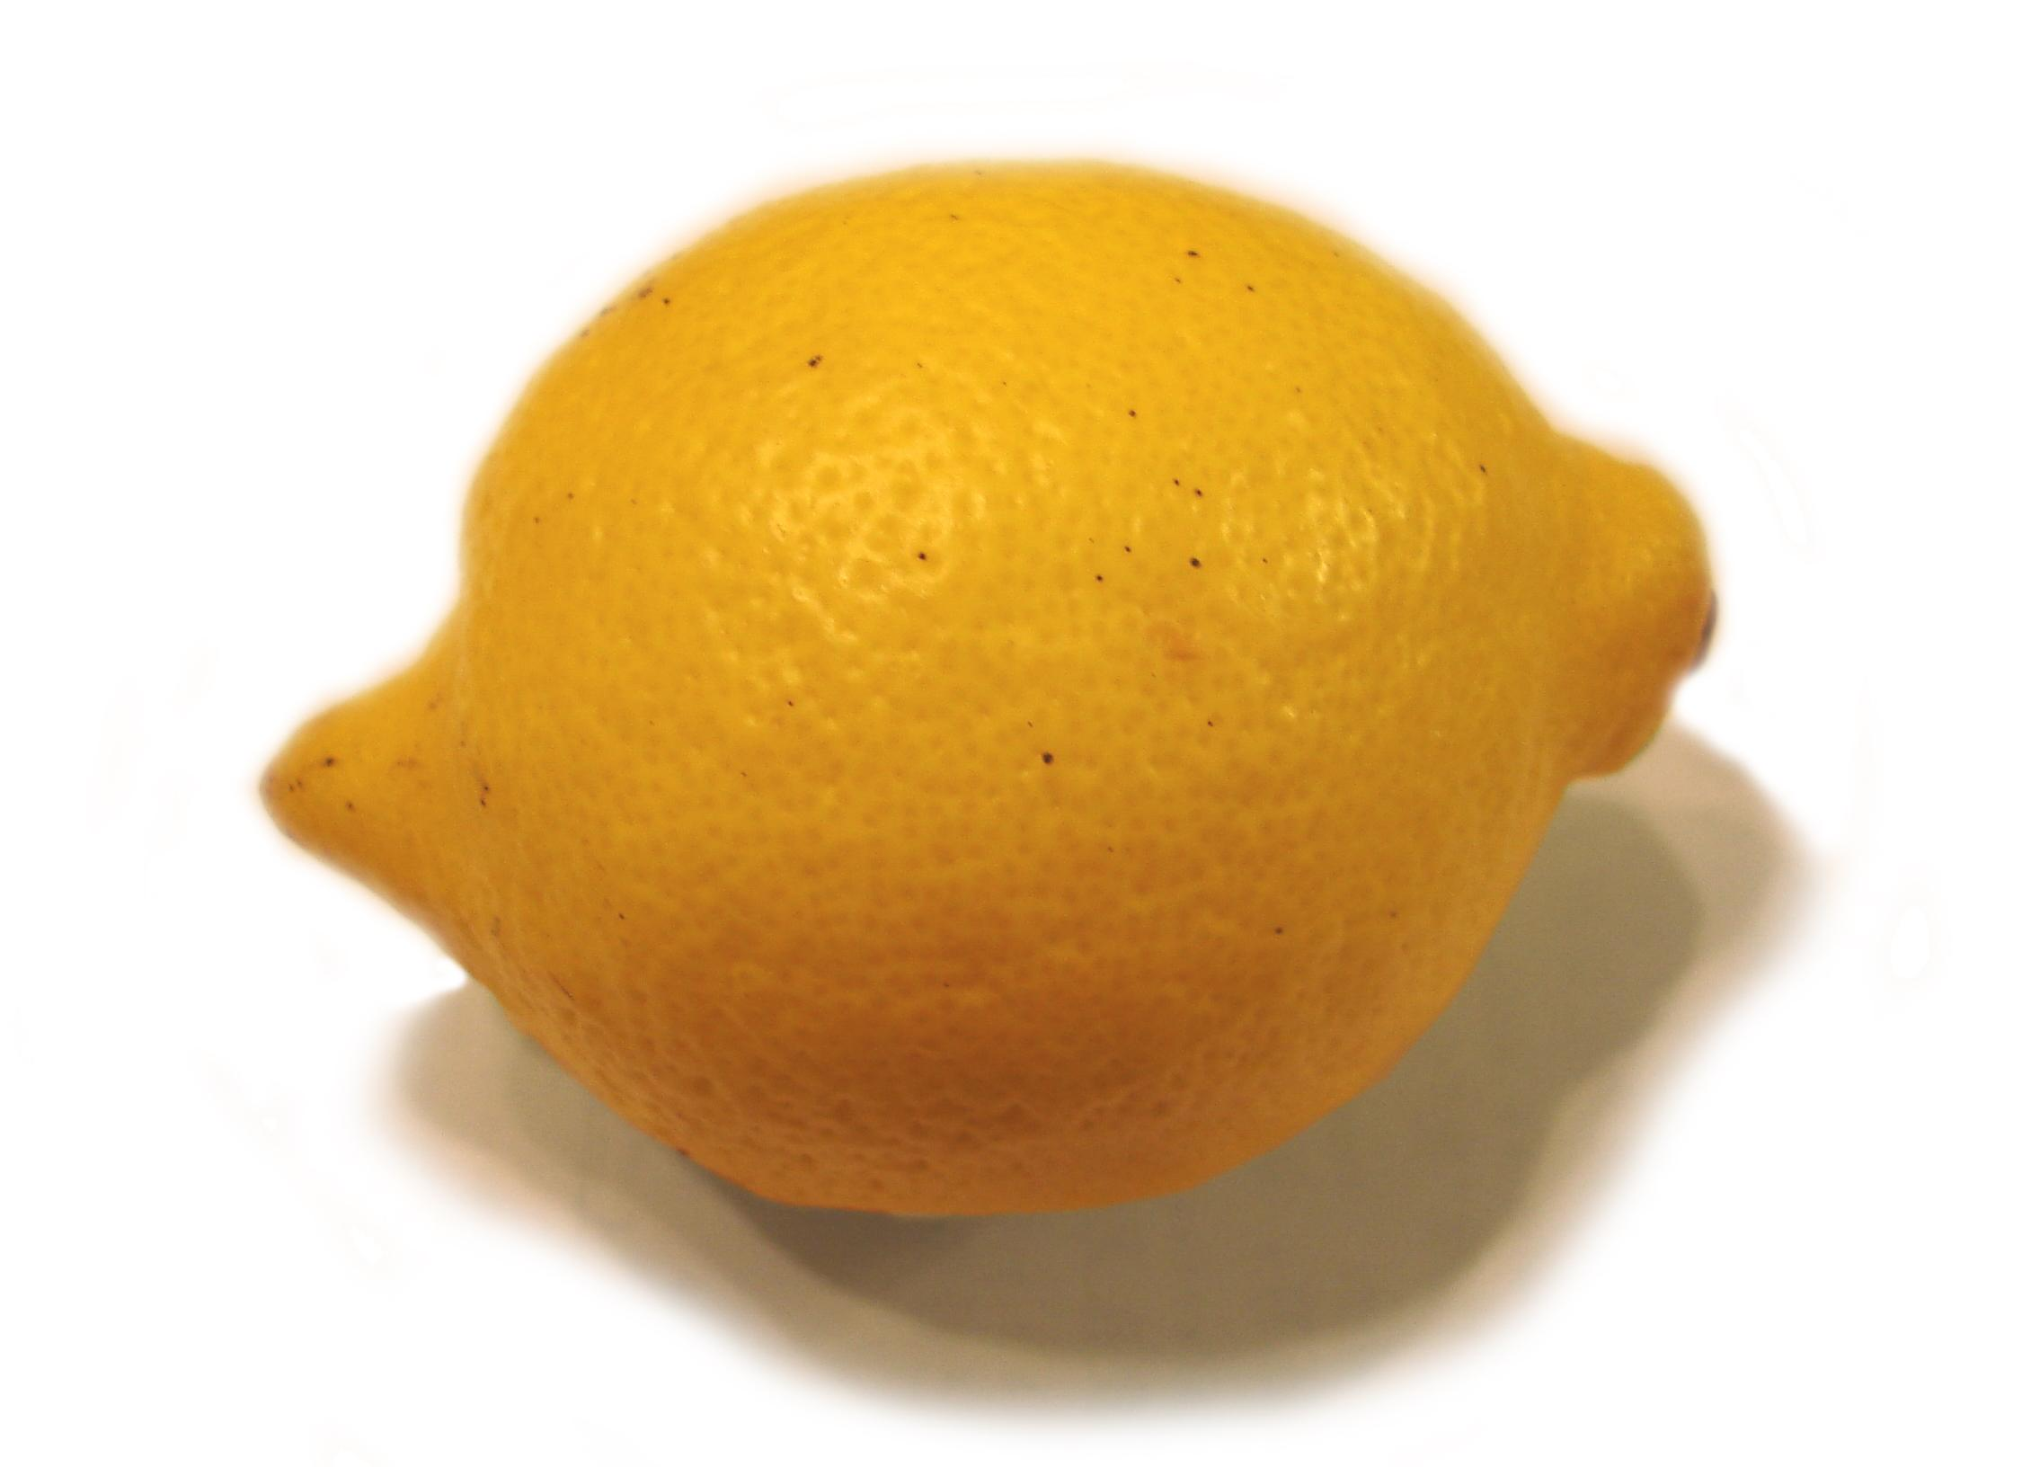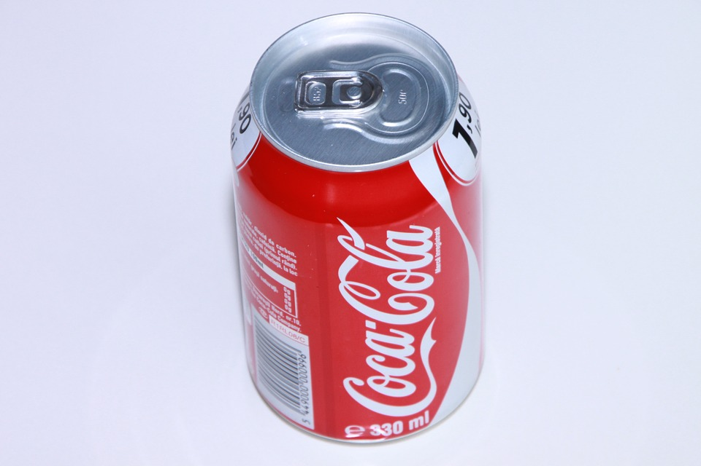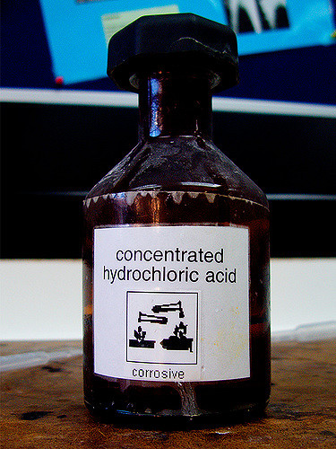
    - Properties of acids
      - Taste sour
      - Can cause damage to skin or eyes depending on strength; “corrosive”
      - React with some metals to form hydrogen gas
      - React with bases to form neutral solutions
    - Uses of acids
      - Flavorings for foods like lemon
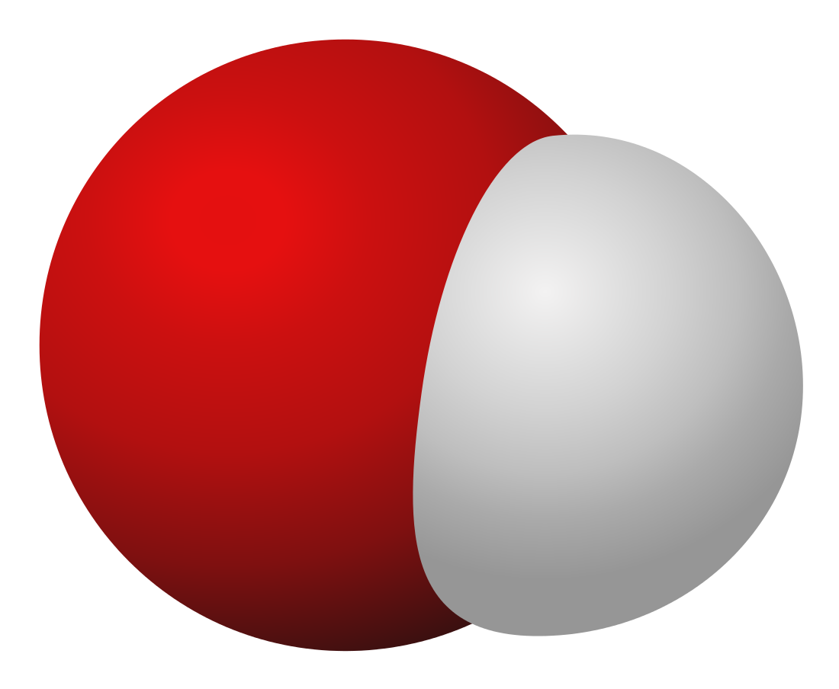
      - The acid in your stomach breaks down the food you eat
      - The production of fertilizers and plastics
  - Base: a substance that produces a hydroxide ion (OH⁻) when dissolved in water.
    - Examples: drain cleaner, detergent, ammonia, sodium hydroxide
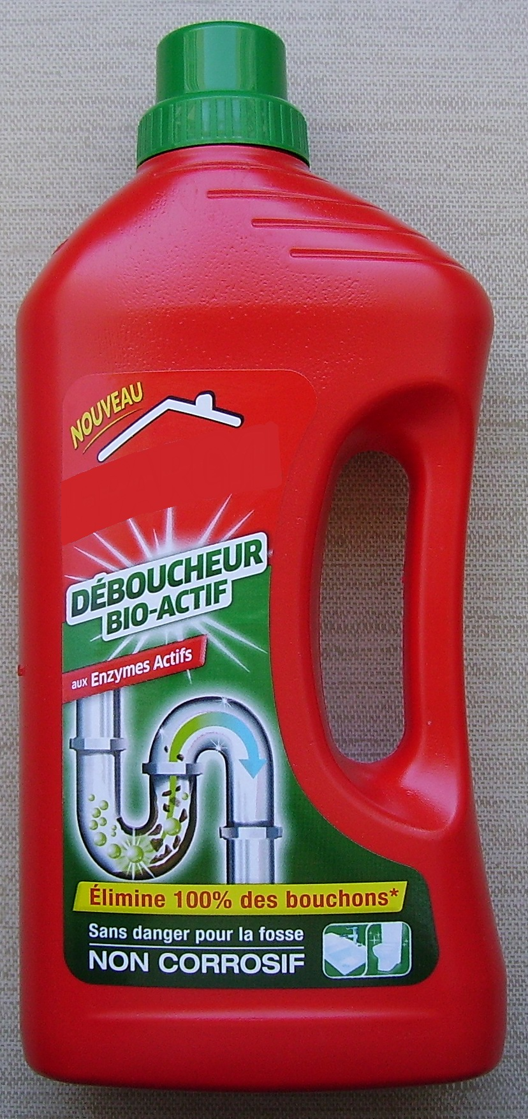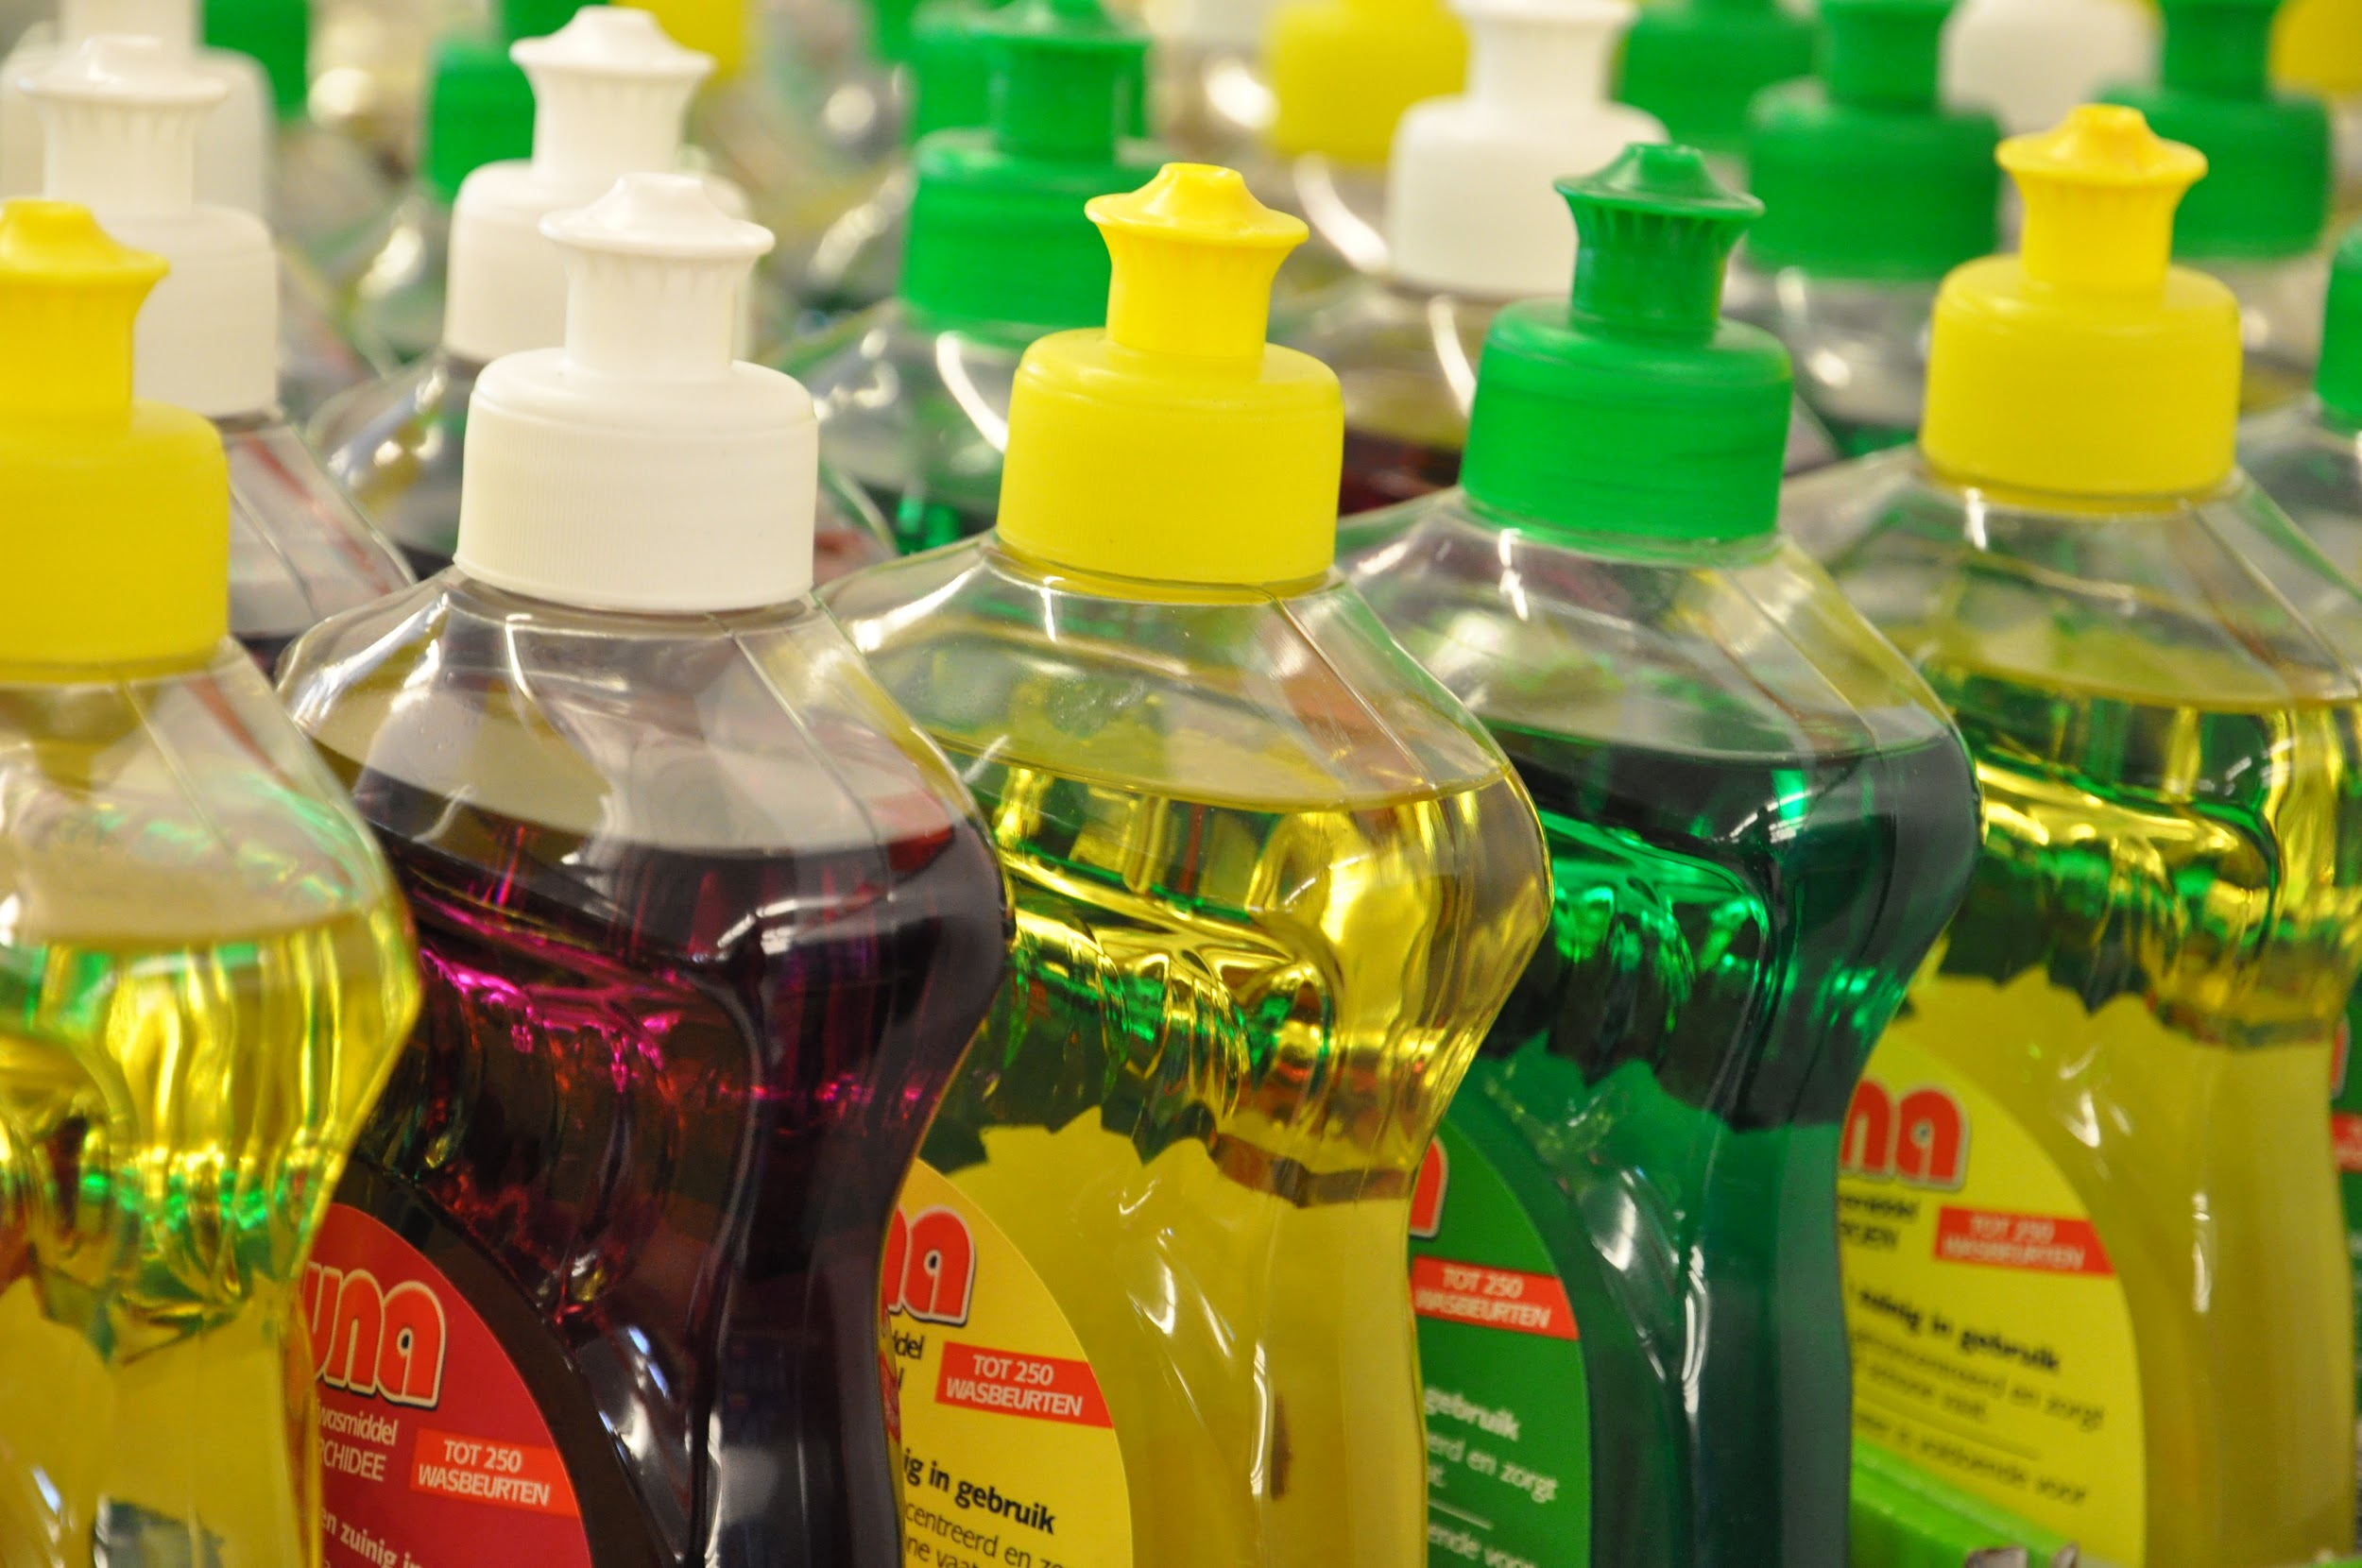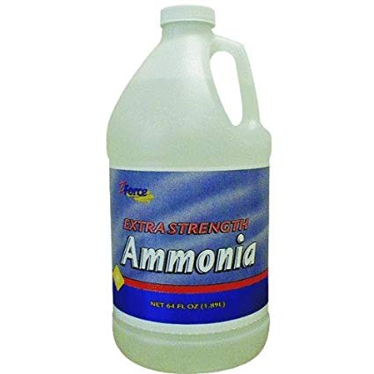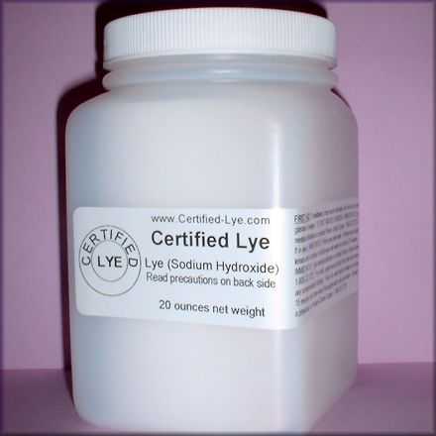
    - Properties of bases
      - Taste bitter
      - Can cause damage to skin or eyes depending on strength
      - Slippery when mixed with water
      - React with acids to form neutral solutions.
    - Uses of bases
      - Flavorings for foods like cocoa beans
      - Neutralize stomach acid to counteract heartburn
      - Found in cleaners like shampoo, dish detergent, and Windex

  - Measuring pH
    - We can learn how acidic or basic a solution is by measuring a value called pH. (More info in this video.)
      - Indicators
        - One way to measure the strength of an acid or base is to use an indicator. An indicator changes color based on how acidic or basic the solution is.
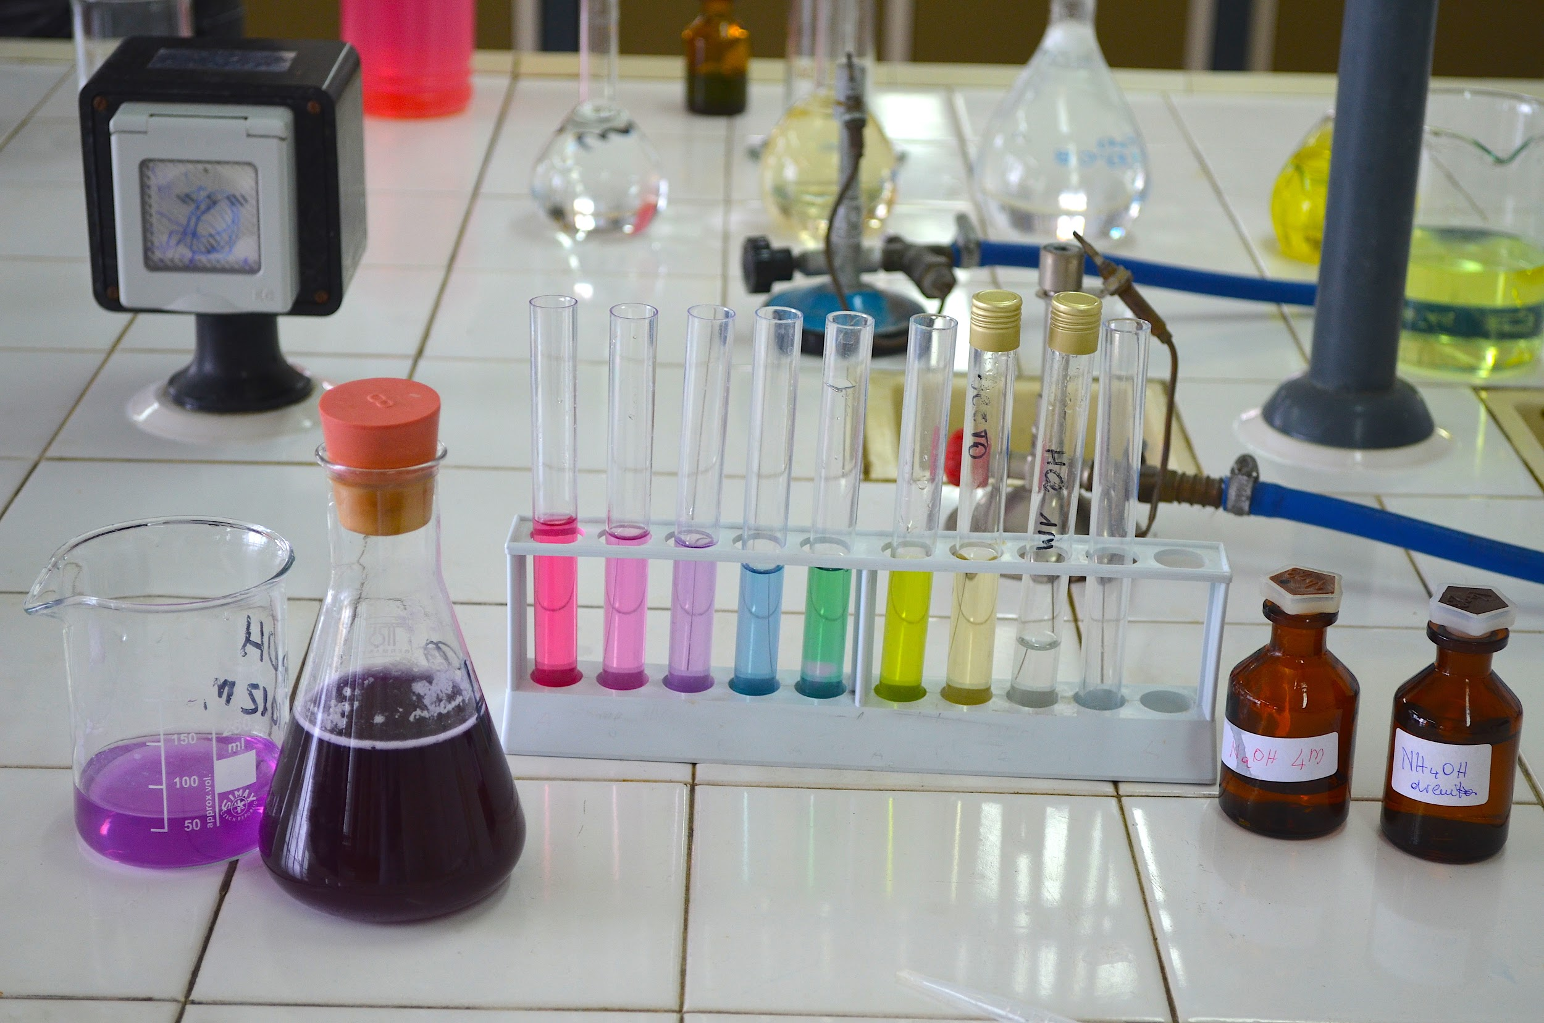
      - pH Testing Strips
        - Dipping these strips into a solution and matching the color to a chart will tell the pH
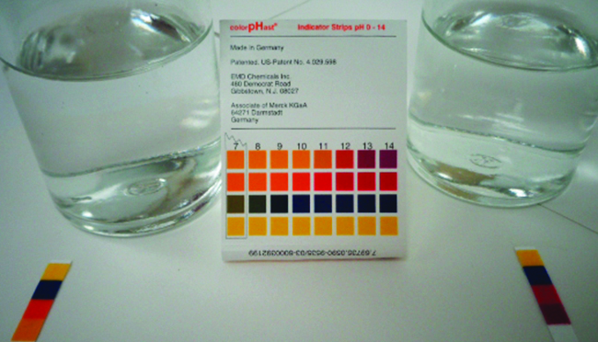
      - pH Meters
        - A pH meter is a more accurate way to measure pH because it can pinpoint a more specific pH value than indicators or testing strips
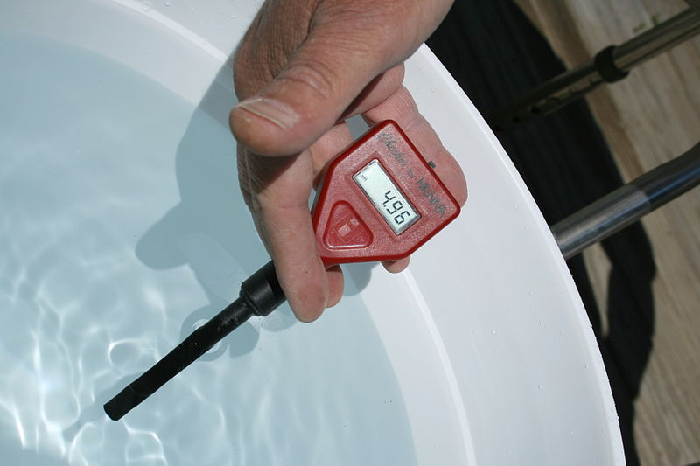

NOTE INTERACTION
Create a T-chart that compares and contrasts acids and bases. Are there any acids or bases in your home? If so, list them on the chart.

pH
- pH is a measure of how acidic or basic a substance is and is an inverse measure of the concentration of hydronium ions released into a solution. That means that as the concentration of hydronium ions increases, the pH decreases.
pH

    - Because acids produce hydronium ions in water, they will have lower pHs than bases which produce hydroxide ions in water.
    - Because all substances create either hydronium or hydroxide ions in water, they can all be placed on the pH scale.
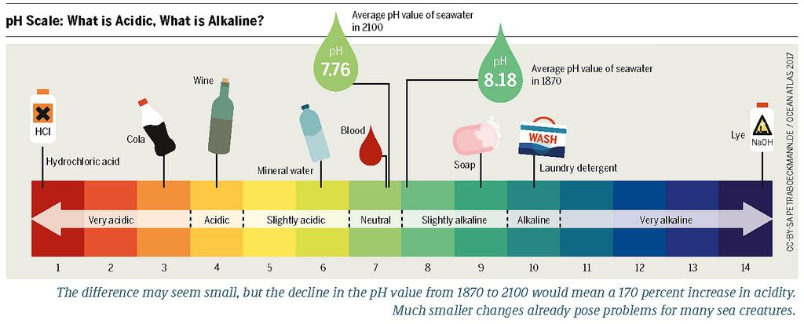
- The pH Scale
  - The pH scale ranges from 0 (a very strong acid) to 14 (a very strong base)
  - The number 7 is considered neutral meaning it is not acidic or basic. Any number below 7 is considered acidic and any number higher than 7 is considered basic. The further away from 7 the number is, the STRONGER the acid or base will be.
  - How does the scale work?
    - The numbers on the pH scale represent the strength of the acid or base, but how do they compare to one another? Let’s compare stomach acid and lemon juice.
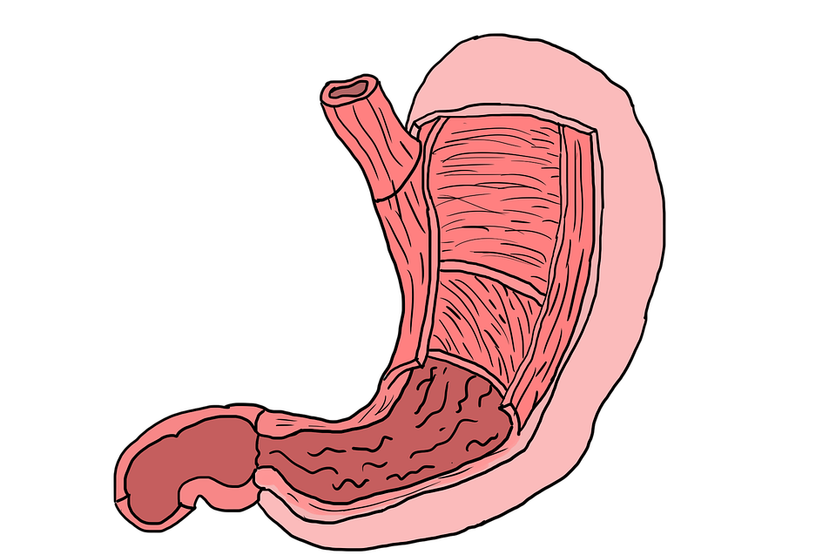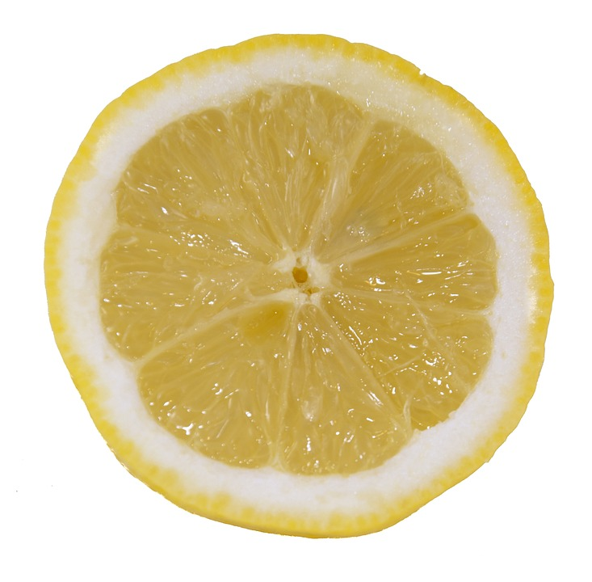
Stomach Acid Lemon Juice
pH 1 pH 2

    - REMEMBER: the LOWER the number the STRONGER the acid!
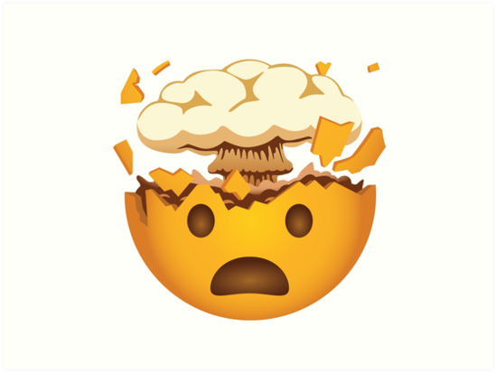
    - If the stomach acid has a pH of 1 and the lemon juice a pH of 2, this does not make the stomach acid twice as strong as the lemon juice.
      - Each step on the pH scale represents a 10 fold change in strength of the acid or base!
      - This means that the stomach acid is TEN TIMES stronger than the lemon juice!

    - What about the difference between stomach acid and a soft drink?
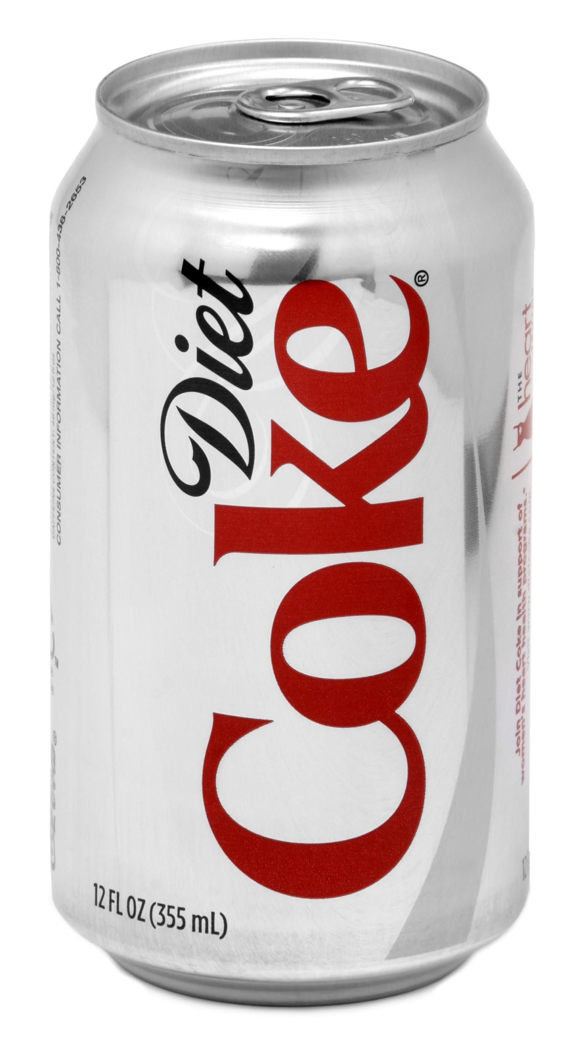
Stomach Acid Soft Drink
pH 1 pH 3
      - Here you see there are TWO steps from a pH of 1 to a pH of 3.
      - Remember that each step is a ten-fold change in the acidity!
x10 x10
Stomach Acid Lemon Juice Soft Drink
pH 1 pH 2 pH 3

      - Because there are TWO sets of ten-fold differences, you would have to multiply the 10s together meaning that stomach acid is 100 times more acidic than soft drinks!

NOTE INTERACTION

Vinegar has a pH of 2.0 and tomatoes have a pH of 4.0. How much more acidic is vinegar than a tomato?

Ammonia has a pH of 12.0 and detergent has a pH of 9.0. How much more basic is ammonia than detergent? (*Hint: remember that the further you get from 7, the more basic the solution becomes so we are not looking for the LOWEST number this time!!)

Natural Resources and Synthetic Materials

- Natural resources are substances that can be found naturally (in nature) without interference. Coal and cotton are great examples of natural resources.
- Synthetic resources occur when natural resources are used by people to make something else. These resources most often undergo a chemical change in which to make the new synthetic resource, therefore changing the properties of the substance.
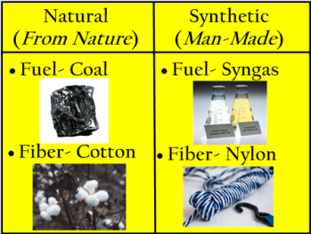
- There are a number of reasons why humans have created synthetic materials over time. Both natural resources and synthetic materials have advantages and disadvantages.

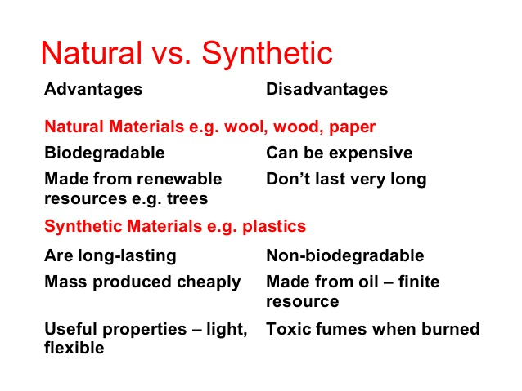

Article on Synthetic Materials

Earth Friendly Fabrics: Shirts made from bamboo, socks made from corn, and jackets made from chicken feathers may be in your fashion future.
By Emily Sohn / Retrieved from https://www.sciencenewsforstudents.org/article/earth-friendly-fabrics

Shopping for clothes involves tricky decisions about fit, color, style, and price. And if a growing number of companies have their way, you'll soon start checking labels for another key detail: environmental impact. Earth-friendly fabrics are in. It's already possible to buy shirts made from bamboo and socks made from corn. Shopping malls of the future might also carry clothes made from chicken feathers or rice straw.
The companies that make such fabrics are interested in sustainable development. This means trying to provide things that people need while protecting natural resources and preserving biodiversity.
"A fully sustainable business would be one that creates no negative impact on the environment," says Gordon Rands. He's an environmental business expert at Western Illinois University in Macomb. "I don't think [such a business] exists yet, but theoretically it's very possible. And companies are moving in this direction." So, scientists are now looking for new ways to make fabrics for clothes that are good both for your image and for Earth.

Born in the lab
Making clothes and shoes traditionally involves harsh chemicals and lots of energy. Some fabrics, such as cotton, leather, and wool, begin as plants or animal parts. But that doesn't mean they're gentle on the environment. Cotton plants, for instance, are often smothered with noxious chemicals to keep away bugs and weeds.
Other fabrics are born in laboratories, where scientists create molecules called polymers and make synthetic (human-made) materials. Polyester, for example, is made from a polymer called polyethylene terephthalate (PET), which can be molded into soda bottles or drawn out into long, thin threads. Textile companies weave or knit PET threads into fabrics that are remarkably silky, sturdy, and quick to dry.
The problem, from an environmental viewpoint, is that most synthetic fibers are made from petroleum, which must be extracted from the ground. Accessing, transporting, and processing oil is expensive, and the supply is limited. Still, petroleum-based materials appear in exercise clothes, shoe soles, plastic zippers, buttons, dyes, and thousands of other products.
To overcome this reliance on petroleum, some companies have experimented with creating polymers from substances such as corn sugar, then weaving the resulting threads into fabrics. Other companies have developed products from recycled materials. Efforts to use recycled materials, however, haven't always been successful. In the 1990s, for example, recycled fleece came and went, mostly because the resulting clothes were scratchy and flimsy. Now, however, advances in technology have made it possible to convert a larger variety of old plastic bottles and worn clothes into much thinner threads that make more comfortable recycled clothes. Likewise, a new type of finely woven organic cotton is soft, yet chemical-free.
Clothes from waste
In the past few years, textile scientist Yiqi Yang of the University of Nebraska in Lincoln has figured out how to make yarn out of cornhusks, chicken feathers, and rice straw (part of the rice plant). All three are agricultural by-products that usually end up in the trash.
"We already have a problem with how to get rid of [these waste products]," Yang says. "Instead, let's use them to make beautiful materials." The process involves chemical reactions that break down the raw materials into fibers, followed by cleaning. The scientists then spin the fibers into yarn, which they use to make fabrics.
On the basis of chemical analyses of the resulting fibers, Yang predicts, rice-straw and cornhusk fabrics will resemble linen or cotton. And chicken-feather fabrics, still in the early stages of research, will wear like wool. Chicken feather fibers are unusual, Yang says, because they are very light and they contain lots of small air pockets arranged like a honeycomb. "That means," he says, "it will be very warm if you use it to make a jacket or sweater."
Clothes made from farm waste are still years away from hitting the stores, but clothes made from organic or recycled fabrics and products made from coconut, bamboo, and corn sugar are already available in many places. Simply by choosing carefully how you get dressed in the morning, you can help decide Earth's future.

NOTE INTERACTION:

How important is it to be “Earth conscious” when developing synthetic materials? On a scale of 1-10 rate the importance with 1 being not important at all and 10 be extremely important. Then justify your decision.

