**Instructional Focus**:

**Reading**- Story for week- Henry and Mudge

Reading Skill: Cause and Effect

**Phonics Skills**: Suffixes –ly -ful (Ex: slowly, useful)

Vowel Sound in moon: oo

**Grammar Skill:** Adjectives that Compare

**Math** – Topic 12 Measurement and Data

**Science/ Social Studies** – State of Alabama

**Leader in Me** – Habit 7 “Sharpen the Saw”

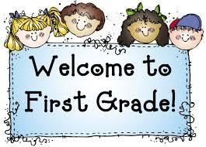 Week of April 19th – April 23rd

Mrs. Lyness’ Newsletter

Spelling Words:

1. slowly

2. useful

3. sadly

4. wonderful

5. careful

6. painful

7. gladly

8. quickly

9. playful

10. nicely

*Test on Friday

**Important Dates Coming Up**:

April 30th – Special Snack/ Spirit Day

May 31st – No School; Memorial Day Holiday

*If you can send in some Clorox Wipes and Paper towels that would be greatly appreciated.

High – Frequency Words:

1. across

2. only

3. told

4. because

5. opened

6. dance

7. shoes

*On Reading Test