One of the Science/Social Studies units that I was going to start after spring break was landforms. I am sharing three youtube videos that discuss landforms and also a video that shows how to draw landforms. One of the videos talks about oceans and continents and this will be a great review for them since we have already covered this. I will add this to my school website as well.

Learning About Landforms – Mr. DeMaio 4:40
https://www.youtube.com/watch?v=KWTDmg8OI_Y&t=127s
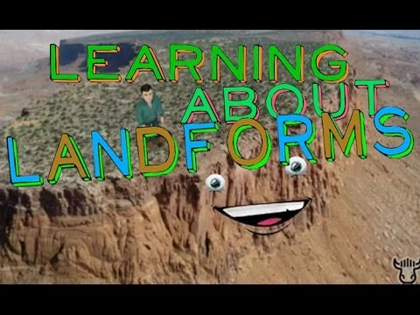 | Learning About Landforms - YouTube  Listen to Mr. DeMaio teach a social studies lesson on geography and the many landforms found all over the world  www.youtube.com

Exploring Landforms and Bodies of Water for Kids – Free School 9:18
https://www.youtube.com/watch?v=BsqKTJtK_vw&t=363s
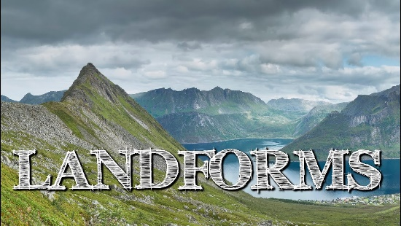 | Exploring Landforms and Bodies of Water for Kids - FreeSchool - YouTube  https://patreon.com/freeschool - Help support more content like this! Landforms are natural features of the earth's surface. Landforms are all around us! Mou...  www.youtube.com

Exploring the Landforms of the Earth/Periwinkle 6:05
https://www.youtube.com/watch?v=7GxBe-3CG3E&t=83s
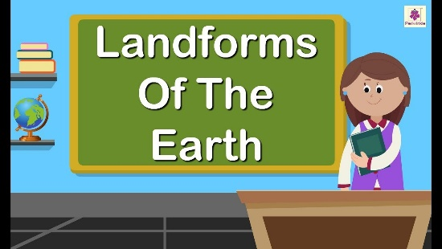 | Exploring The Landforms of the Earth | Periwinkle - YouTube  Exploring The Landforms of the Earth | Periwinkle 0:53 Mountains 2:23 Plateaus 3:31 Plains 4:12 Deserts Watch our other videos: English Stories for Kids: htt...  www.youtube.com

Let’s Draw Landforms 9:35
https://www.youtube.com/watch?v=4tdIgwtkYU4
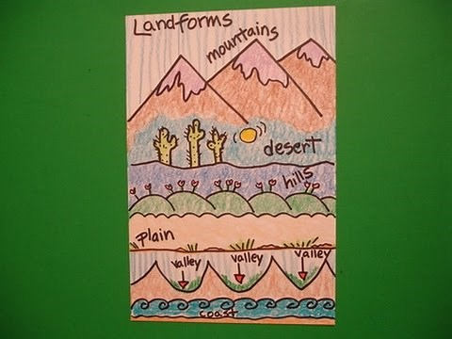 | Let's Draw Landforms!  Easy to follow directions, using right brain drawing techniques, showing how to draw landforms.  www.youtube.com

