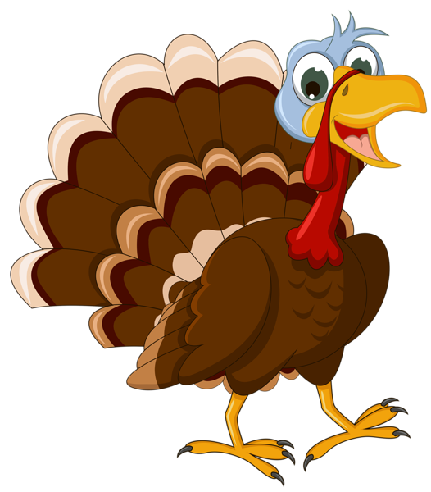

Weekly news from

Mrs. Newburn

**Upcoming Events / Reminders…**

* We have been talking about Veterans Day and what it means!
* If you have not sent in headphones for technology, please do so ASAP.
* Thanksgiving break is from November 27th – December 2nd.
* Looking ahead, Christmas break will be December 23rd – January 5th.
* We will be having a Christmas celebration for families…more will come home at a later time!

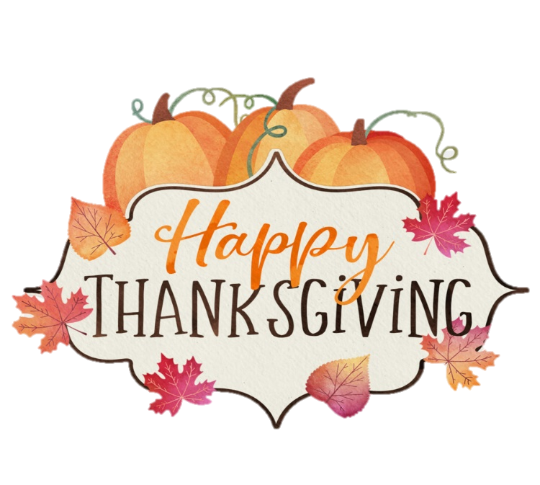

**Skills we are working on…**

* The letters “Aa, Tt, Ff, Ii, Ee, & Ll”, their sounds and how to make them in sign language
* Writing names

**Things to work on at home…**

**Things to work on at home…**

* Days of the week
* The more practice with fine motor skills, the better! Practice writing, coloring, and cutting!
* Help your child write the first letter of their name