The Best Day Ever
One day I woke up feeling ___________, and I knew
Emotion
it was going to be a special day. The sky was ___________
Color
and the weather was ___________, so I hopped out of
Weather
bed, put on my 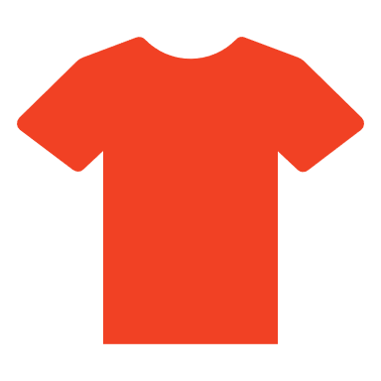___________ and my ___________
Article of clothing Adjective
___________, and I was ready to ___________.
Type of footwear Verb
Outside, I caught the first ___________, which took
Type of vehicle
me straight into ___________. I went ___________
Town/City Direction
until I came to a store selling ___________ ___________,
Adjective Plural noun
where I bought the perfect ___________ ___________!
Adjective Noun
Next, I treated myself to a ___________ snack at a
Type of food
___________ restaurant. It was very ___________,
Type of food Temperature
but it was still good enough to ___________.
Verb
Finally, I went back home. I fed the ___________,
Animals
then sat down on the ___________, and thought, "What
Piece of furniture
a/an ___________ day!"
Adjective

The Case of the Missing ____________
* Special Noun *
There once was a detective named ____________. One day, the
Name
detective's neighbor knocked on the door.

"I am so ____________," said the neighbor. "I can't find my ____________
Adjective * Special Noun *
anywhere. I saw it before I went to ____________ club, but later it was gone!"
Verb ending in "ing"
The detective grabbed a pencil and a ____________ and asked, "Will
Noun
you describe it?"

"Certainly," said the neighbor. "It is ____________, ____________, and
Color Adjective
it never ____________."
Plural verb
The detective searched ____________ around every ____________ and
Adverb Noun
behind every ____________.
Noun
"____________!" said the detective, "I found it! It was right here under
Exclamation
your ____________ the whole time!"
Noun
They both had a good ____________, and the detective thought,
Verb
"Another case ____________ solved!"
Adverb

Story Title
Ready to create your own Funny Fill-in story? To get started right away, just replace this text with your own. You can customize your story by adding your own pictures, shapes, and icons. On the Insert tab of the ribbon, just tap the option you need.
Once your story is complete, go back and replace the nouns, adjectives, adverbs, and other words with fill-in blanks. To create the fill-in blanks, just add a series of underscores, like this: ____________.
To add the labels, at the end of each line of your story, press Enter twice to create an empty paragraph between each line. Type the label text, and then select the Fill-In-Label style from the Styles gallery on the Home tab. Use tabs and spaces in front of the label to position it under the fill-in blank: ____________.
Fill-In Label
Get creative with your fill-in labels by using an Icon from the Insert tab in place of the label text. Resize and recolor the icons on the Format tab, and then select the Fill-In Icon style for the label paragraph:____________.
Stuck for story ideas? Get inspiration from a favorite story, fairytale, song, movie, or show. For a special occasion, such as a birthday or family get-together, write a story about the person or a funny family story.

