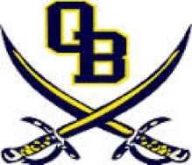

OBMS December Events

December 7: Soccer at home v CHMS
December 10: Soccer at Horn Lake Middle School
December 11: PTA Meeting (Library)
December 13: Social Studies Exam (all grades)
CFA Chicken Biscuits sold
Basketball at home v LMS
December 14: 6th and 7th grade Science Exam
8th Grade Reward trip: Strike Zone (permission form required)
December 17: Cyber Foundations Exam (8th grade only)
7th Grade Reward Trip: Malco (permission form required)
December 18: Make Up Exams
December 19: Christmas Break Begins (no school)
January 3: Students Return to School
Report Cards

Exam Reminders:
- Students are not exempt from December exams.
- All students will take the scheduled exams on the scheduled day.
- Exams will be given during the regular class period.
- Attendance will be taken through the end of the day on December 18.

Dates are subject to change; updates will be posted on our school website.

