Mrs. Daniel’s Newsletter
February 1-5, 2021
Grammar (adjectives for number, size, and shape)
and Skills Test (sequence): Thursday
Vocabulary and Spelling Test (oo, u): Friday
Feb. 5th-Report Card Day
Feb. 12th- 100th Day of School, Valentine Snacks, Cookie Dough Fundraiser Begins
Feb. 26th- Spirit Day, Special Snack

Story:  “Life Cycle of a Pumpkin”  by Ron Fridell and Patricia Walsh  Phonics/Fluency:  vowel patterns  oo, u  Text-Based Comprehension:  sequence, important ideas  Grammar: adjectives for number, size, and shape |  | Selection Vocabulary Words (Students will be tested on these):  - bumpy –covered with high spots or lumps  - root – part of a plant that takes in water and holds the plant in place  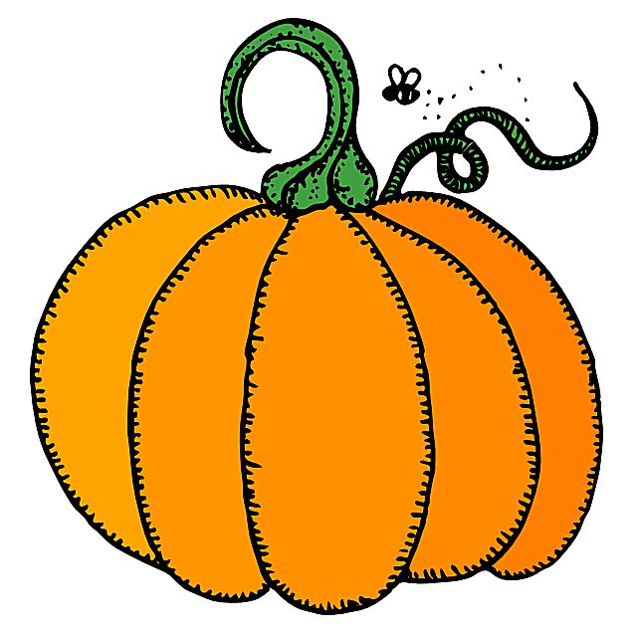  - vine – a plant with a long thin stem  - fruit – part of a plant that has seeds  - smooth – flat or even  - harvest – to gather crops  - soil – top layer of Earth’s surface  Amazing Words  adapt, nutrients, drought, massive,  annual, blazing, ancient, sprout
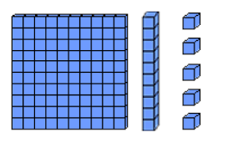  Math: Topic 9  Subtraction with Regrouping  Lesson 3: Subtracting two and one digit numbers.  Lesson 4: Models to subtract two digit numbers.  Lesson 5: Subtracting two digit numbers. |  |  |  | Social Studies/Science  We will learn to identify continents, oceans,  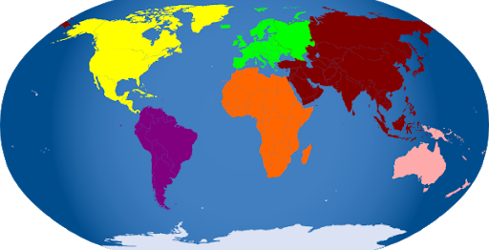  the equator,  the  prime  meridian,  and North  and South Poles.
Spelling Words:
- cook  - stood  - full | - wood  - July  - shook |  | - push  - brook  - book |  | - put  - hood  - pull

