Mrs. Cook’s Messages
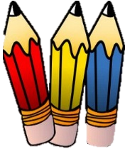
February 1-5, 2021
Grammar (adjectives for number, size, and shape)
and Skills Test (sequence): Thursday
Vocabulary and Spelling Test (oo, u): Friday
 | Check folders daily. | Practice HW each night.
 | Check for graded papers. | They are in Tuesday Folders.
Thank you for those who returned the Chromebooks and chargers. The Chromebooks will only be sent home when we have to go to virtual learning. We will continue to use them everyday in class. If your child didn’t return the charging cord, please do so as soon as possible. We have to charge them every night.

Story:  “Life Cycle of a Pumpkin”  by Ron Fridell and Patricia Walsh  Phonics/Fluency:  vowel patterns  oo, u  Text-Based Comprehension:  sequence, important ideas  Grammar: adjectives for number, size, and shape |  | Selection Vocabulary Words (Students will be tested on these):  - bumpy –covered with high spots or lumps  - root – part of a plant that takes in water and holds the plant in place  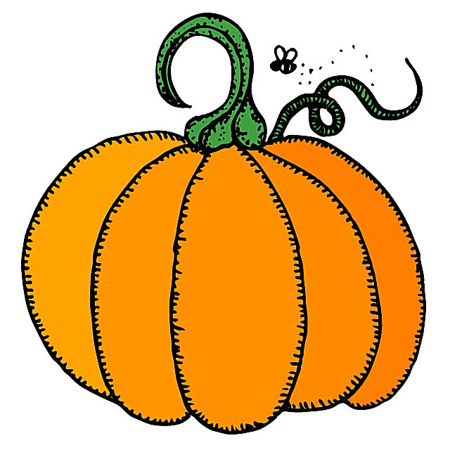  - vine – a plant with a long thin stem  - fruit – part of a plant that has seeds  - smooth – flat or even  - harvest – to gather crops  - soil – top layer of Earth’s surface  Amazing Words  adapt, nutrients, drought, massive,  annual, blazing, ancient, sprout
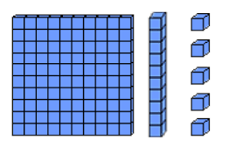  Math: Topic 10  Place Value to 1,000  Lesson 1: Building 1,000  Lesson 2: Counting Hundreds,  Tens, and Ones  Lesson 3: Reading and Writing Numbers to 1,000  Lesson 4: Changing Numbers by Hundreds and Tens  Lesson 5: Patterns with Numbers on Hundreds Charts |  |  |  | Social Studies/Science  We will learn to identify continents, oceans,  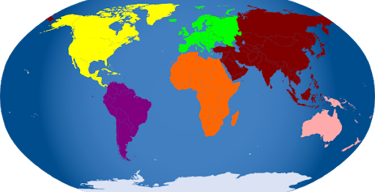  the equator,  the  prime  meridian,  and North  and South Poles.
Spelling Words:
- cook  - stood  - full | - wood  - July  - shook |  | - push  - brook  - book |  | - put  - hood  - pull

