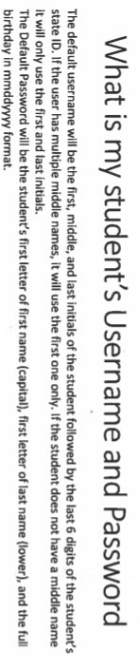
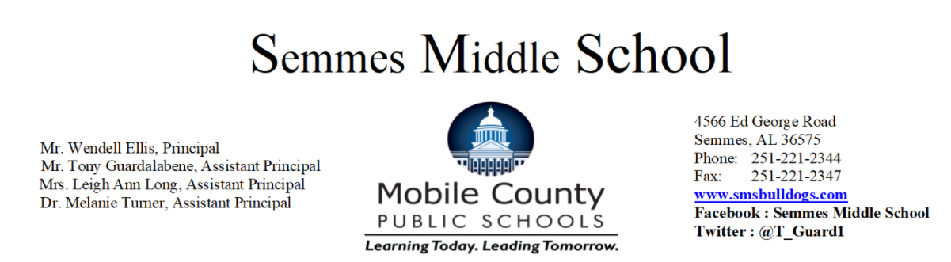

Dear Parents/Guardians:
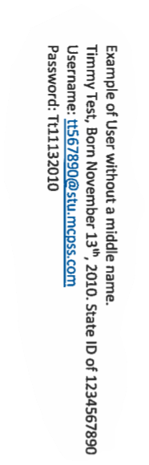
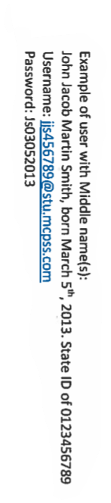
Semmes Middle School will be using Schoology, as our online learning platform starting September 1, 2020. As a parent, you will be able to view your child’s activity within the platform. If you have questions or feedback regarding Schoology, please email Ann Brooks at abrooks1@mcpss.com or call Semmes Middle School at 221-2344.
?

Sign on to Schoology with a MCPSS Computer
-Simply login to the Clever Student icon on the computer desktop.
-Login to the active directory
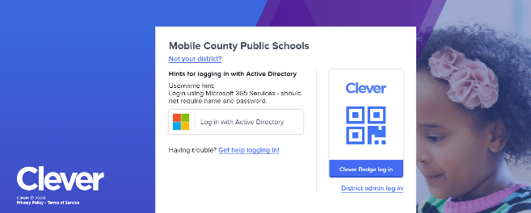

-It may prompt you to use your Mobile County Username and Password, if not, you will go straight to the Clever website.
-Once in Clever, you will see the Schoology icon to login to Schoology

Log on to Schoology with a Personal Computer

-Make sure Google Chrome is downloaded to your computer. If not, download Google Chrome to your computer.

-Go to our school’s website smsbulldogs.com

-Click on the Clever icon

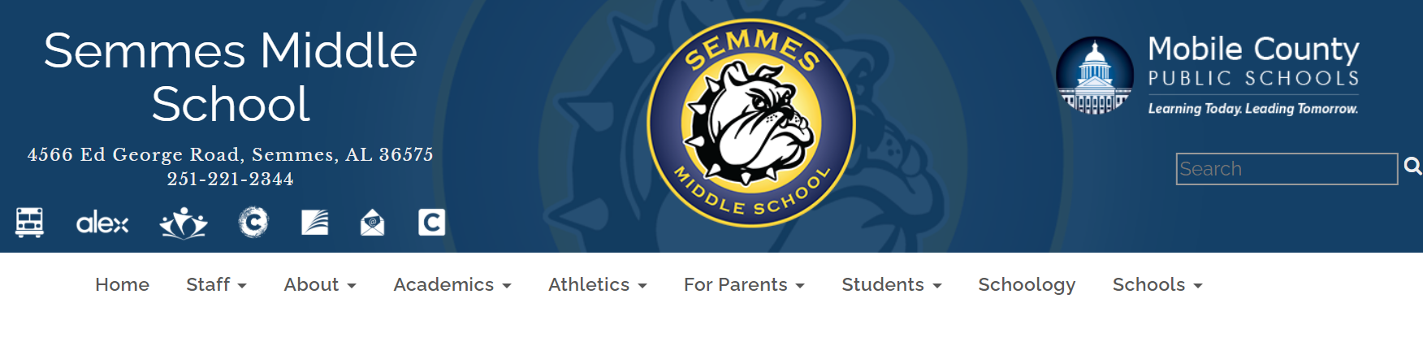

-Clever will prompt you to login to the active directory
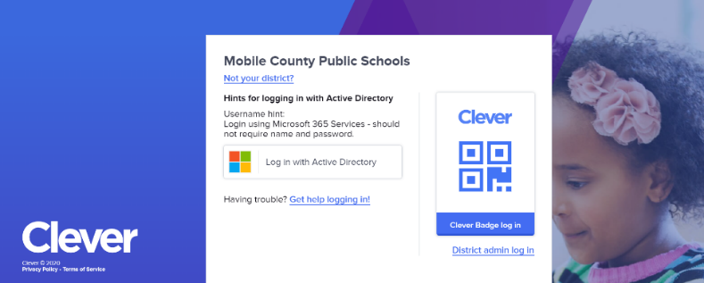

-It may prompt you to use your Mobile County Username and Password, if not, you swill go traight to the Clever website.
-Once on Clever, you will see the Schoology app to login to Schoology

Wendell Ellis
Principal
Semmes Middle

