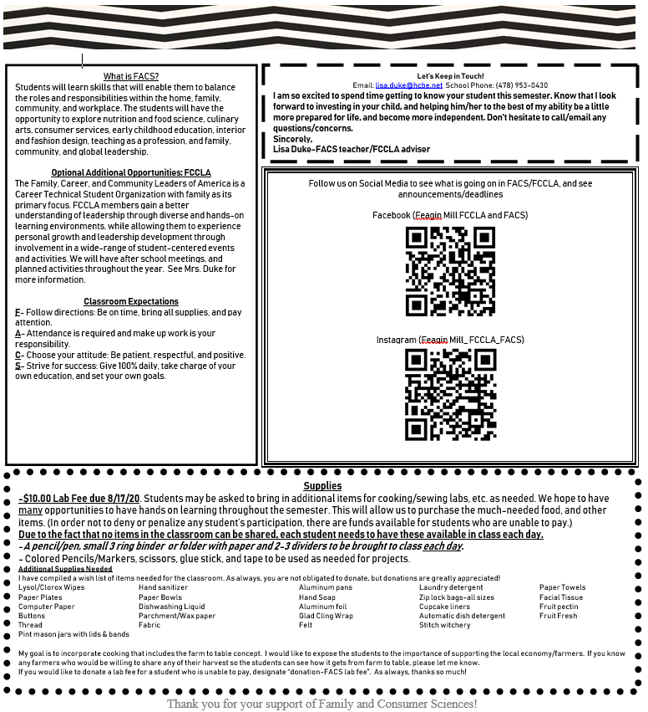

Sign and Return
Please return this page completed and signed along with lab fee to Mrs. Duke ASAP: No later than August 17th, 2020
This form will need to be turned in completed and signed, along with a passing grade on the lab safety test before your student will be able to participate in cooking labs.

Student Name (Print): ______________________________________ Grade: _________ Homeroom Teacher: _________________________

**Please list ANY known food allergies or food restrictions (must also be notated on paperwork with school nurse):
_________________________________________________________________________________________________________________________________________________________________________________________________________________________________________________________________________________________________________________________________________________________________________________
I acknowledge that Mrs. Duke will inform all students of major ingredients utilized during cooking labs, and my student is aware of the ingredients they should avoid.
**Check one: YES _______ NO_________

I give permission for my child to be photographed during FACS/ FCCLA Events and for pictures to be published on social media sites and other media outlets for the purpose to promote Family and Consumer Sciences and FCCLA.
**Check one: YES _______ NO_________

**Check one or more of the choices below:
______ $10 Lab fee attached
______ I am unable to pay lab fee at this time
______ I have attached a donation to assist student/s who are unable to pay
(In order not to deny or penalize any student’s (or child’s) participation, there are funds available for students who are unable to pay.)

VIDEO/MOVIE INFORMATION:
We may have the opportunity to incorporate a few of videos/movies into our content of study that align with our standards. Please look over the videos/movies. Your student may not watch all of these since this is the list for the 6th-8th grade for the entire school year, but these are the ones that we may utilize as a tool periodically. An alternative assignment will be given to those who are not allowed to watch these. If you have any questions or have any objections to any of these, please feel free to contact me, or notate in the comments below.

Inside Out, a Pixar production. Movie is rated PG.
Ratatouille, by Brad Bird. Movie is rated G.
Before the Plate, by Dylan Sher. Documentary is rated G.
Jamie Oliver’s Food Revolution, by Jamie Oliver. Video series is rated PG.
The Andy Griffith Show, by Andy Griffith. Television series rated G.
Supersize Me by Morgan Spurlock. Documentary rated PG/PG-13.

Comments/ information you feel I may need to know________________________________________________________________________
___________________________________________________________________________________________________________________________
Parent Phone Number/s __________________________________________________________________________________________________
Parent email: ______________________________________________________________________________________________________________

***Parent Name (Print): ________________________________________**Parent Signature: _______________________________________

I have read the syllabus, and I agree to abide by the classroom expectations. I also understand that it is my responsibility to read over all ingredients that are utilized in each cooking lab to ensure my overall safety in the lab setting.

***Student Signature: _____________________________________________Date: __________________________________________________

