Stay informed by using the following:
- INOW Parent Portal is available for pre-order beginning August 6. Passwords will be sent home by August 20. Cost: $10 for 1st child, $15 for two or more children. Send to Mrs. A. Turner in the Media Center. Please include your child’s name and homeroom teacher. Make checks payable to PLES.

- NOTIFY ME is used to notify parents of updates through your email and phone text (if you choose). Go to www.pinelevelelem.com. Click on Notify Me tab and follow promptings to complete.

- Stay informed about happenings at PLES by following us on Instagram at pine_level_rocks and viewing our school website at www.pinelevelelem.com.

Assessments:

- Performance Series – Begins August 19
Reading & Math – Grades 2, 3, 4, 5
Science – Grades 4, 5

- DIBELS – August 21 – September 5
Kindergarten and 1st Grade

Special Days:

- Spirit Day – Wear your Pine Level Elementary Bulldog shirt.
- Friday Fun Day – Students who have not received an office referral for the previous month or an SBR (Student Behavior Report) for the current week will have an extra “break” and have the opportunity to purchase special snacks.

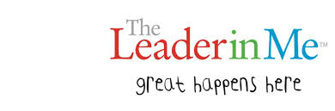

Habit 1: Be proactive
Habit 2: Begin with the End in Mind
Habit 3: Put First Things First
Habit 4: Think Win-Win
Habit 5: Seek First to Understand, Then to Be Understood
Habit 6: Synergize
Habit 7: Sharpen the Saw

