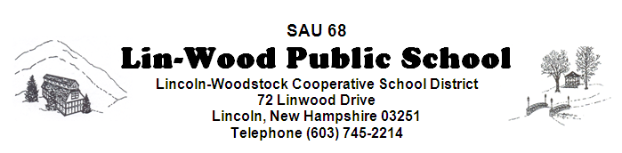

The Policy Committee and the Facilities Committee both meet at 5:30 pm. The Policy Committee will meet in the music room. The Facilities Committee will meet in the Elementary MPR. The Lincoln-Woodstock Cooperative School Board will meet in the Elementary MPR at 6:30 pm on September 25, 2019

**Board members are encouraged to arrive early to sign manifests**

AGENDA

- CALL TO ORDER – Matt Manning, Chairperson
- EDUCATIONAL FOCUS – Dan Adams – Due to a schedule conflict moved to October 9th
- MINUTES
  - Approval of Minutes of September 11, 2019
  - Approval of Non-Public Minutes of August 28, 2019
  - Approval of Non-Public Minutes of September 11, 2019

- COMMUNICATION
  - CORRESPONDENCE
  - REPORTS
    - Business Administrator’s Report
    - Superintendent’s Report
    - Principal’s Report
    - Committee Reports
- COMMITTEES
  - Policy Committee
FIRST READING: SECOND READING:
DAF – Administration of Federal Grant Funds
DJ – Purchasing
DJB – Purchasing Procedures
EB/JLI – Joint Loss Management
EBB/ADD – School Safety
EBBB – Accident Reports
EBBC/JLCE – Emergency Care and First Aid
EBBD – Indoor Air Quality
EBCA – Crisis Prevention & Emergency Response Plans
EBCB – Fire Drills
EBCC – Bomb Threats
EBCD – Emergency Closings
EBCE – School Closings
EBCF – Pandemic/Epidemic Emergencies
EC – Buildings and Grounds Management
ECA – Buildings and Grounds Security
ECAB – Access to Buildings
*Please note that Policies are available for your review in the SAU Office and on our school page at www.lin-wood.org
VI. BUSINESS REQUIRING BOARD ACTION
- Staff Nominations, Recommendations and Resignations
VII. NEW BUSINESS

- None

VIII. CONTINUING BUSINESS

- Strategic Plan

IX. RECOGNITION OF VISITORS / PUBLIC PARTICIPATION
- Student
- Staff
- Community – Please state your name and address. This agenda item is intended to give citizens a voice and the Board an opportunity to hear directly from citizens. The total time limit is 15 minutes as per policy BEDH. This time is not intended for Q & A. Questions about programs or practices may be directed to respective administrators during the school day.
X. NON-PUBLIC SESSION (RSA 91-A:3) Discussion of matters that are likely to adversely affect the
reputation of a person other than a member of the school board.
XI. ADJOURNMENT

