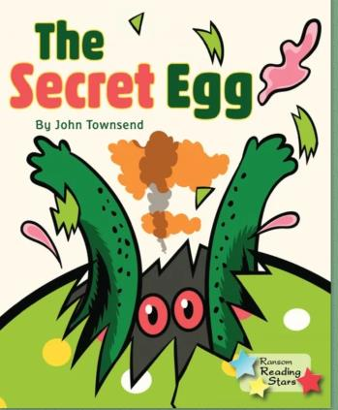
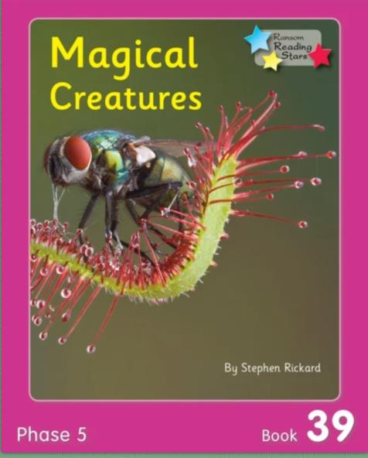

DCPS

2ND GRAD E NEWS
May 18th- 22nd
Last Newsletter

3 R’s:
Remember me

Read/Refl
ex/ReadingEggspress Summer Checklist: Fiction B

1. Don’t forget to
ook: The Secret Egg
Read: Here are some great chapter book suggestions.

Comprehension Questions Parents Can Ask:
Magic Tree House

1. Why is this The Secret Egg title Ivy and Bean

of the story? Can you think of another title that could replace it?
The Last Kids on Earth

The Box Car Children 2. There are a lot of adjectives in I Survived

this story. Remember an The Hardy Boys
adjecti
ve describes a noun. What Who Was Series
are three adjectives you could use Junie B Jones
to describe yourself?

Geronimo Stilton

3. Make a story web. Incl
Judy Moody
ude
Ask Me Why?

charact
ers, setting, problem, and solution.
A to Z Mysteries

My Weird School
Non-Fiction Book: Magical Cr eatures

Goosebumps
Comprehension Questions Parents Phonics
Cam Jansen
Can Ask:
1. What are two text features you 2. Reflex: Your child will have the rest of found in the text? Why are they important?
the summer to work on multiplication and division. This is a great resource to use to be 2. List 3 facts you learned from the prepared for 3rd grade!
text.

3. Please remember that all of our computer 3. Which magical creature would you programs will be available this summer.
like to learn more about and why?
You can access these accounts on your teacher’s website through lab links.

Videos for k
Writing Prompt
ids:
We hope you have a Great Summer!!
https://youtu.be/6Li

BqvzMh-E: Mythical Math Skills

The last sentence in The Creatures
Secret Egg was: Their
Did you get a green light on Reflex

today?
story’s only just begun…
https://youtu.be/Nbu

This week your teacher will post on who knows where it will all u1Fa-c1k: Stingray

their website:
end? Write a paragraph Mythical Creatures

• Word Problem of the Day about the dragon and the cat’s friendship. Don’t
• 9 Box Review
https://youtu.be/uhf
forget to include an Remember you can do this on
XbSSrabw: Gecko opening and a closing.
notebook paper too.
Feet: How do they

stick to walls?

