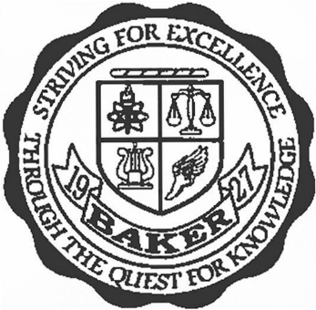

Baker High School Summer School 2021

Baker High School will be offering summer school for students that did not meet course requirements for the 2020-21 school year. Students will be allowed to take up to two classes. ALL students will be required to attend classes on campus.

June 1st – June 30th (For Seniors who still have requirements to complete for graduation)
7:30 AM – 11:30 AM – Monday – Thursday

July 1st – July 29th (For Juniors, Sophomores, & Freshmen who have failed a course)
7:30 AM – 11:30 PM - Monday – Thursday
12:30 PM – 4:30 PM – Monday - Thursday
No class on July 5th
Breakfast and Lunch will be provided daily.

Courses offered:

English 9
English 10
English 11
English 12
Algebra
Geometry
Algebraic Connections
Algebra 2
Physical Science
Biology
Environmental Science
Earth and Space Science
World History
U. S. History 10
U. S. History 11
Government
Economics
Parenting
Personal Finance
Health

Important Dates:

Tuesday, May 25th 8:00 AM – 12:00 PM - Senior Summer School Registration for June
Registration will be held in the front lobby

Tuesday, June 15th 8:00 AM – 12:00 PM - Student Summer School Registration for July
Registration will be held in the cafeteria

