First Grade Lesson Plans -
Day 1- March 30

Reading: | Select a book on myON to read and take a test on. These points will go towards your child’s AR points for the 9 weeks!
ELA: | Watch the video on capitalization  https://www.youtube.com/watch?v=MwUjGtdTxVo  Skywrite (take your finger and write in the air) 5 words that need to begin with a capital letter.
Writing: | Listen to “The Littlest Bunny in Georgia” read aloud.  https://www.youtube.com/watch?v=tiI4z4gxSZ8&feature=emb_logo
Math: | *Log in to xtramath.org or reflex math to practice math fact fluency  *Watch Ms. Fick’s video introducing telling time.  https://youtu.be/tdvnxNrLjaY  Make a paper clock. You can do this on a paper plate or a piece of paper.
Science/
Social Studies

First Grade Lesson Plans -
Day 2- March 31

Reading: | Login to myON and read “Crabby Pants”. After you read, discuss the problem and solution in the story with your parents. You can take a test if you would like to increase your AR points!
ELA:
Writing: | Think about the story “The Littlest Bunny in Georgia”. We are going to begin thinking about a narrative writing we’ll be working on this week, which we will title “The Littlest Bunny in Villa Rica”. In our story we will choose 3 places in Villa Rica that we think the Bunny would like to visit. Watch the slideshow then complete the thinking map below. You can include places in Villa Rica from the slideshow or you can add your own ideas. You can print the thinking map out or create your own. Take a picture and send this to your child’s teacher.  https://docs.google.com/presentation/d/1UEroE7UsMl6Fxk0UQi1wMTemb2YGoOQEzvHiM2AtLA4/edit#slide=id.g720664bab4_0_67
Math: | Watch BrainPop video on telling time.  https://jr.brainpop.com/math/time/timetothequarterandhalfhour/
Science/  Social Studies | Watch this video about what plants need.  https://www.youtube.com/watch?v=DPL0F2V9_gY  Write down the 4 needs of plants and either draw a picture of each need OR get outside and take a picture of each need.

First Grade Lesson Plans -
Day 3- April 1

Reading: | Listen to “Arthur’s April Fool”.  https://www.youtube.com/watch?v=DYQDqaGE7gQ  Tell someone in your house the problem and solution in the story.
ELA: | Watch the Brainpop Jr video on different types of sentences (telling, question, exclamation).  Username: ithica Password: brainpop  https://jr.brainpop.com/readingandwriting/sentence/typesofsentences/  Write one example of each kind of sentence.
Writing: | Visit the link below. This lesson will take 2-3 days to complete. You should watch the video today and get started on your writing, then complete the writing tomorrow.  https://www.youtube.com/watch?v=uFoXGPq-qAo&feature=youtu.be
Math: | Play Kahoot! to practice telling time!  https://kahoot.it/challenge/0726836?challenge-id=5fd7a611-de21-43af-8573-c9a114d301b6_1585159029379  Challenge PIN: 0726836
Science/
Social Studies

First Grade Lesson Plans -
Day 4- April 2

Reading: | Listen to Mrs. Montgomery’s read aloud “There Was an Old Lady Who Swallowed a Chick”.  ********Mrs. M’s video*******
ELA:
Writing: | Continue writing “The Littlest Bunny in Villa Rica”.  If you finish today, take a picture and send it to your teacher.
Math: | *Log in to xtramath.org or reflex math to practice math fact fluency  *Watch read aloud, What Time is it, Mr. Crocodile?  https://www.youtube.com/watch?v=k7ILFkEdgZk  Print out the attached worksheet or list the times on piece of paper. Write down what you are doing at each time. When you are finished, you can email it, or a picture of your work, to your teacher.
Science/  Social Studies | Watch the video about the needs of living things  https://www.youtube.com/watch?v=wOXay8rdzRg

First Grade Lesson Plans -
Day 5- April 3

Reading:
ELA: | Fix the following sentences by fixing the capitalization and punctuation errors:  does your friend sarah love to go to target  i have baseball practice on mondays  hooray, easter is coming
Writing: | Complete “The Littlest Bunny in Villa Rica” writing. When finished, take a picture and send it to your teacher.  *Optional* Visit the following links and pick a bunny to do a Directed Drawing. Once you have drawn the bunny, color it! You can use markers, paints, chalk, or crayons! When you have finished, send a picture to your teacher!  https://www.youtube.com/watch?v=aau6xZgIu1A  https://www.youtube.com/watch?v=5QQJ6mMWoFY  https://www.youtube.com/watch?v=Y2Vg1DKlTmg
Math: | *Log in to xtramath.org or reflex math to practice math fact fluency  *Watch “The Clock Struck One” read aloud: https://www.youtube.com/watch?v=wpX3qK4F6NE  *Complete IXL and Education Galaxy Assignments
Science/  Social Studies | Compare and Contrast what plants and animals need. Use the following sentence starter:  Plants and animals are alike because they both need______.  They are different because _____.

Make your Own Clock

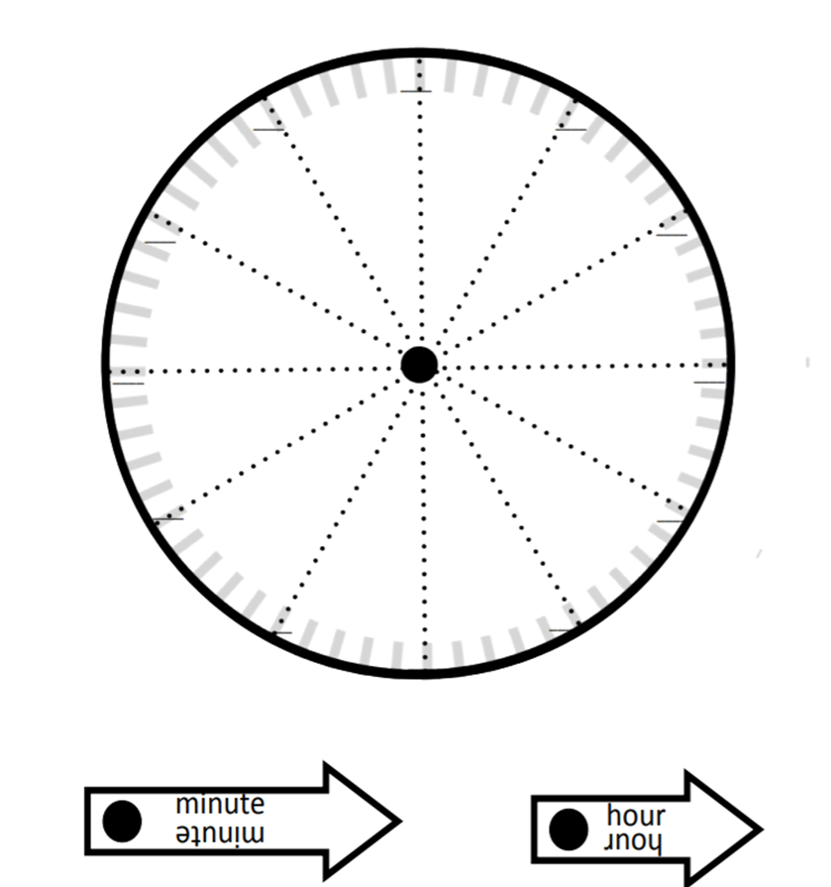

Name _______________________________________________

The Littlest Bunny in Villa Rica thinking map

Directions: After watching the slideshow, complete the map with 3 places in Villa Rica that you think the Littlest Bunny would visit.

The Littlest Bunny
In Villa Rica

Name ___________________________________

Math, Day 4

In the story, What Time is it, Mr. Crocodile?, Mr. Crocodile had a daily schedule.

What is your daily schedule?

8:00 am _________________________________

9:15 am __________________________________

10:30 am _________________________________

12:00 pm _________________________________

1:30 pm __________________________________

2:15 pm __________________________________

Write a complete sentence to answer the following questions.

What time do you wake up for school each day?

____________________________________________________________

What time do you go to bed each night?

____________________________________________________________

What is your favorite tv show and what time does it come on?

____________________________________________________________

