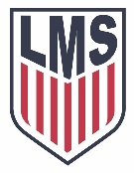
LMS Patriot Soccer ’21 – ‘22

#15 Aiden Booth
#18 Jake Clayton
#2 Nathan Cook
#20 Sean Cook
#14/22 Logan Correro
#5 Trenton Cruseturner
#13 Reid Hodgson
#4 Brolin Haley
#23 Tanner Knight
#19 Ben Lageman,
#1 David Moore
#3 Om Patel
#11 Deyton Tedder
#10 Tyler Thorne
#16 Logan Trest
#12 Joshua Wade
#7 Colby Williams
#21 Max Whittaker
#17 Avery Wilbanks

