CASTLEN ELEMENTARY SCHOOL
Kindergarten School Supply List
2020-2021
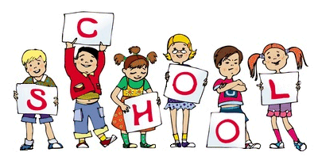
Central Office is requesting that parents provide a face mask for their child to have with them at school each day. Cloth is preferred due to durability.
1-4 oz. bottle of Elmer’s Glue
4 Elmer’s glue sticks
2-regular boxes of Crayola crayons (24 count)
1 pair of Fiskars blunt tip scissors
1 plastic pencil box
1 pack of Crayola washable markers
1 primary composition notebook (with handwriting lines)
2 packages of #2 pencils
1 pack of Ticonderoga Tri-Write pencils
4 PLASTIC pocket folders with 3 brads
1 package of Expo Dry Erase Markers
1 front clear zipper pouch for 3 ring binder
1 tray of Crayola watercolor paints
WISH LIST
2 rolls of paper towels (preferably small size-select a sheet)
1 box of Kleenex
1 large container of wet wipes (Wet Ones Brand or Baby Wipes)
1 Large container of Clorox/ Lysol Wipes
1 large bottle of hand sanitizer
1 box of sandwich Ziploc bags

