7th grade Math & 7th grade Adv. Math

School Supply List

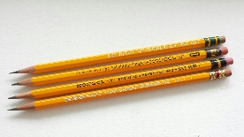
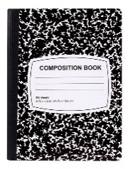
Needed Supplies:
☐ 1 Composition book – wide ruled
☐ Paper (Wide-ruled)
☐ Pencils & Pencil-top Erasers
☐ 1 Folder with fasteners & pockets – any color – to be used for Homework
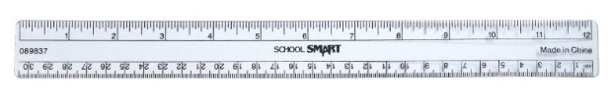
☐ Highlighters
☐ Ruler
☐ 3-Ring Binder – 1 ½ in. or 2 in.
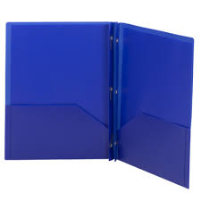
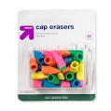
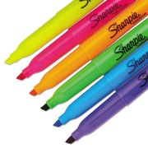

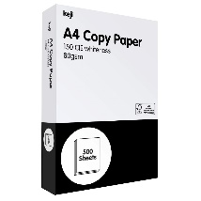
HoMEROOM APPRECIATED Supplies:
☐ White Copy paper
☐ Kleenex boxes…lots and lots!
☐ Hand sanitizer
☐ Paper Towels
☐ Lysol Air Fresheners
☐ Clorox Wipes
