Name: ______________________________
Macromolecule Stations
We ALL start here:

Do Now: What is the importance of knowing that a large percentage of our body is made of C, H, O, and N? How does this knowledge impact our daily lives?

Brainstorming: Explain/conclude what do you think may be happening to the proteins in the frying egg? Use you prior knowledge to answer to the best of your ability. Hint: think about “homeostasis”

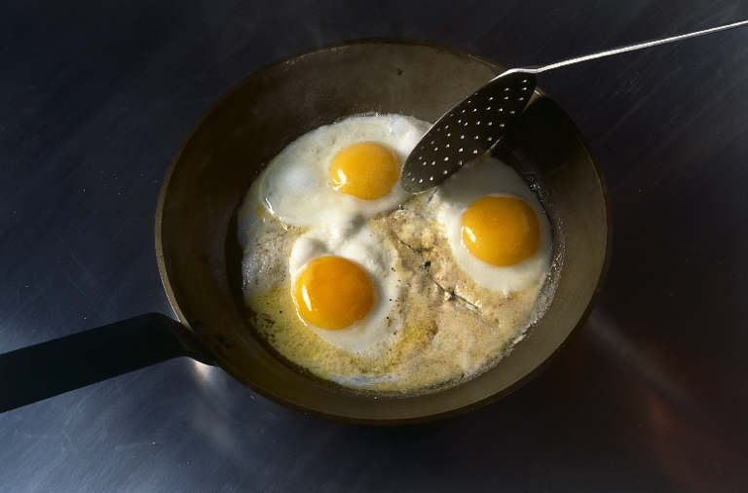

Carbon Compounds- Close Reading/ Annotate:
Organic chemistry is the study of all compounds
Important Vocabulary

Macromolecule Characteristics and Examples
Carbohydrates

Lipids

Proteins

Nucleic Acids

that contain bonds between carbon
atoms. Carbon compounds are also called
organic compounds. Many of the molecules
in living things are so large that they are
known as macromolecules. Macromolecules
are formed in a process called polymerization.
Smaller units, called monomers, join together
to form macromolecules, or polymers.
Four groups of organic compounds
found in living things are carbohydrates,
lipids, nucleic acids, and proteins. Carbohydrates
are compounds made up of carbon,
hydrogen, and oxygen atoms. Living things
use carbohydrates as their main source of
energy. Plants and some animals use carbohydrates
in structures. Starches and sugars
are examples of carbohydrates.
Lipids are made mostly from carbon and
hydrogen atoms. Fats, oils, and waxes are
lipids. Lipids are used in living things to
store energy. Some lipids are important parts
of biological membranes and waterproof
coverings. Lipid molecules are made up of
compounds called fatty acids and glycerol.
Nucleic acids contain hydrogen, oxygen,
nitrogen, carbon, and phosphorus.
Nucleotides are the monomers that make
up nucleic acids. Each nucleotide consists of
a 5-carbon sugar, a phosphate group, and a
nitrogenous base. Nucleic acids store and
transmit hereditary, or genetic, information.
There are two kinds of nucleic acids:
ribonucleic acid (RNA) and deoxyribonucleic
acid (DNA).
Proteins contain nitrogen as well as carbon,
hydrogen, and oxygen. Proteins are
polymers of molecules called amino acids.
Some proteins control the rate of reactions
and regulate cell processes. Some are used
to form bones and muscles. Others transport
substances into or out of cells or
help to fight disease.

What Macromolecules Are In My Food? Analyze the food label below and answer the following questions:
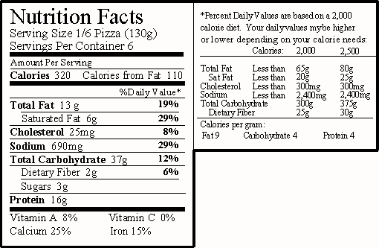

1. What food is this nutrition label from?

2. What macromolecules are found in this food?

3. What type lipid is found in this food?

4. What macromolecule does cholesterol belong to?

5. What polysaccharide does this food have to help us move things through our digestive system and in what percentage?

6. Based on the percentages, what biological functions would this food mainly help us with?

